**SAP FICO Configuration Document**

**for Bhole Baba Milk Food Industries Ltd Implementation Project** **SAP S/4HANA Cloud, Public Edition 2308 Release General Settings 🡪 Organizational Structure 🡪 Create Company**

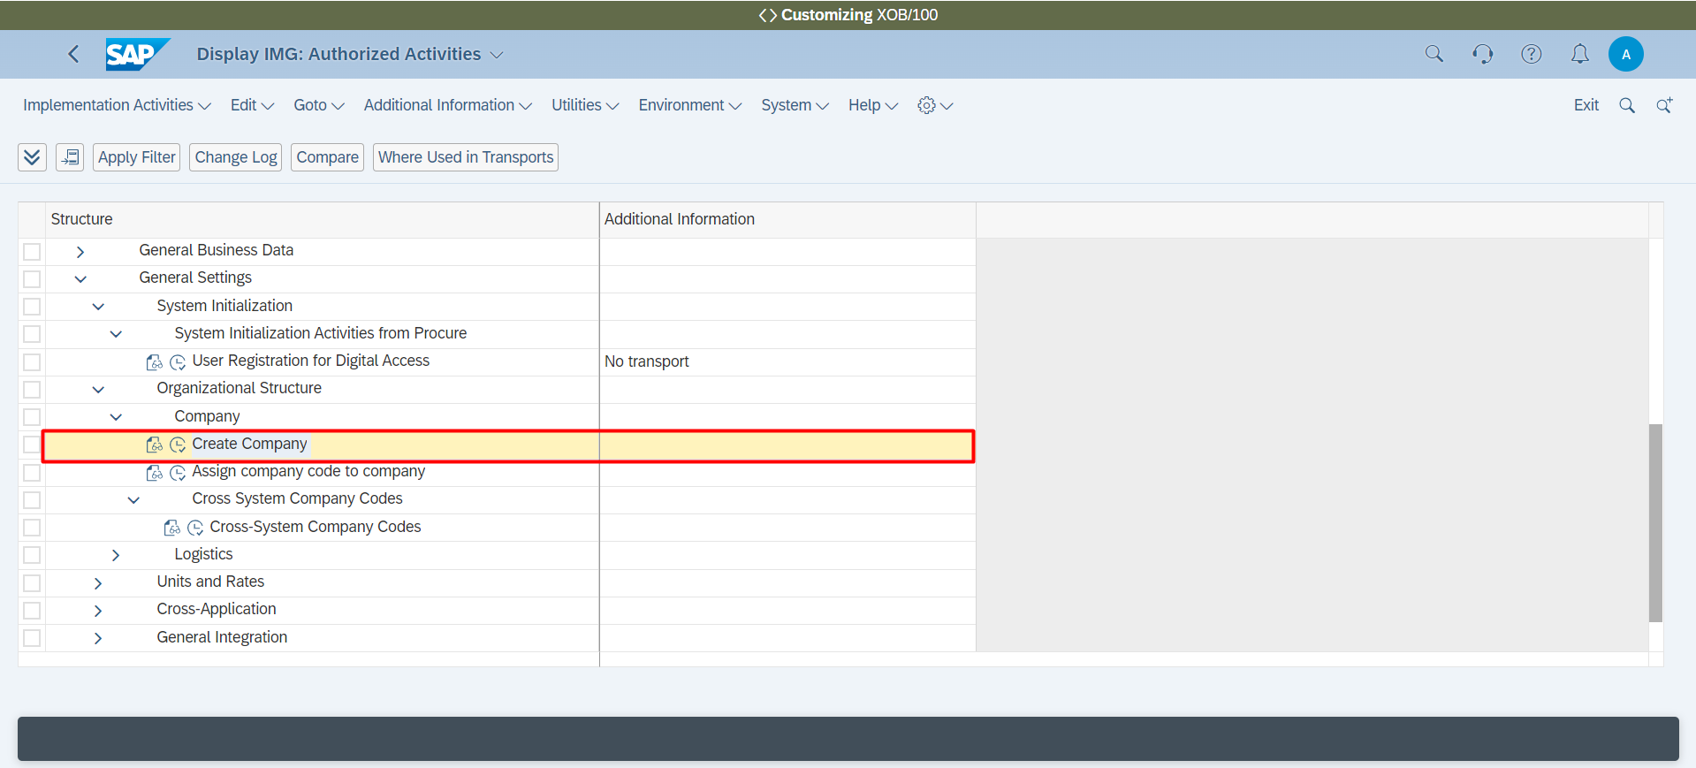

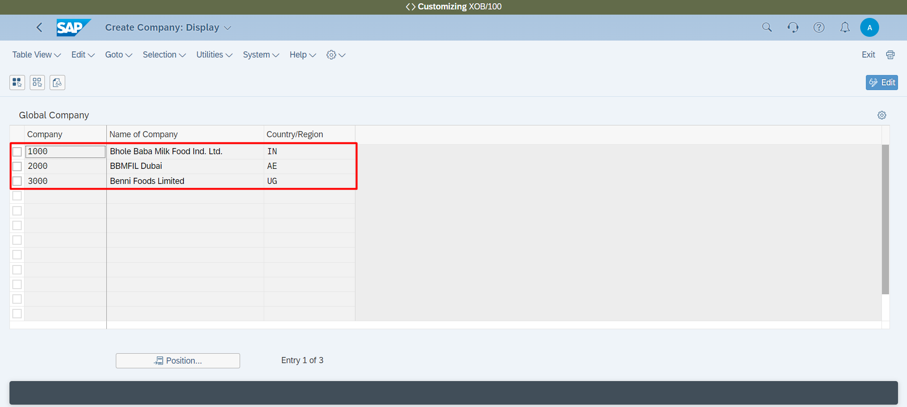

**General Settings 🡪 Organizational Structure 🡪 Assign company code to company**

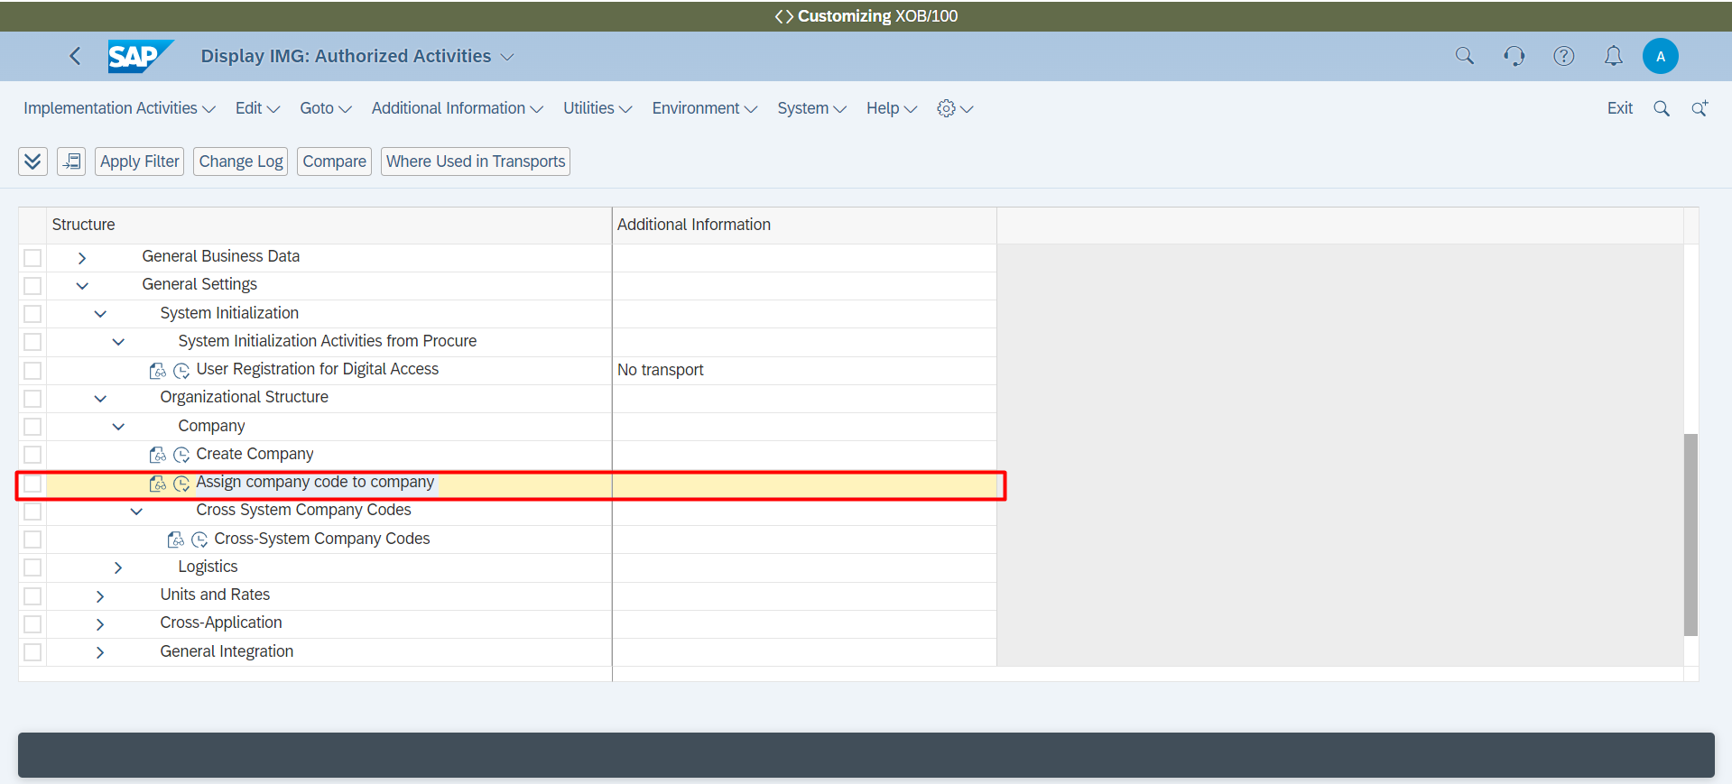

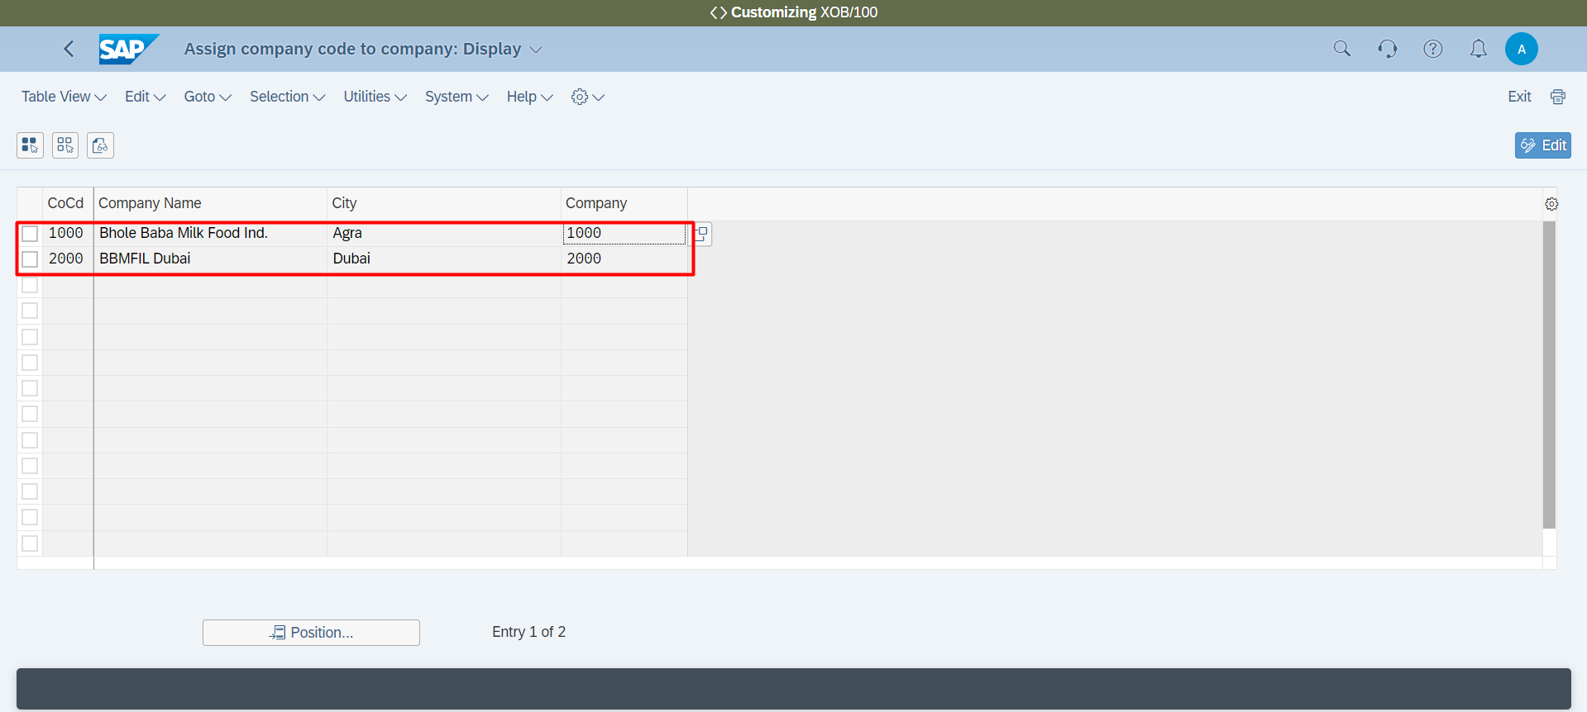

**General Ledger 🡪 Fiscal Year 🡪 Financial Reports using Different Fiscal Year Variants 🡪 Define Variants for Open Posting Periods**

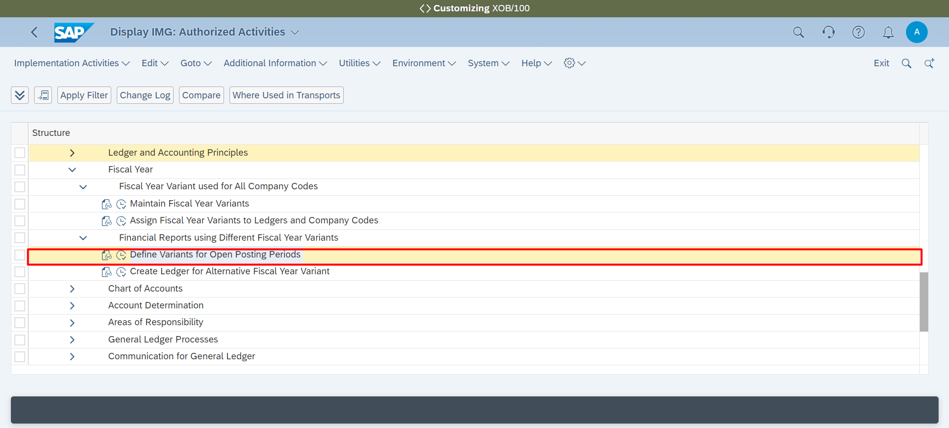

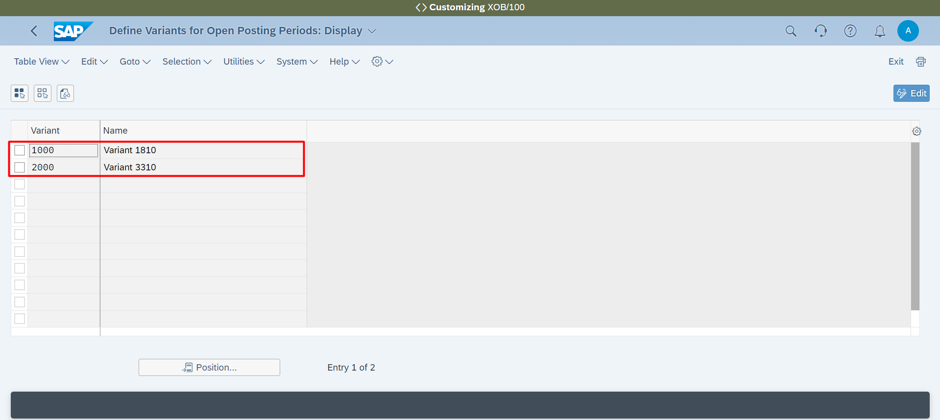

**Accounting 🡪 General Ledger 🡪 General Ledger Processes 🡪 Define Field Status Variants**

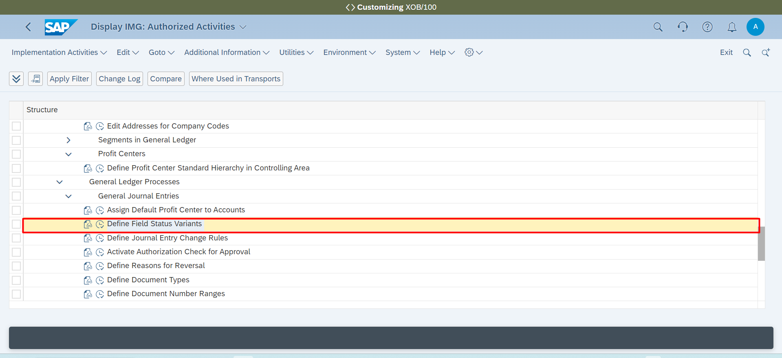

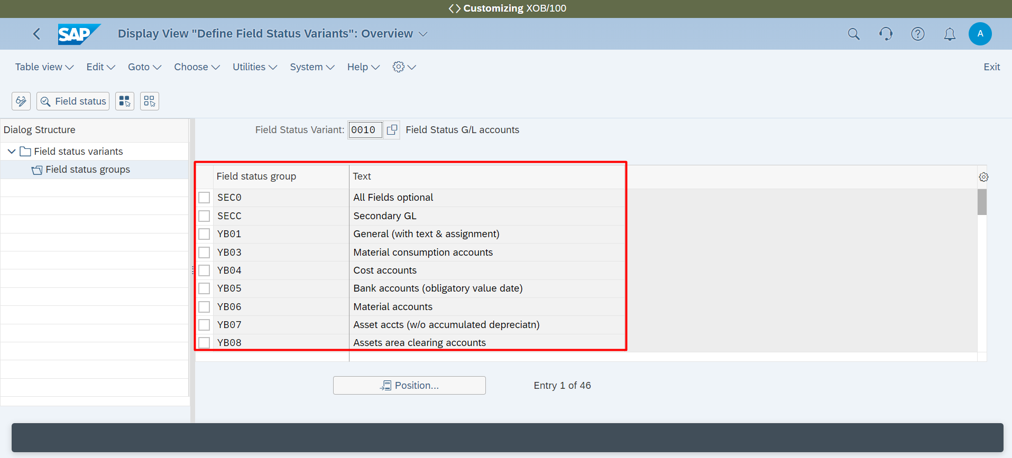

**Accounting 🡪 General Ledger 🡪 Fiscal Year 🡪 Maintain Fiscal Year Variants 🡪**

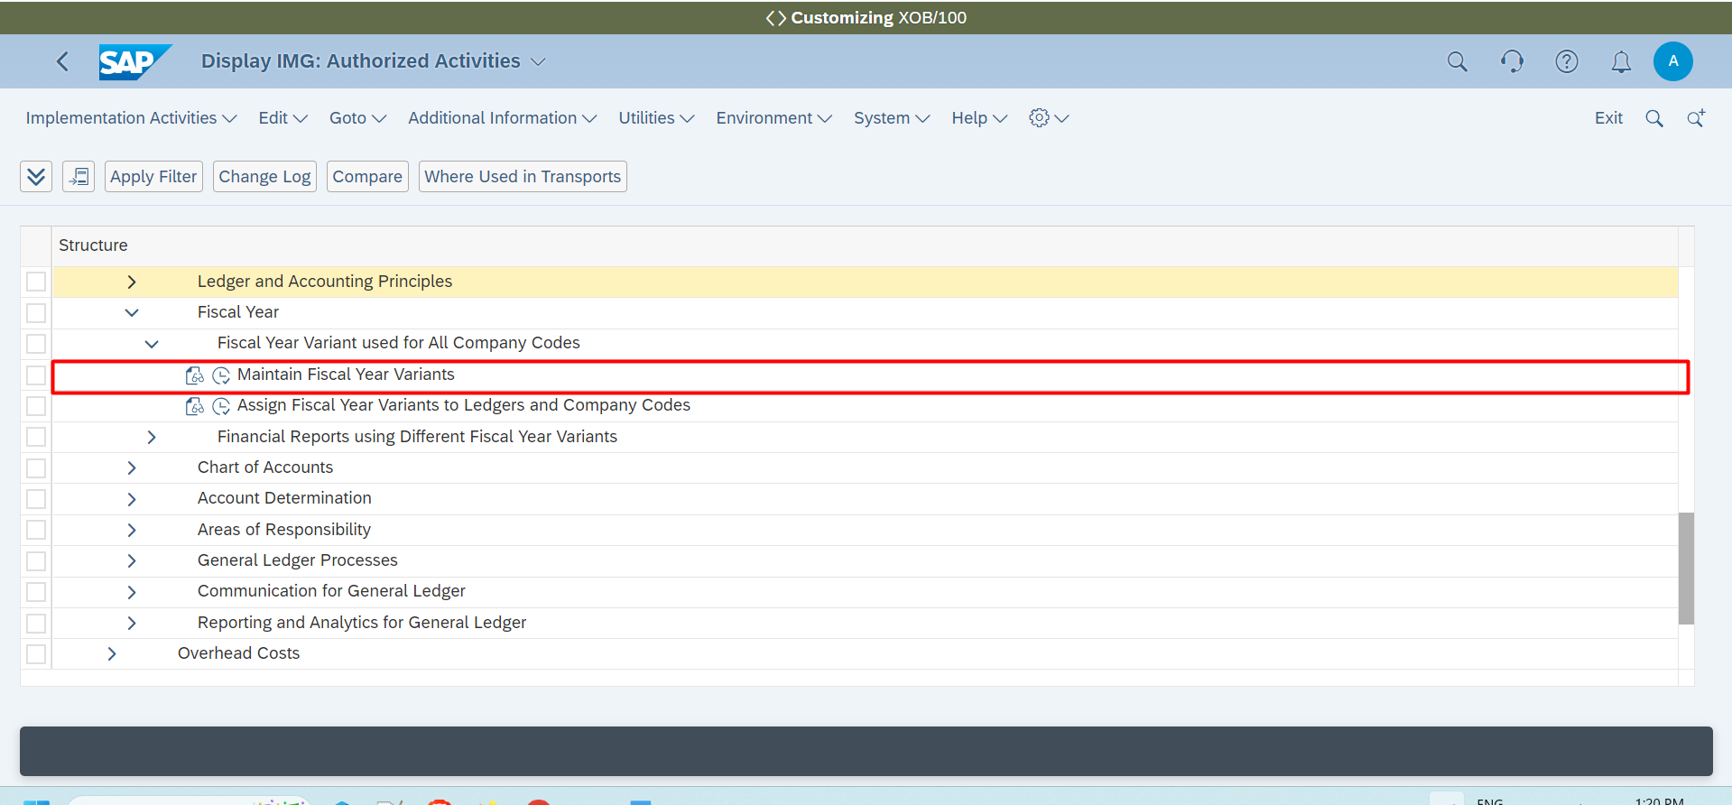

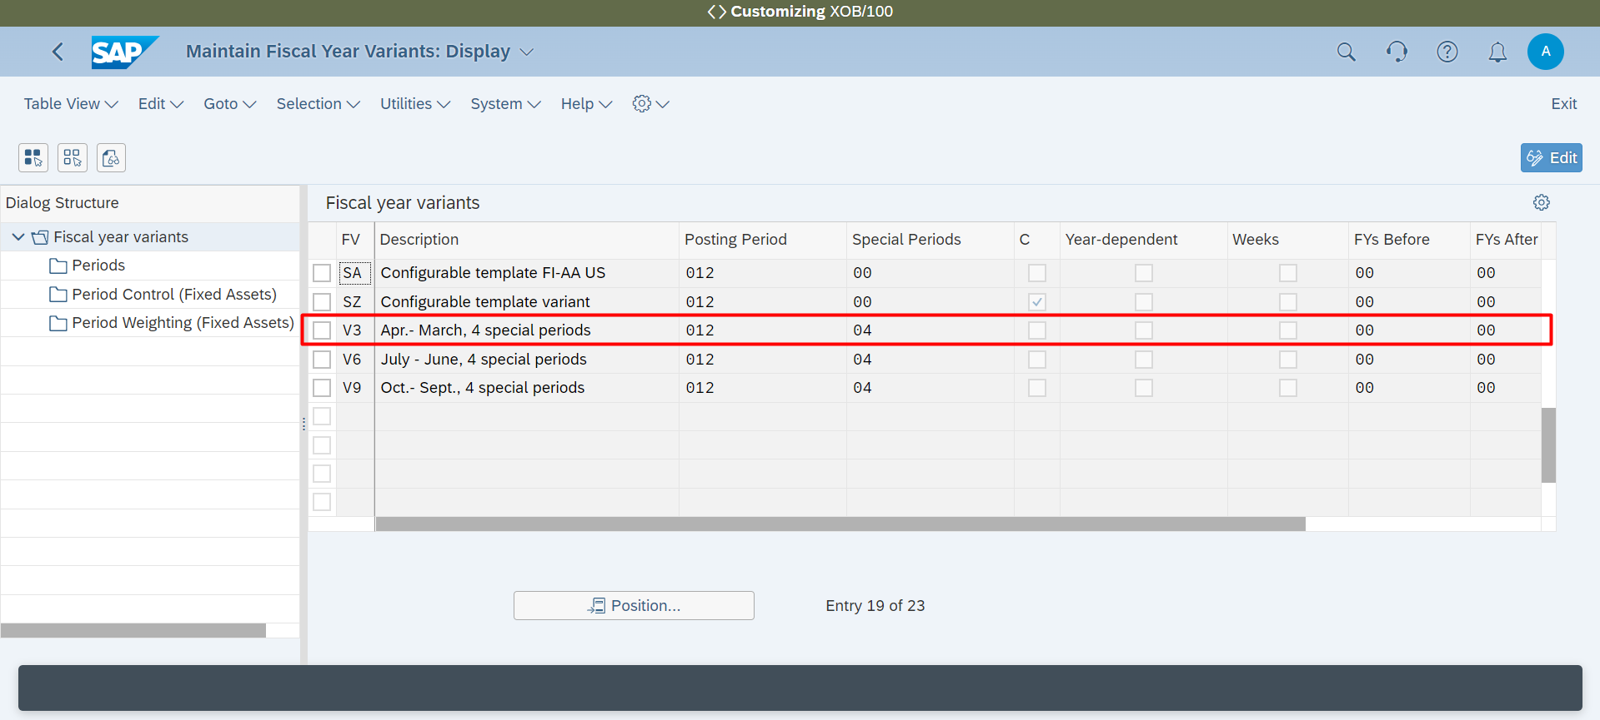

**Accounting 🡪 General Ledger 🡪 Fiscal Year 🡪 Maintain Fiscal Year Variants 🡪 Assign Fiscal Year Variants to Ledgers and Company Codes**

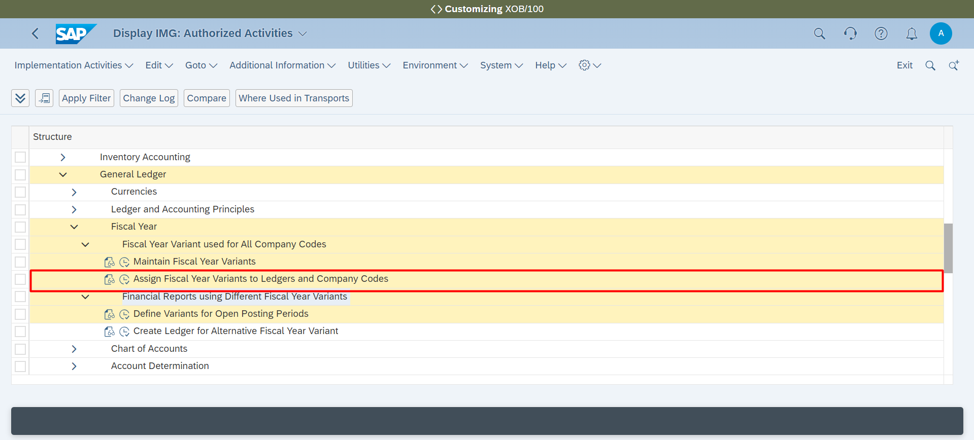

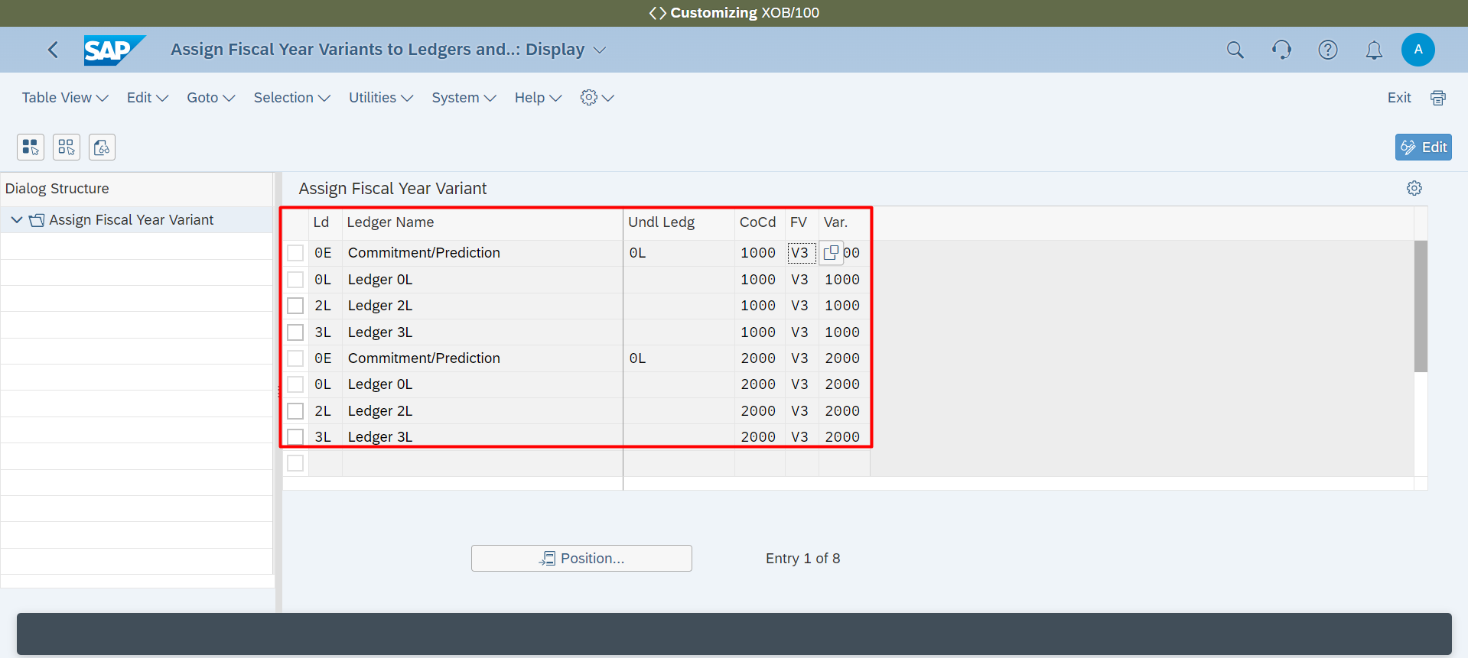

**Accounting 🡪 General Ledger 🡪 Chart of Accounts 🡪 Manage Chart of Accounts**

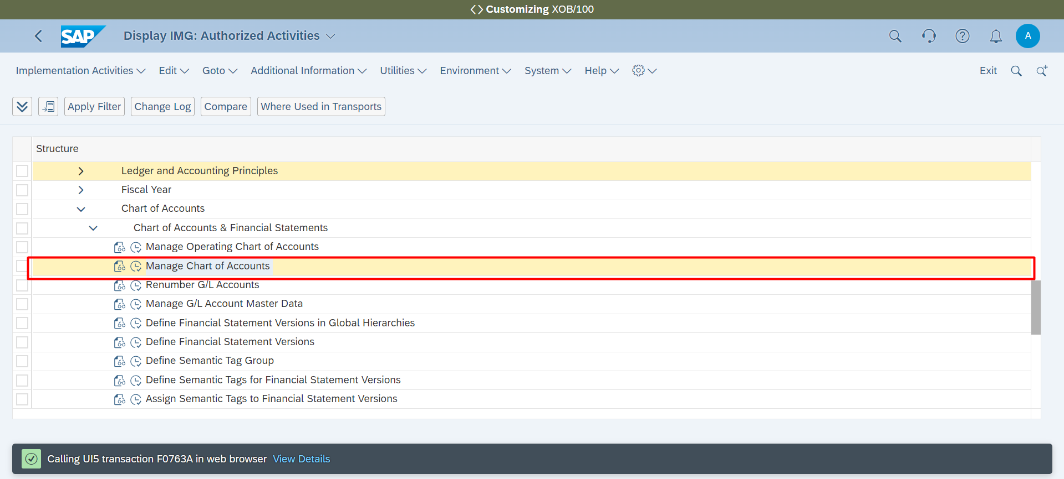

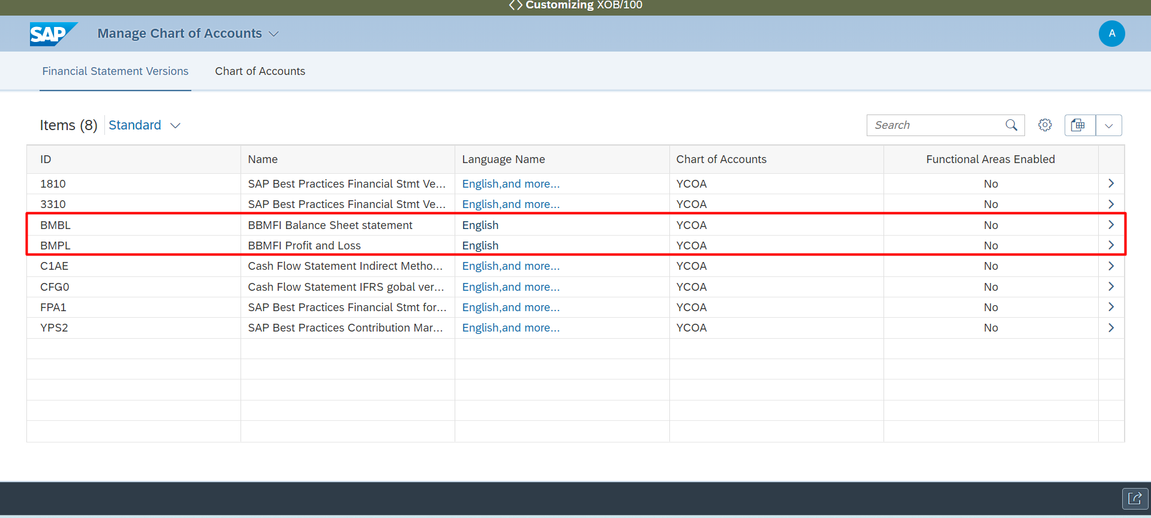

**General Ledger 🡪 Chart of Accounts 🡪 Define Account Group**

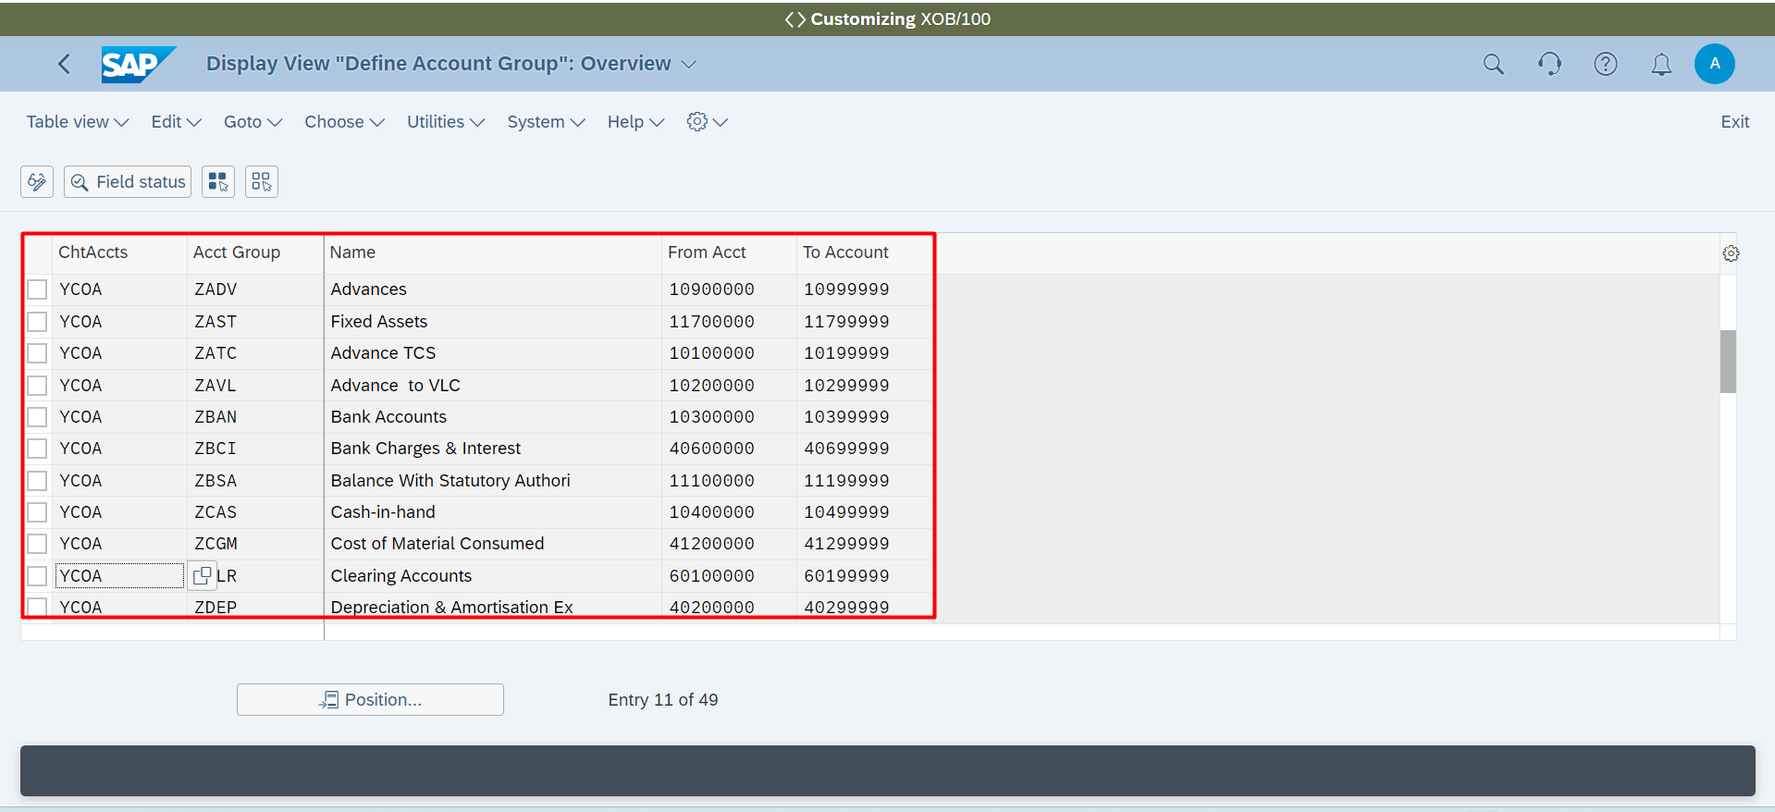

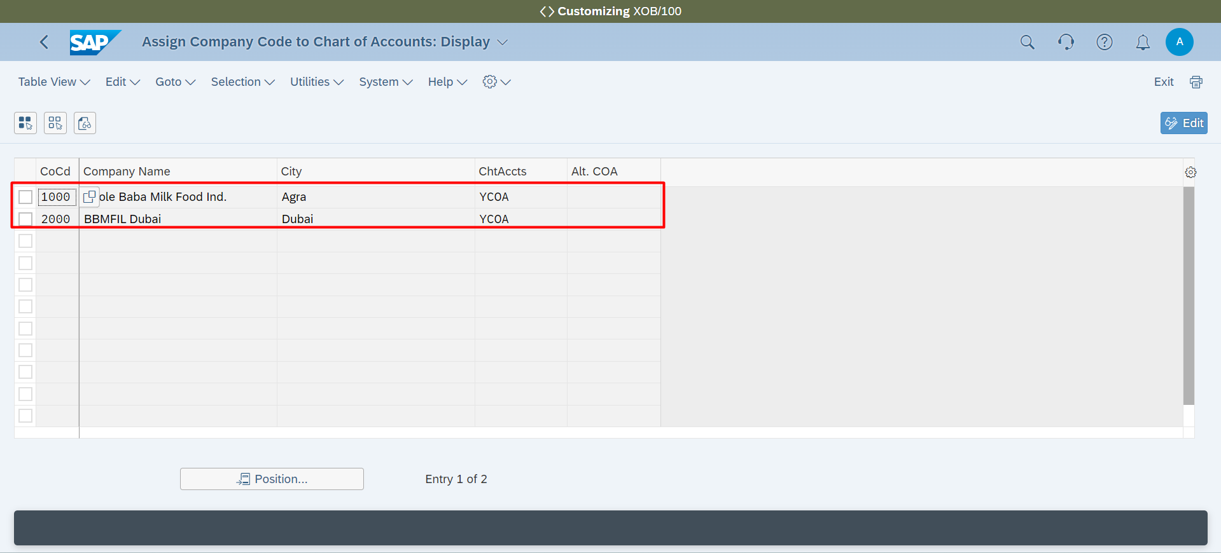

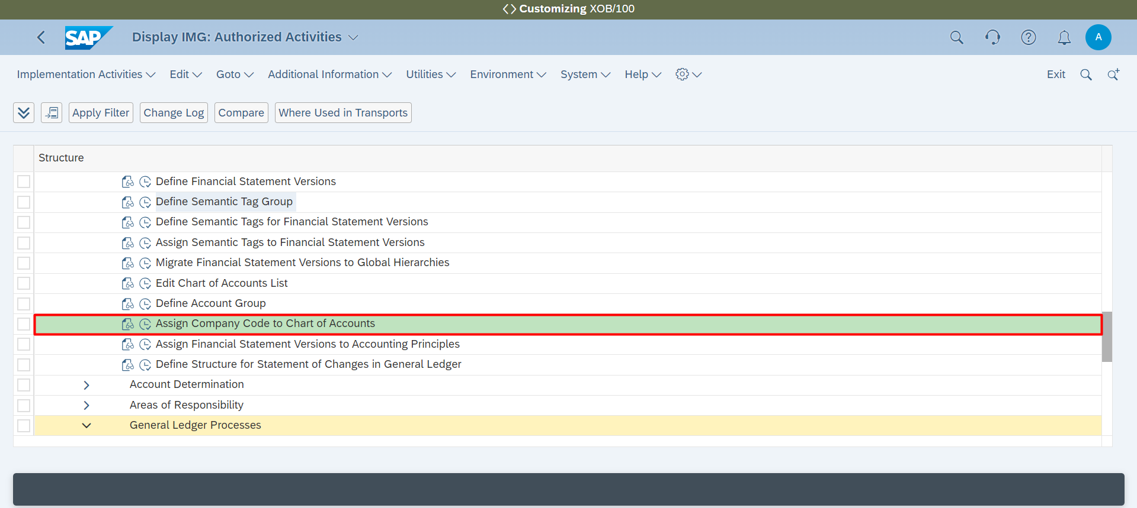

**Accounting 🡪 General Ledger 🡪 General Ledger Processes 🡪 Define Tolerance Groups for G/L Accounts**

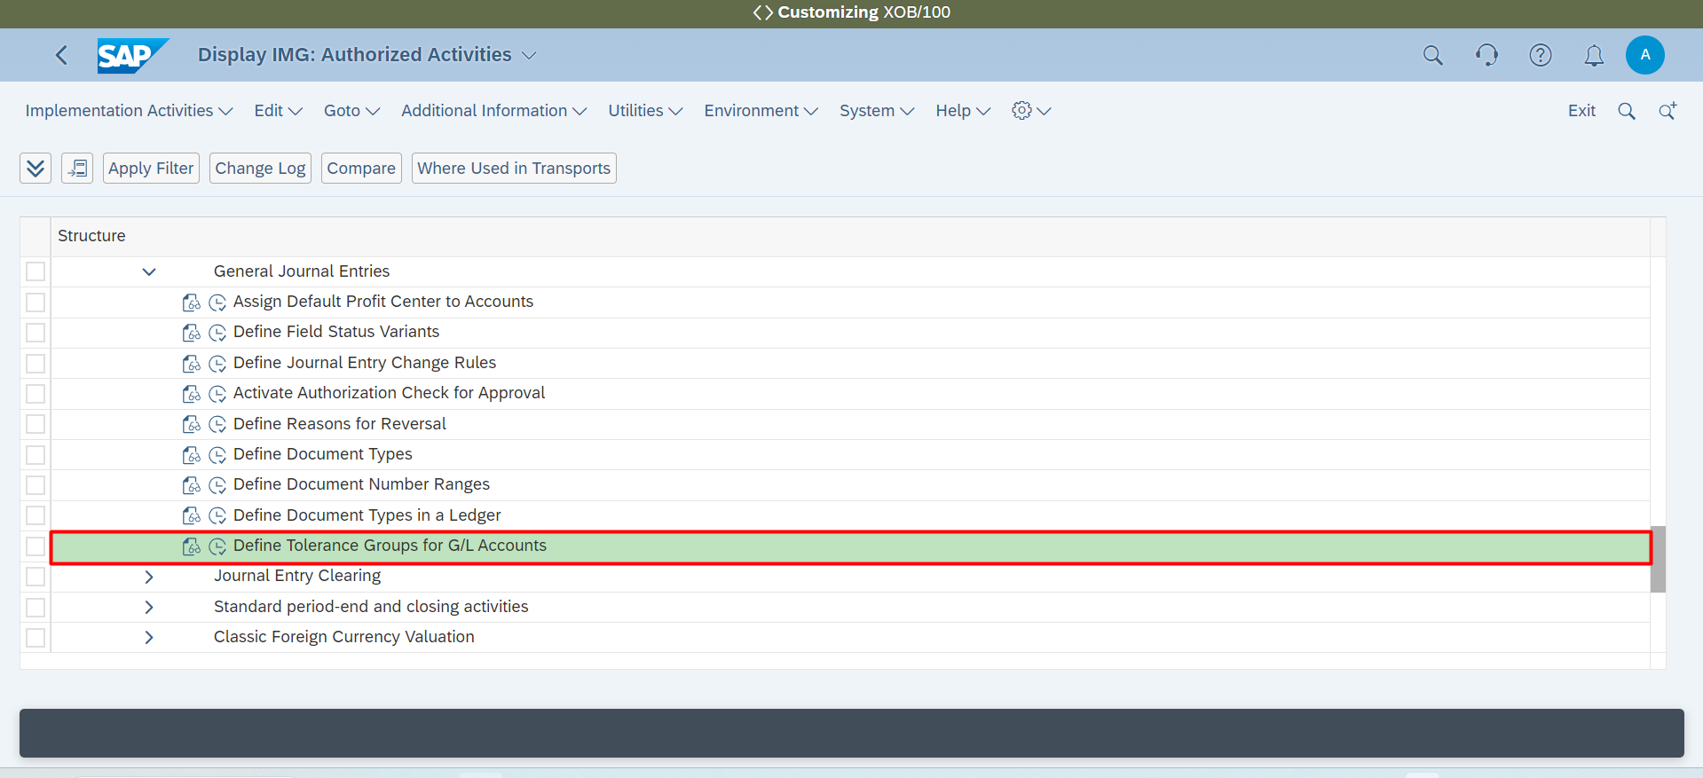

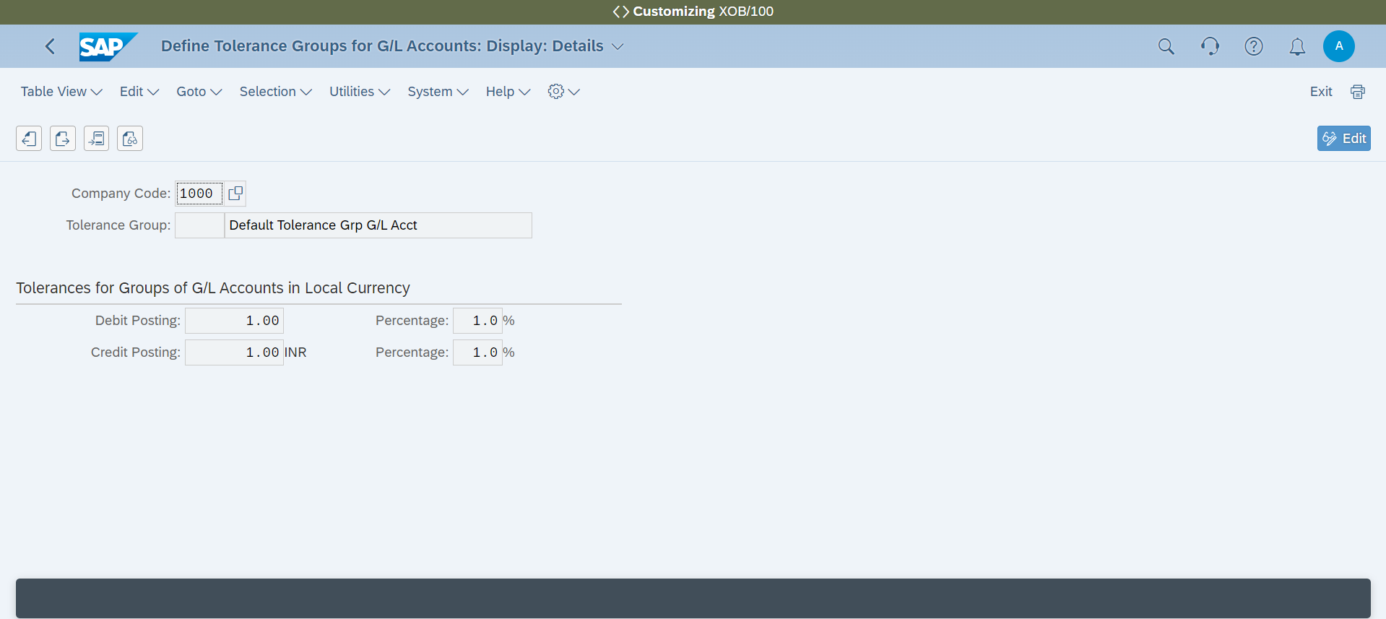

**Accounting 🡪 Tax Management 🡪 Tax Management 🡪 Tax on Goods and Services 🡪 Tax on Goods and Services 🡪 Define Tax Codes for Sales and Purchases**

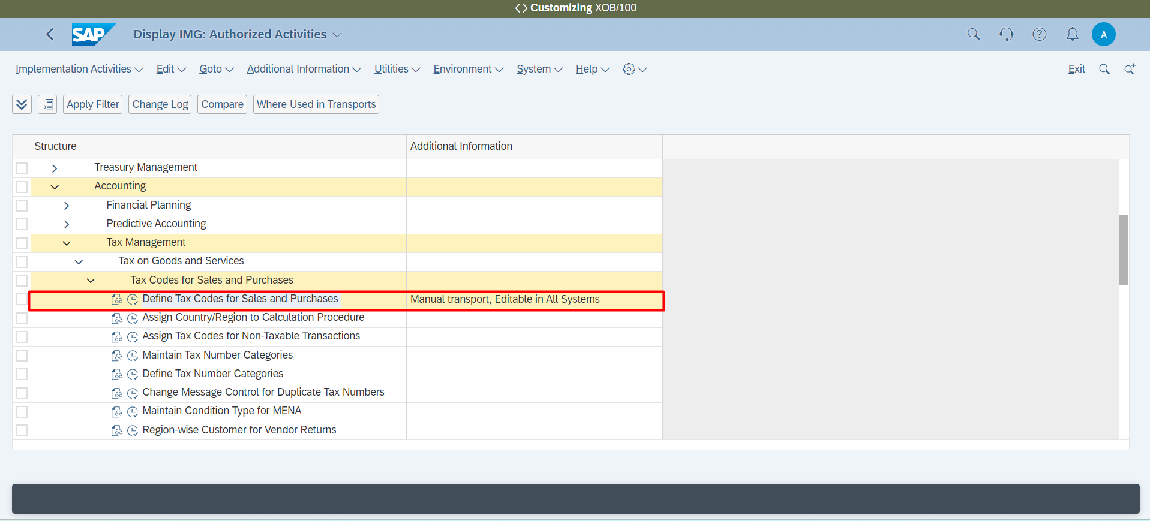

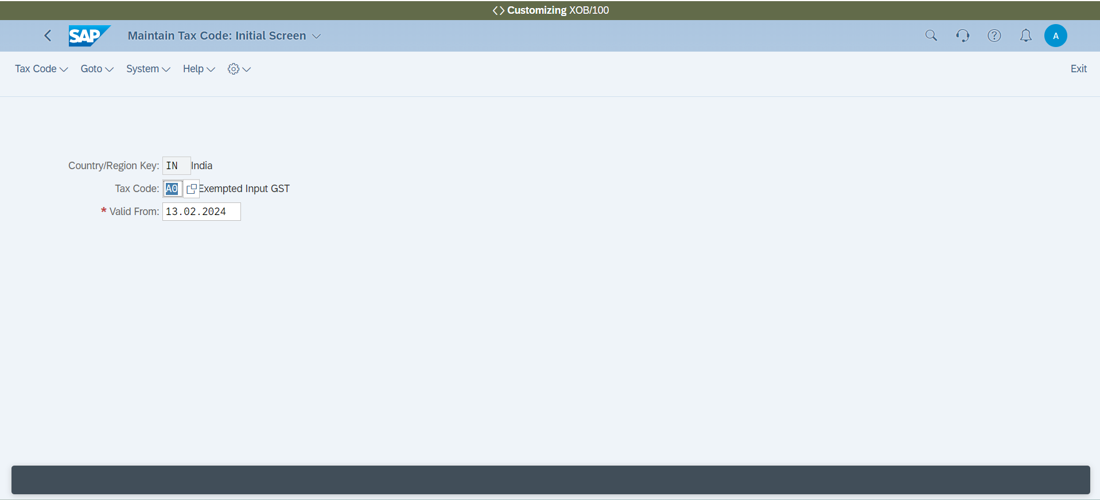

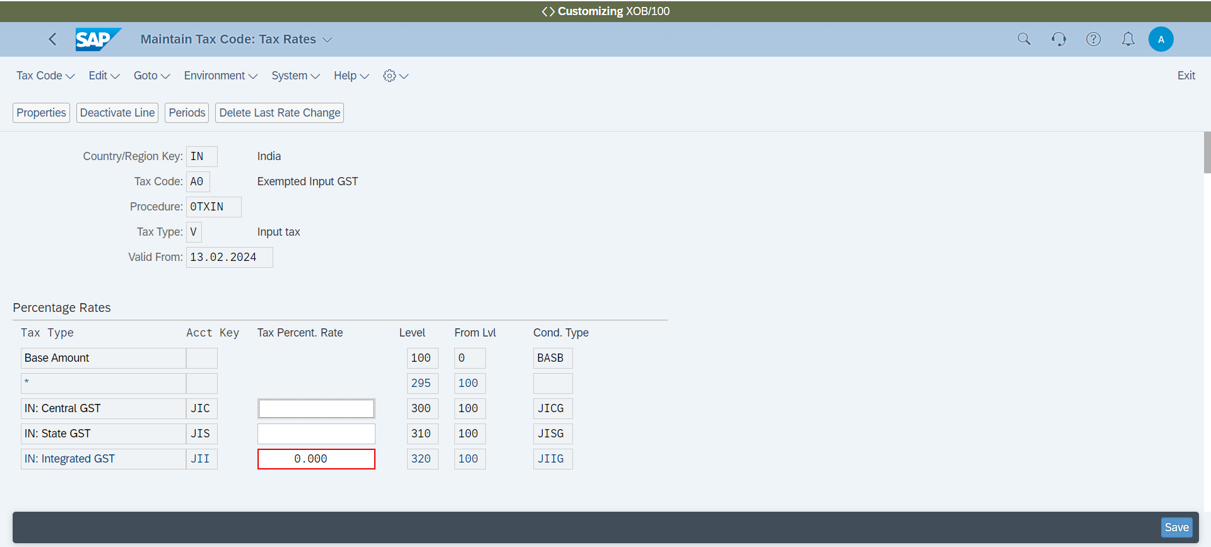

**Accounting 🡪 Tax Management 🡪 Tax Management 🡪 Tax on Goods and Services 🡪 Tax on Goods and Services 🡪 Define Tax Codes for Sales and Purchases 🡪Assign Country/Region to Calculation Procedure**

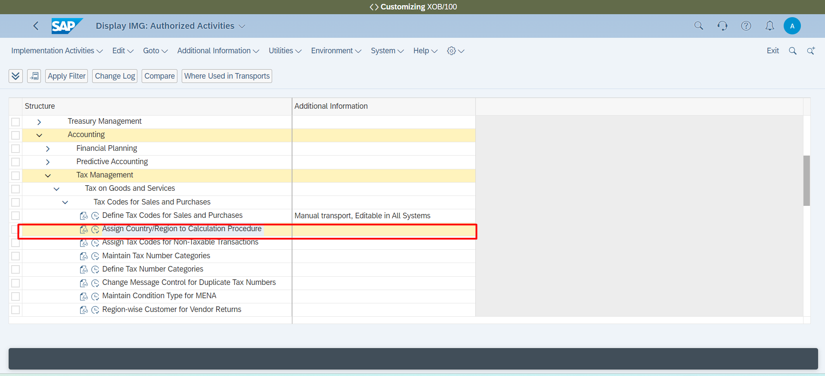

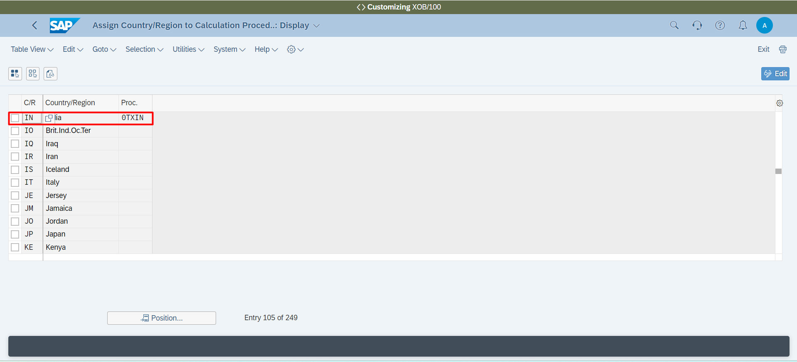

**Accounting 🡪 Tax Management 🡪 Tax Management 🡪 Tax on Goods and Services 🡪 Tax on Goods and Services 🡪 Define Tax Codes for Sales and Purchases 🡪 Assign Tax Codes for Non-Taxable Transactions**

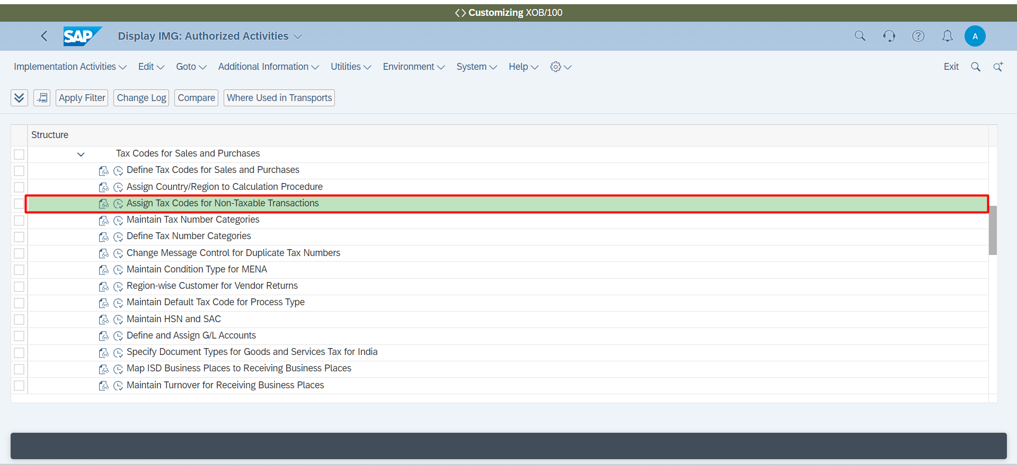

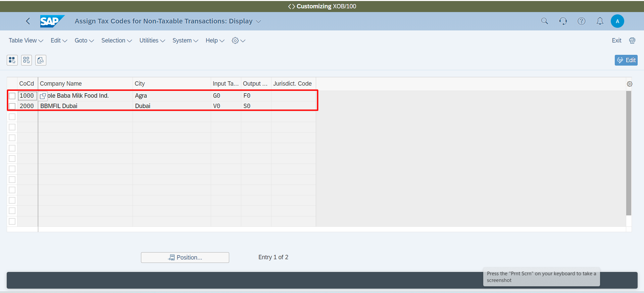

**Accounting 🡪 Tax Management 🡪 Tax Management 🡪 Tax on Goods and Services 🡪 Tax on Goods and Services 🡪 Define Tax Codes for Sales and Purchases 🡪 Classify Condition Types for Goods and Services Tax for India**

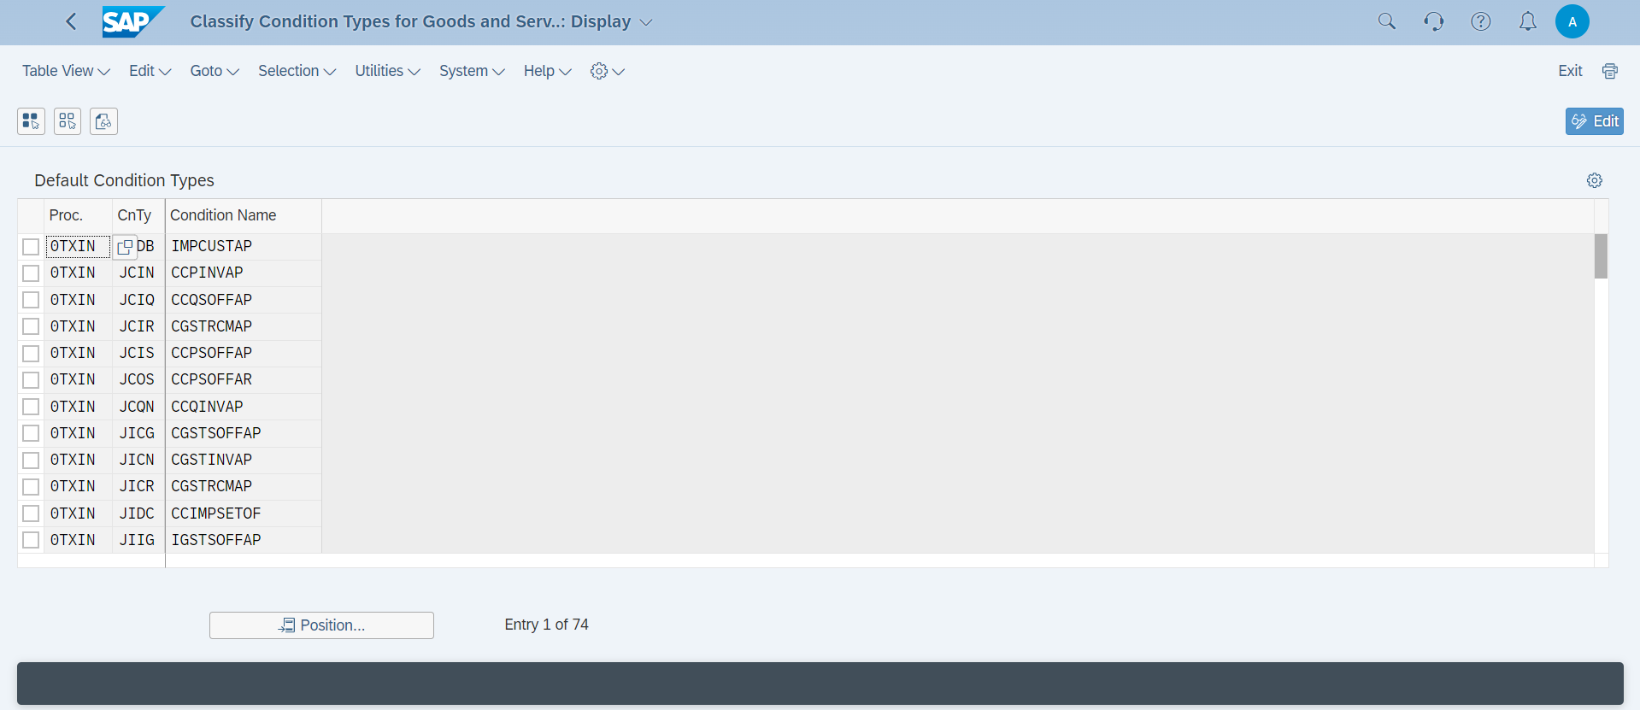

**Accounting 🡪 Tax Management 🡪 Tax Management 🡪 Tax on Goods and Services 🡪 Tax on Goods and Services 🡪 Define Tax Codes for Sales and Purchases 🡪 Assign Tax Code to Company Codes**

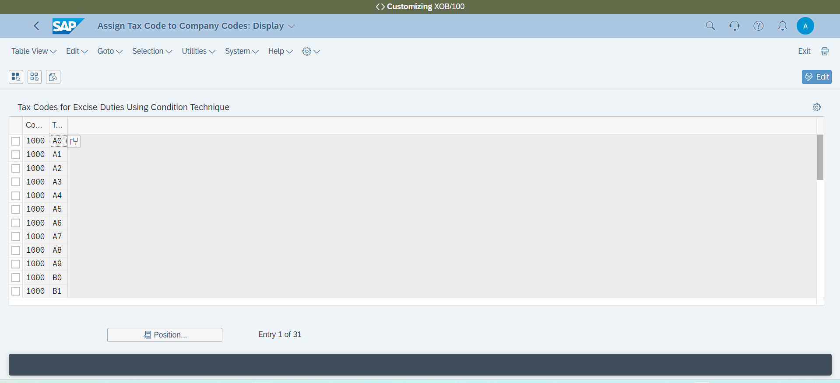

**Accounts for Tax Postings 🡪 Deferred Tax 🡪 Assign Deferred Tax Rules to Company Codes**

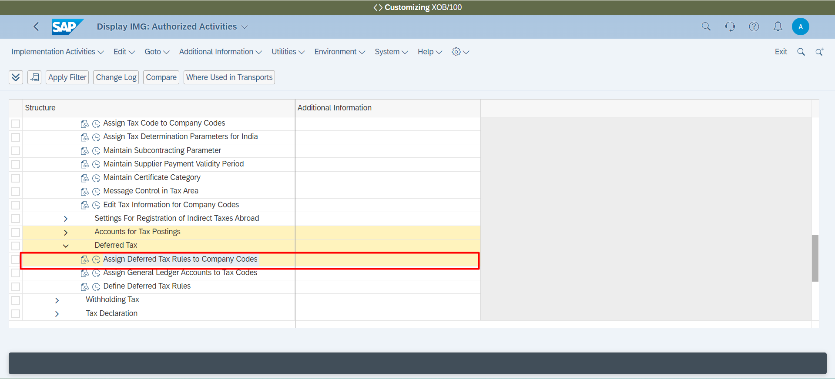

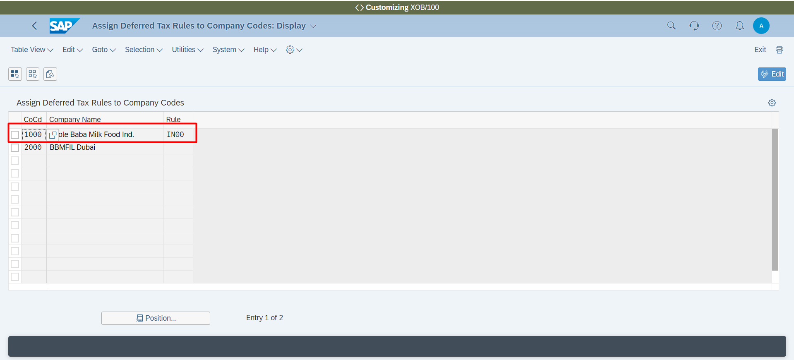

**General Ledger 🡪 General Ledger Processes 🡪 Financial Reports Based on Profit Centers 🡪 Define Document Splitting Characteristics for General Ledger Accounting**

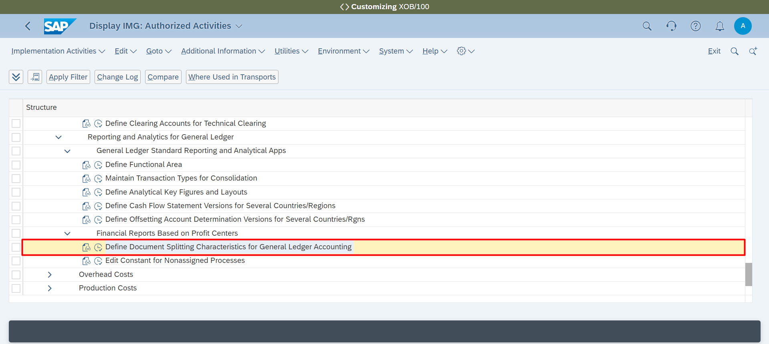

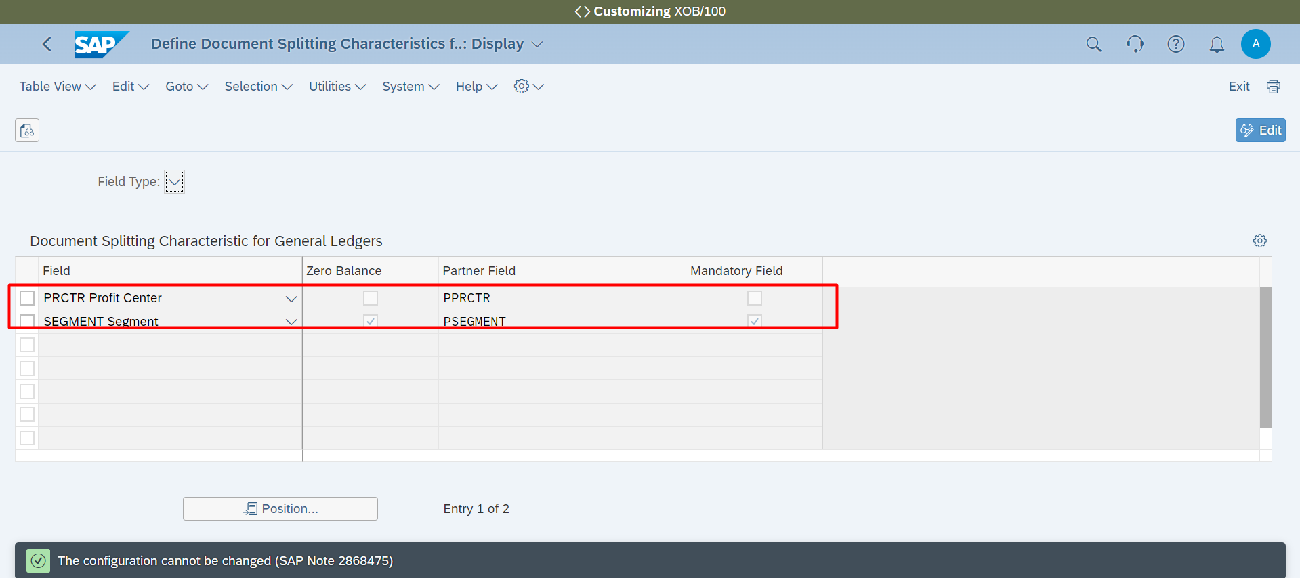

**Accounting 🡪 Areas of Responsibility 🡪Profit Centers 🡪Define Profit Center Standard Hierarchy in Controlling Area**

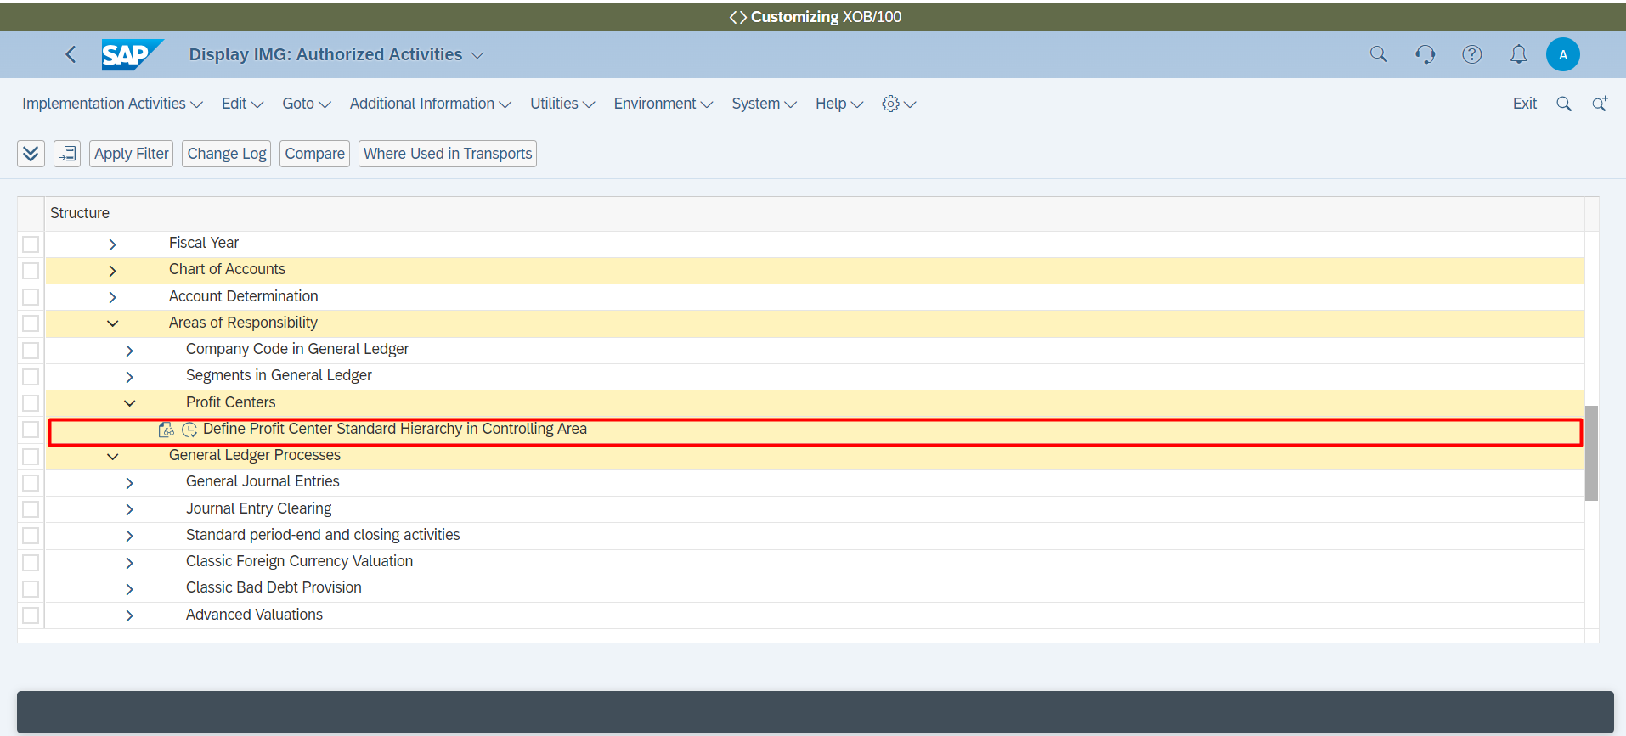

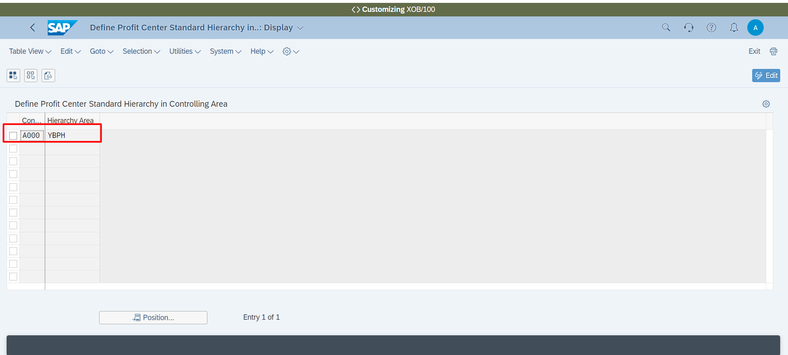

**Accounting 🡪 General Ledger 🡪 Define Currency Settings for Ledgers and Company Codes**

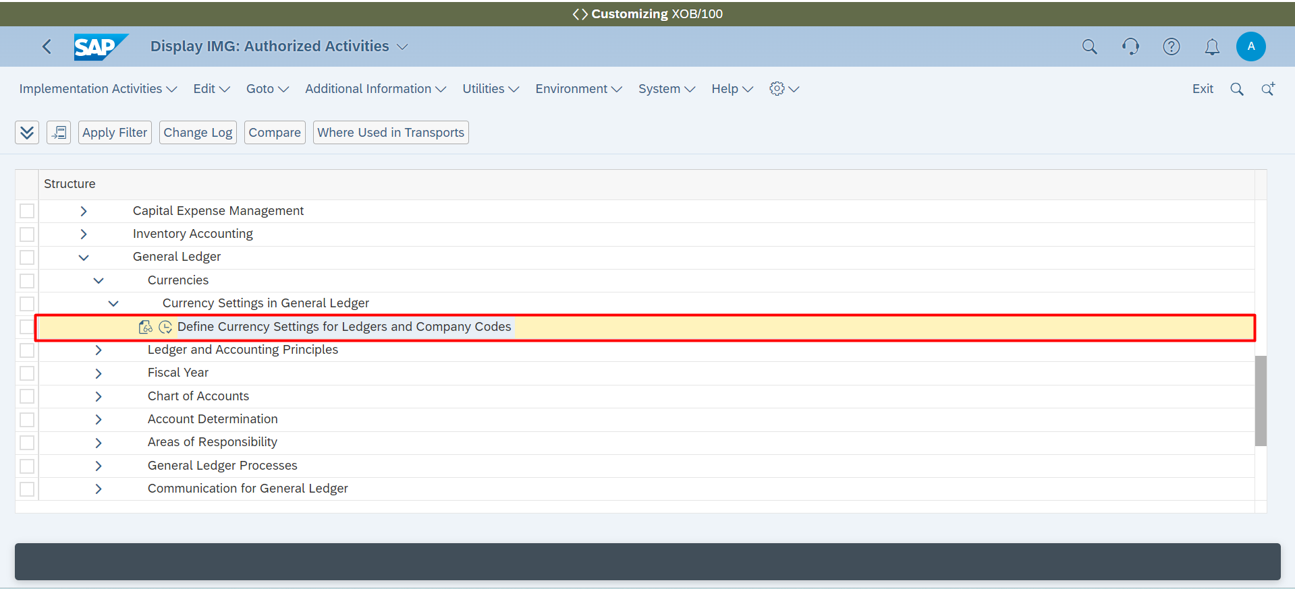

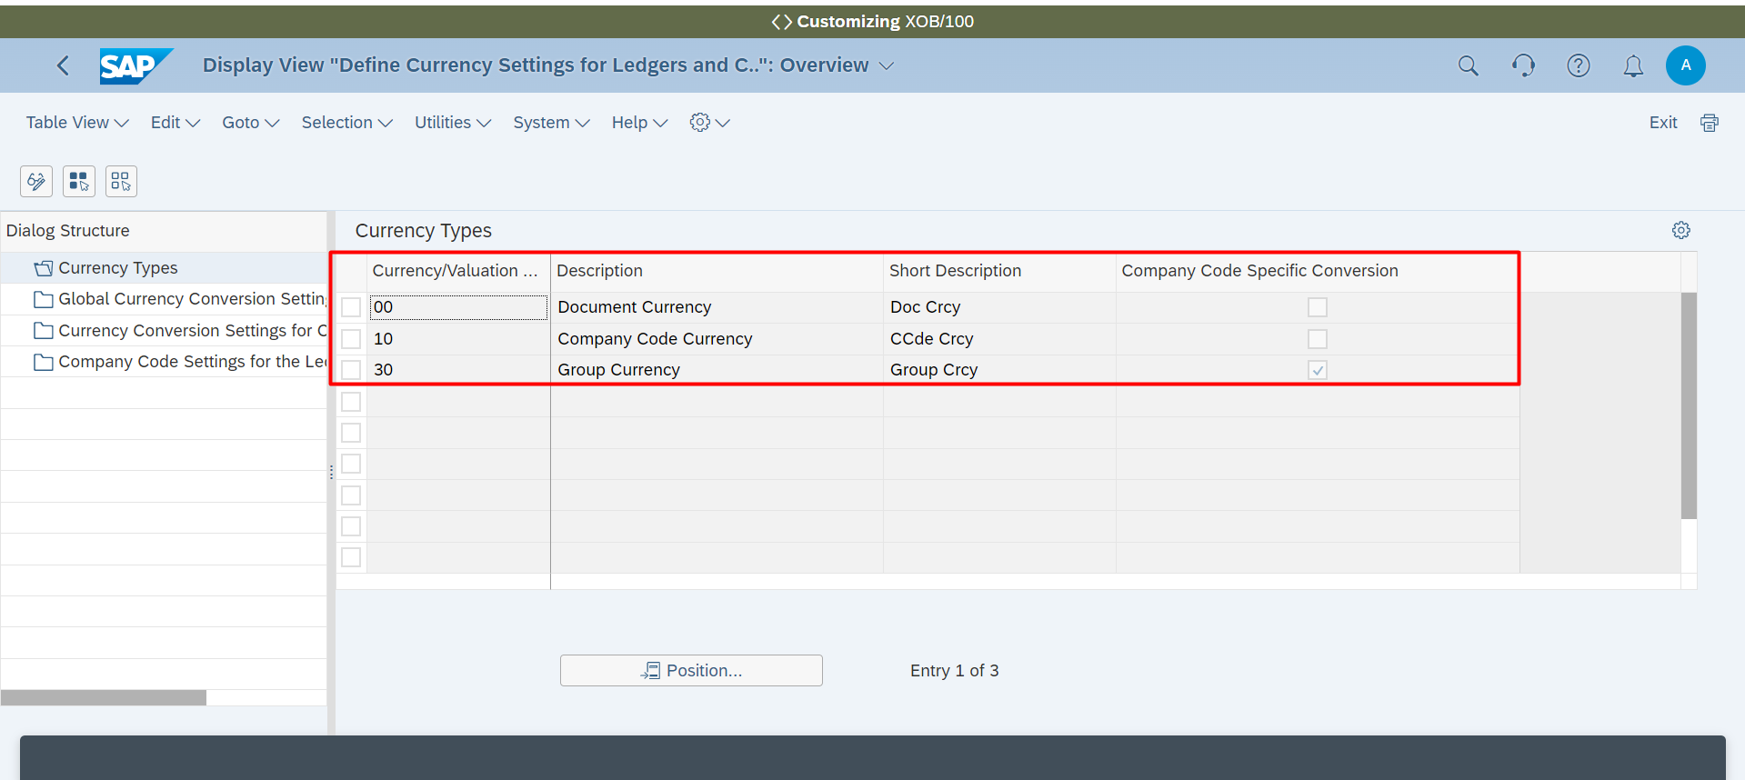

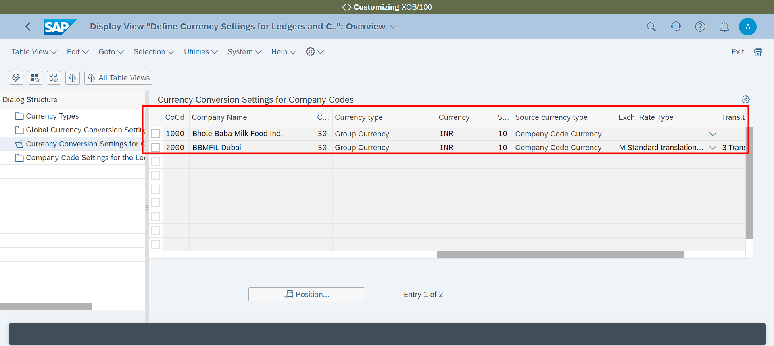

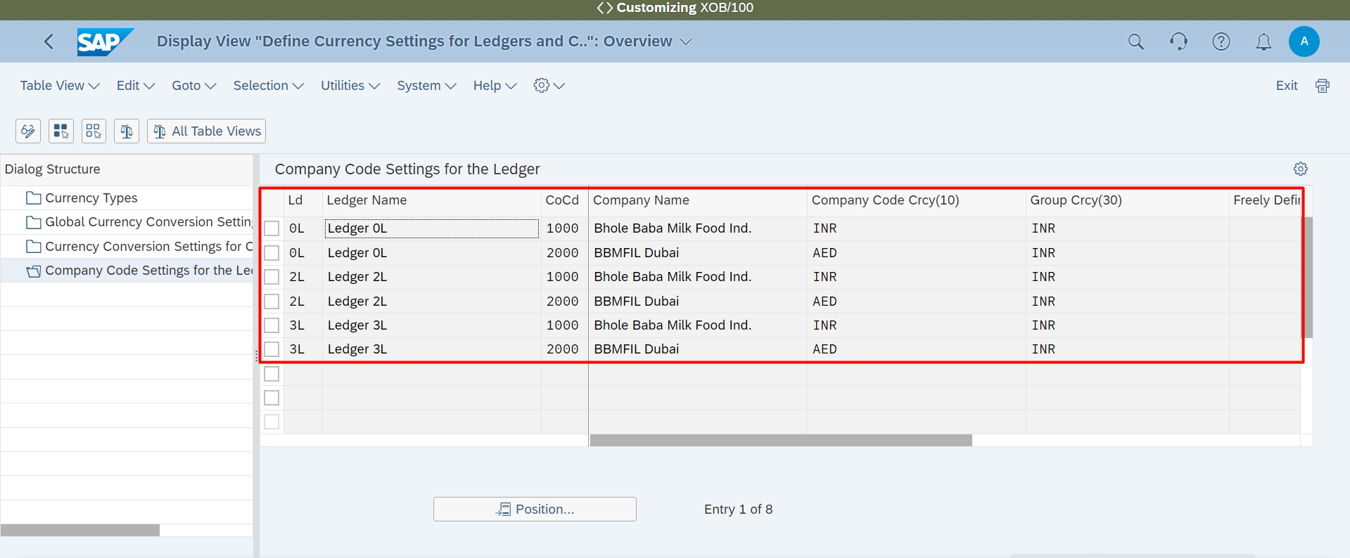

**Accounting 🡪 General Ledger 🡪 Ledger and Accounting Principles 🡪 Multiple Ledgers for Reporting 🡪 Assign Accounting Principles to Ledgers and Company Codes**

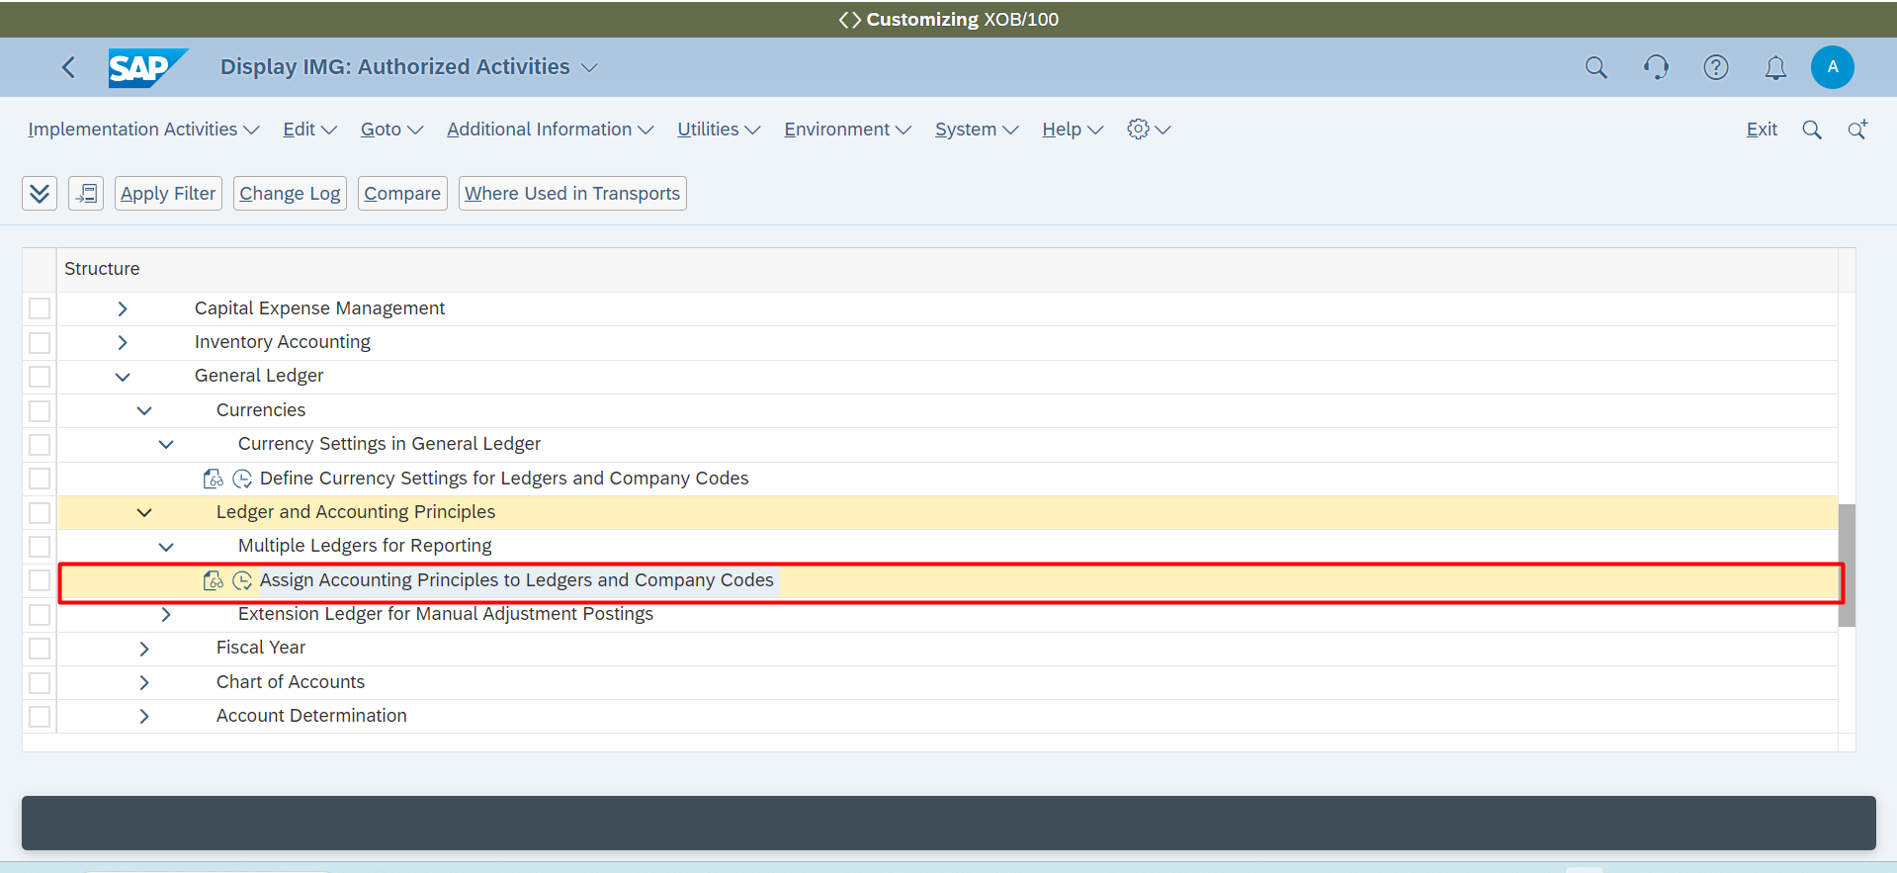

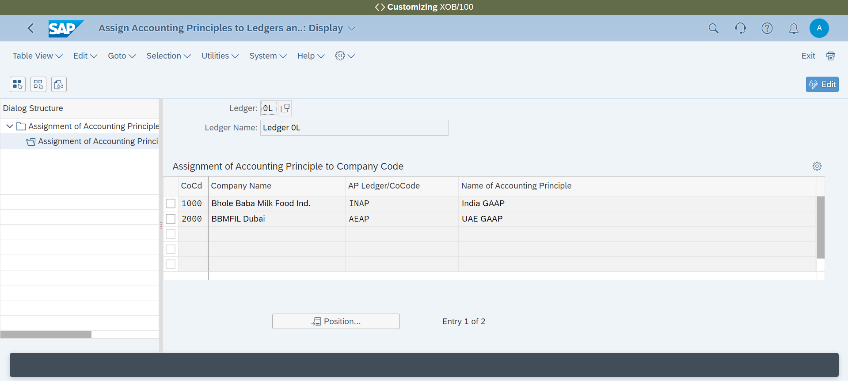

**Accounting 🡪 Withholding Tax 🡪 Withholding Tax Calculation 🡪 Activate Withholding Tax Reporting Date**

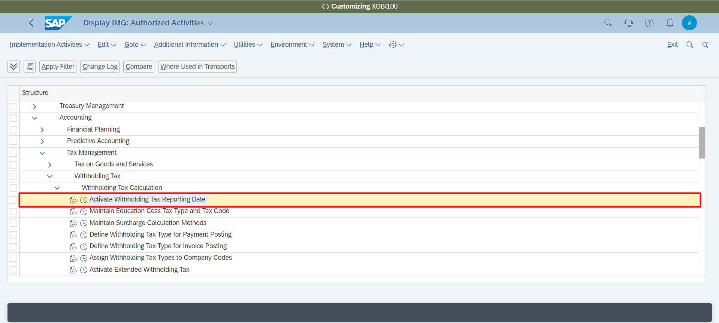

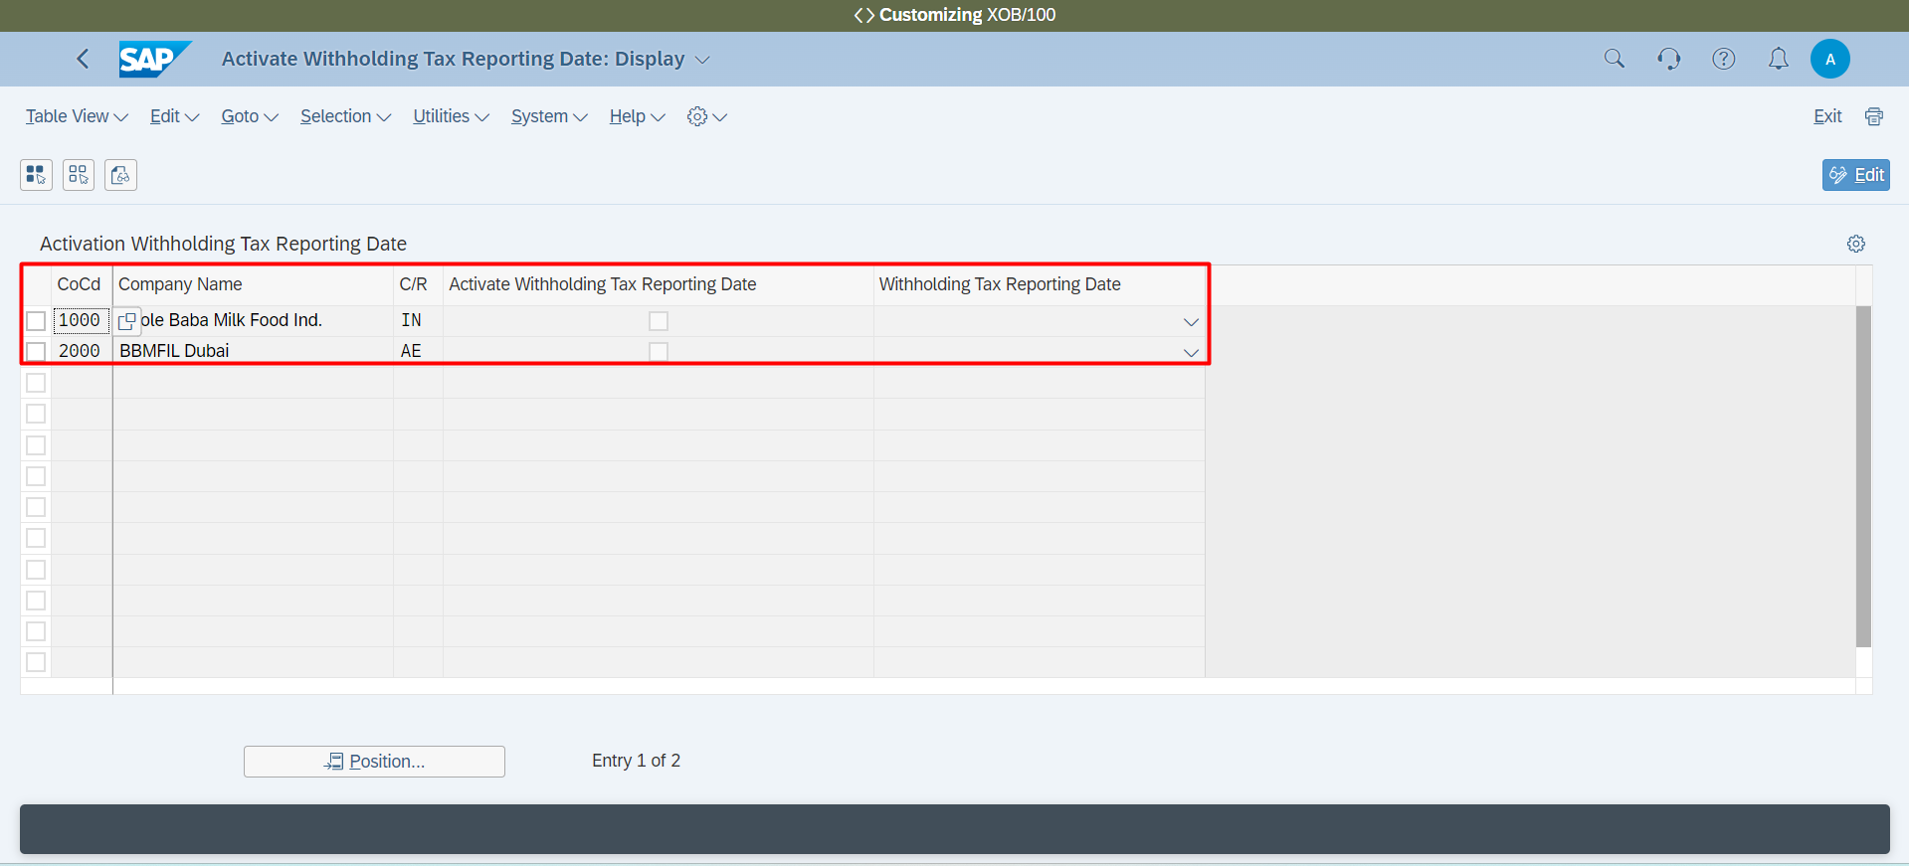

**Withholding Tax 🡪 Define Withholding Tax Type for Payment Posting**

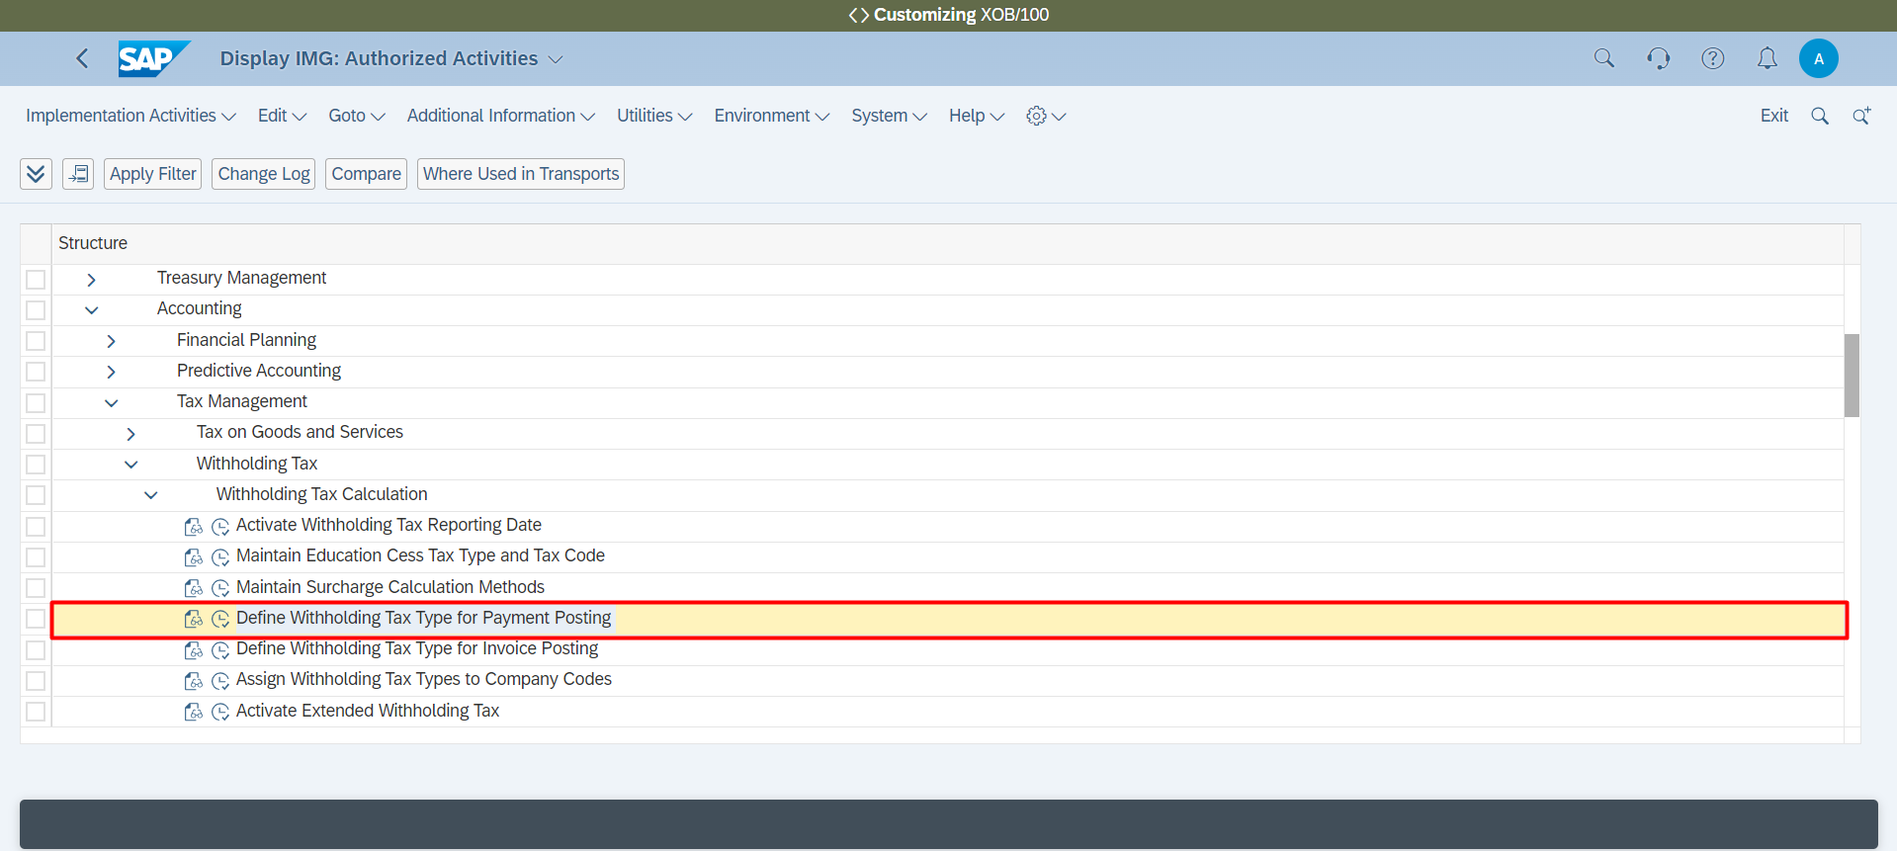

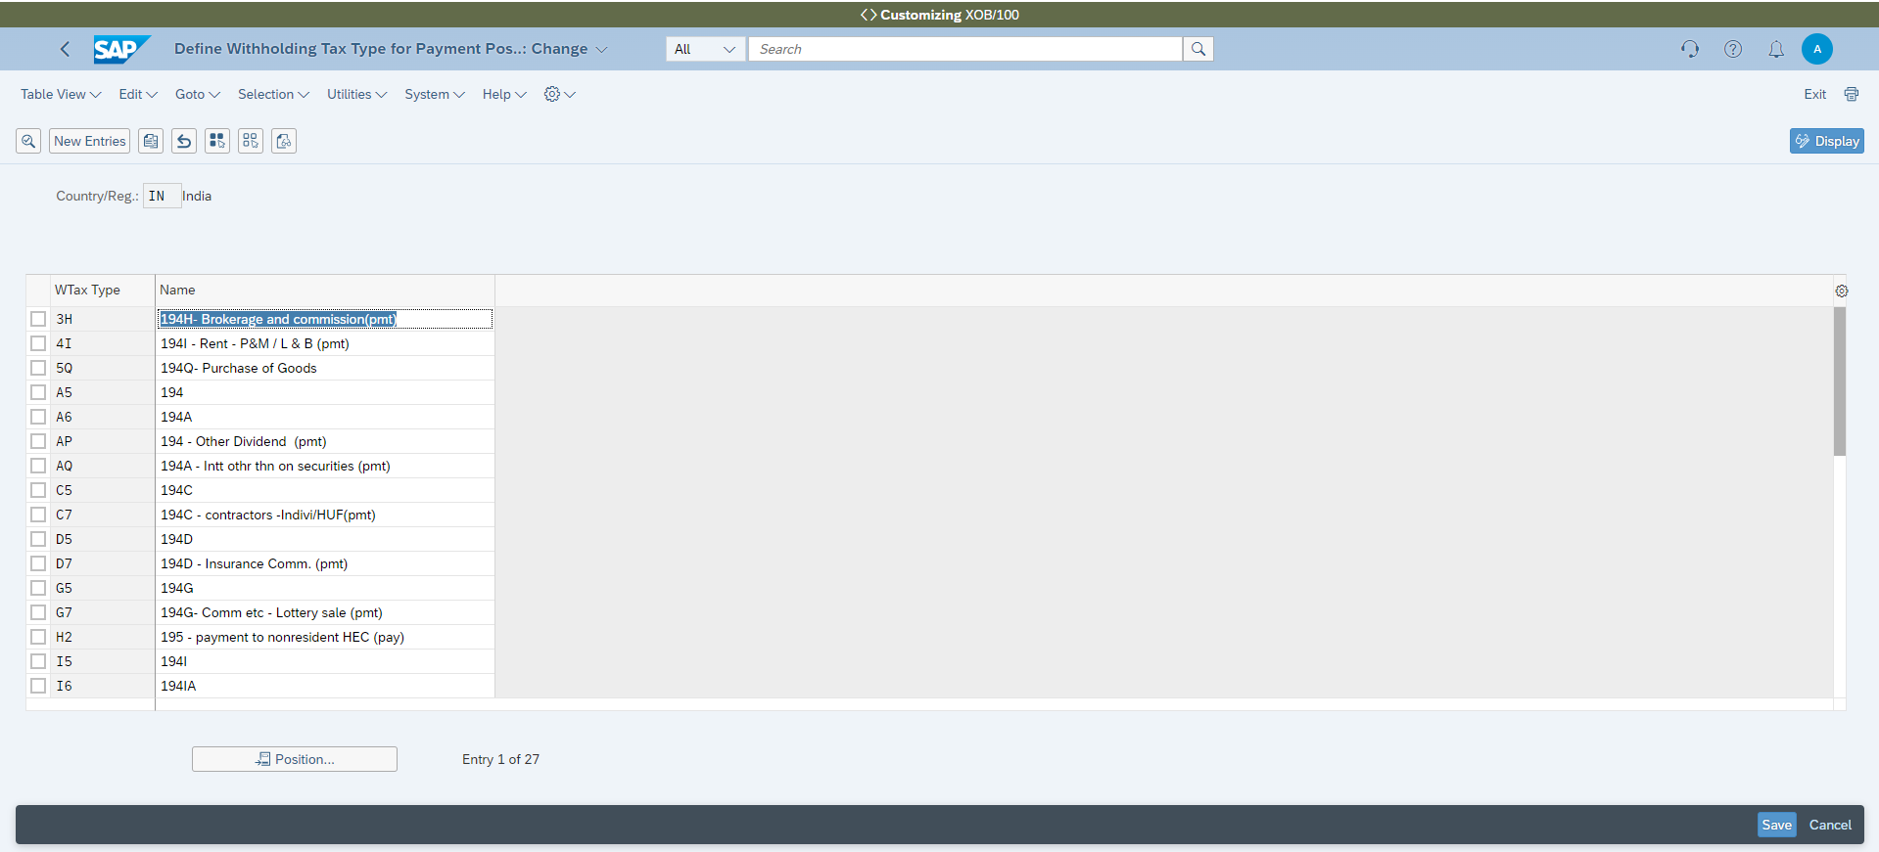

**Withholding Tax 🡪 Define Withholding Tax Type for Invoice Posting**

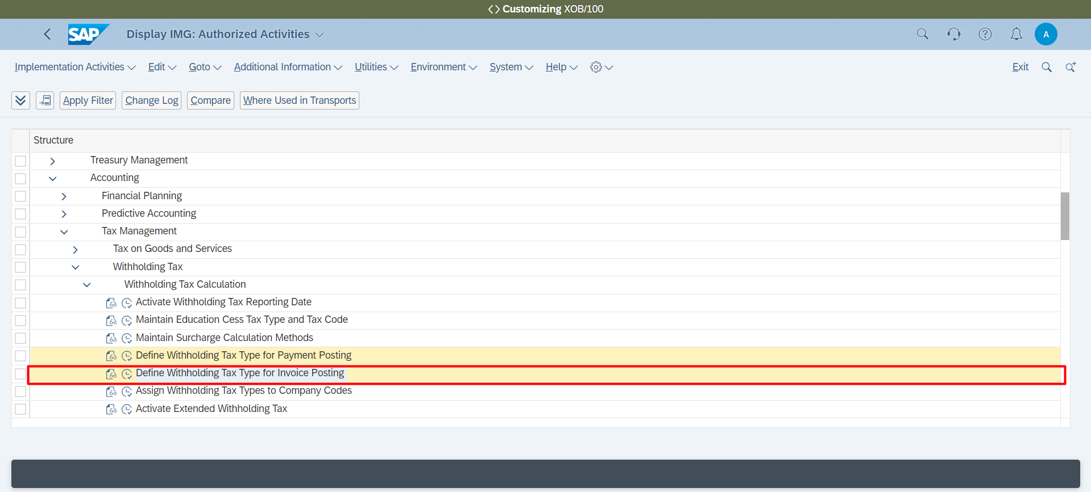

**Withholding Tax 🡪 Assign Withholding Tax Types to Company Codes**

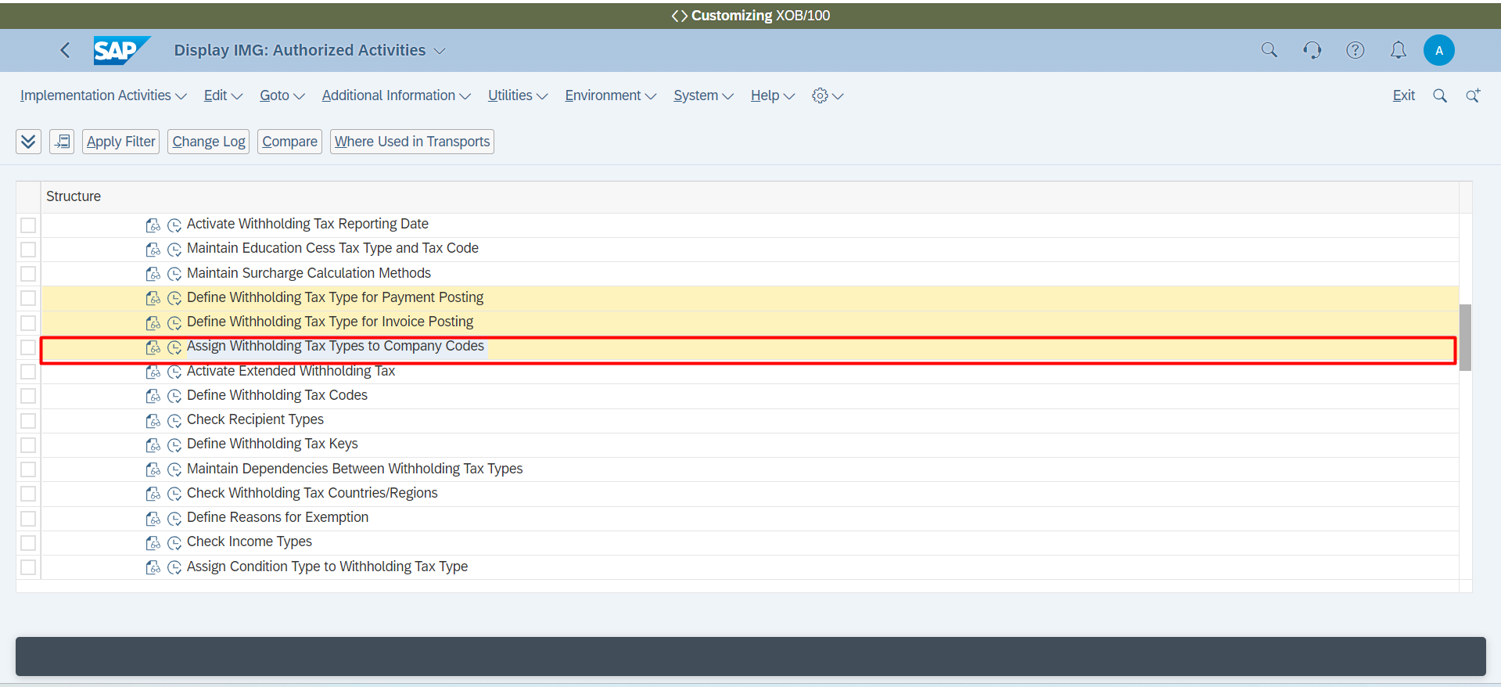

**Withholding Tax 🡪 Activate Extended Withholding Tax**

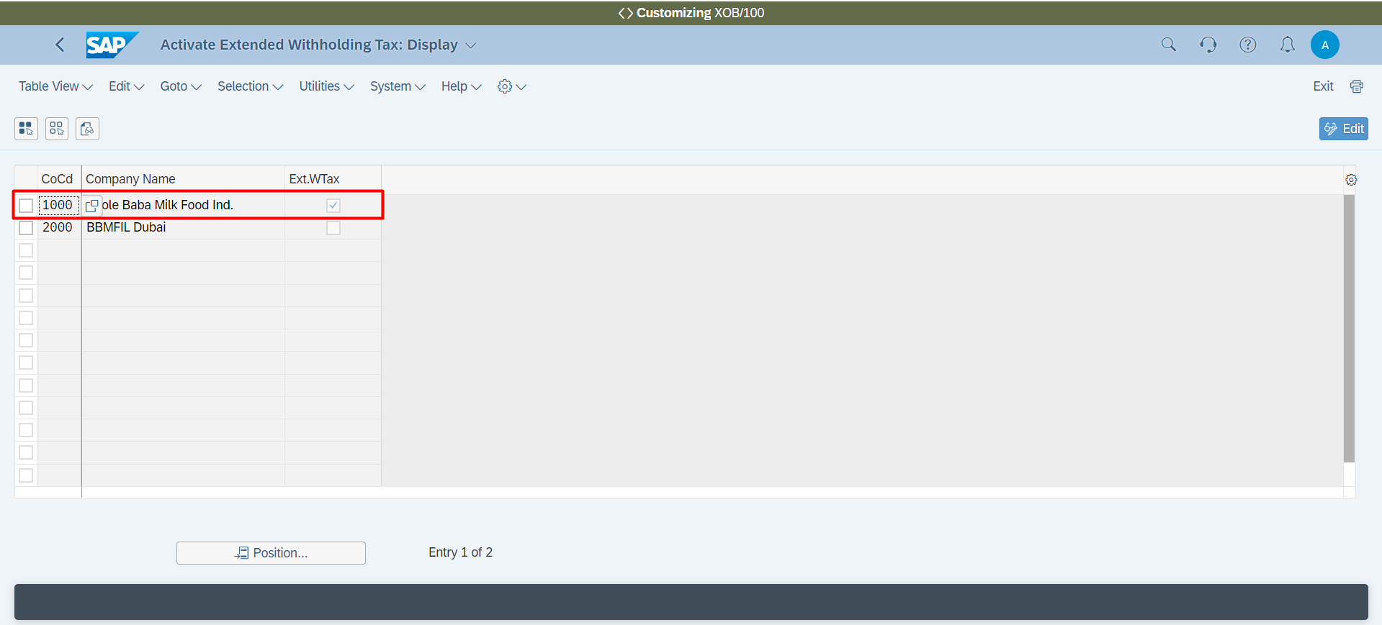

**Withholding Tax 🡪 Define Withholding Tax Codes**

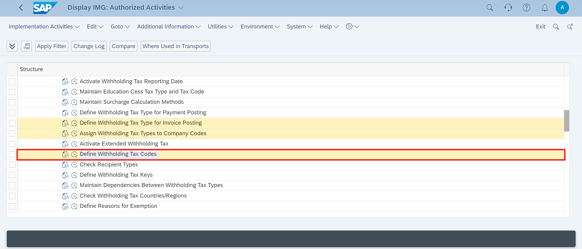

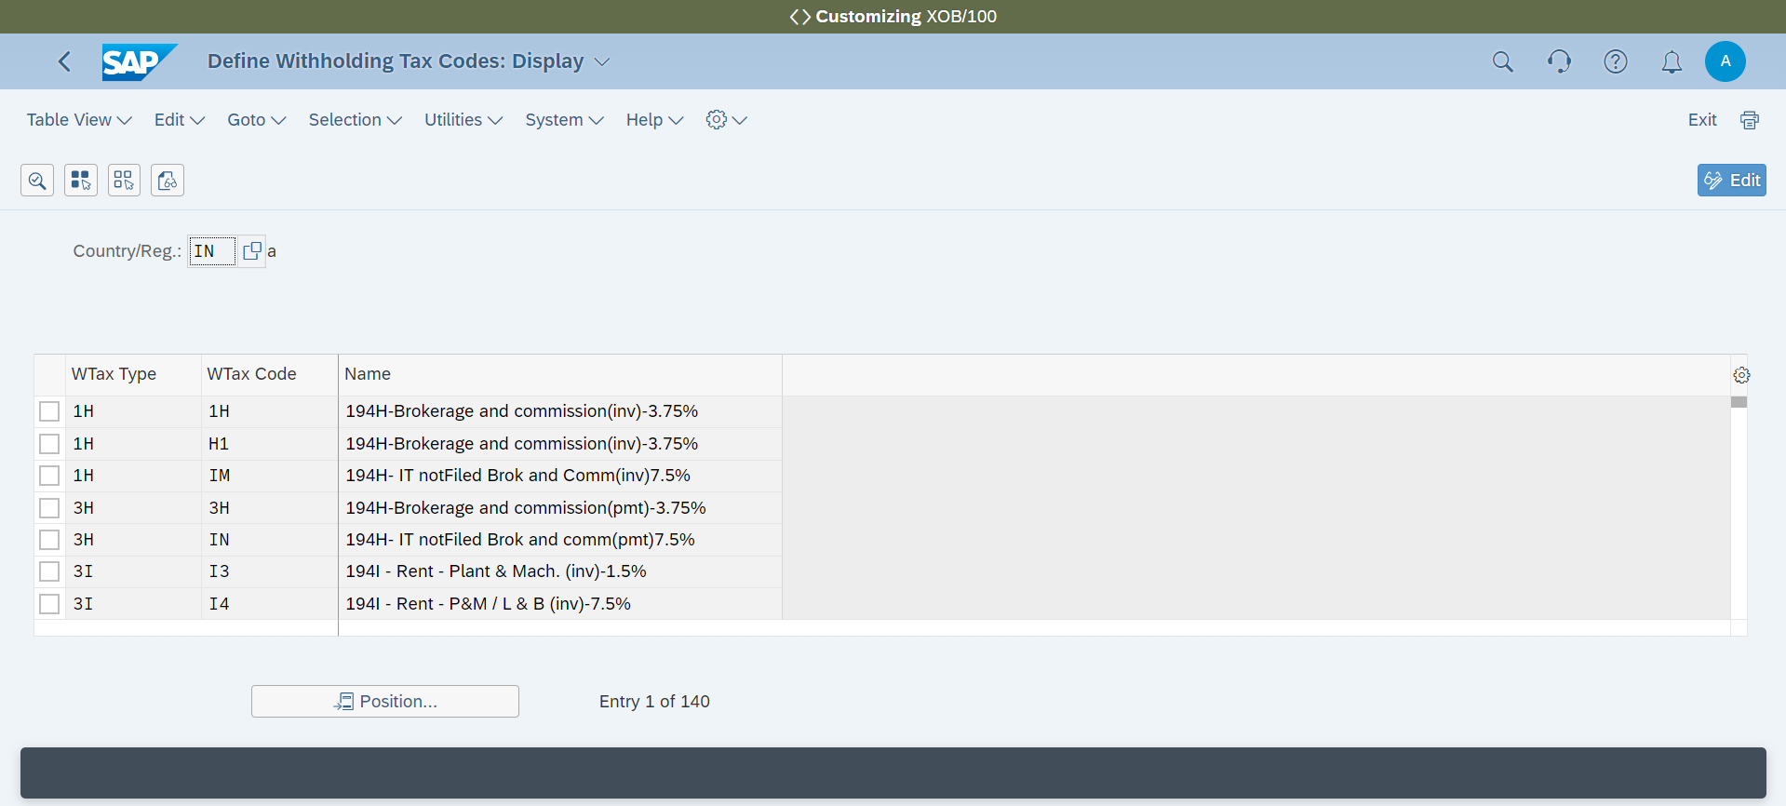

**Withholding Tax 🡪 Check Recipient Types**

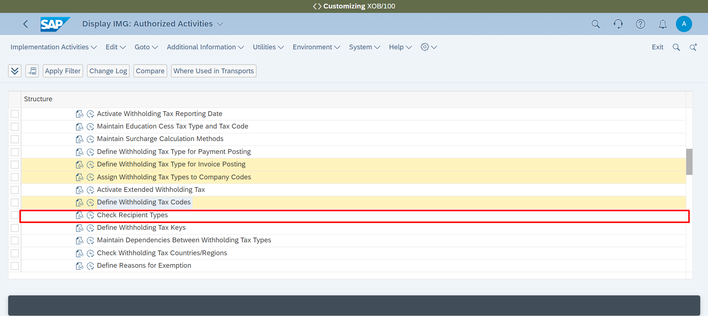

**Check Recipient Types**

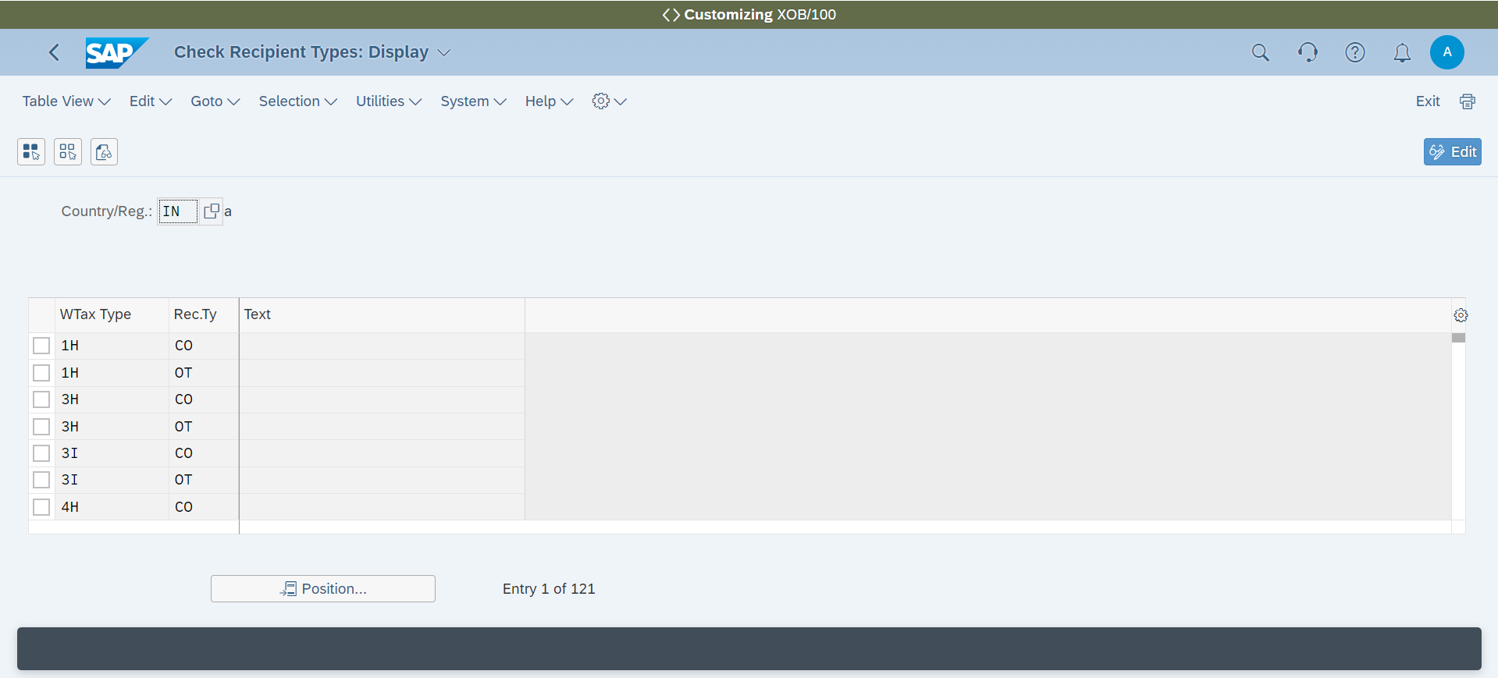

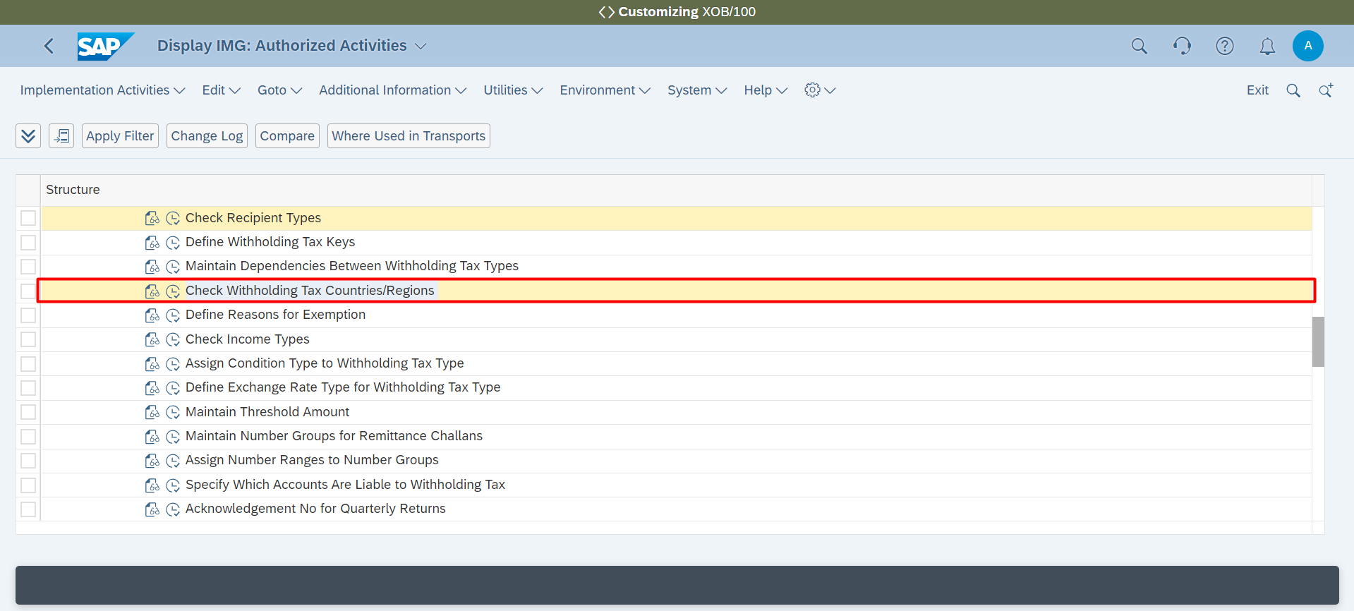

**Withholding Tax 🡪 Define Withholding Tax Keys**

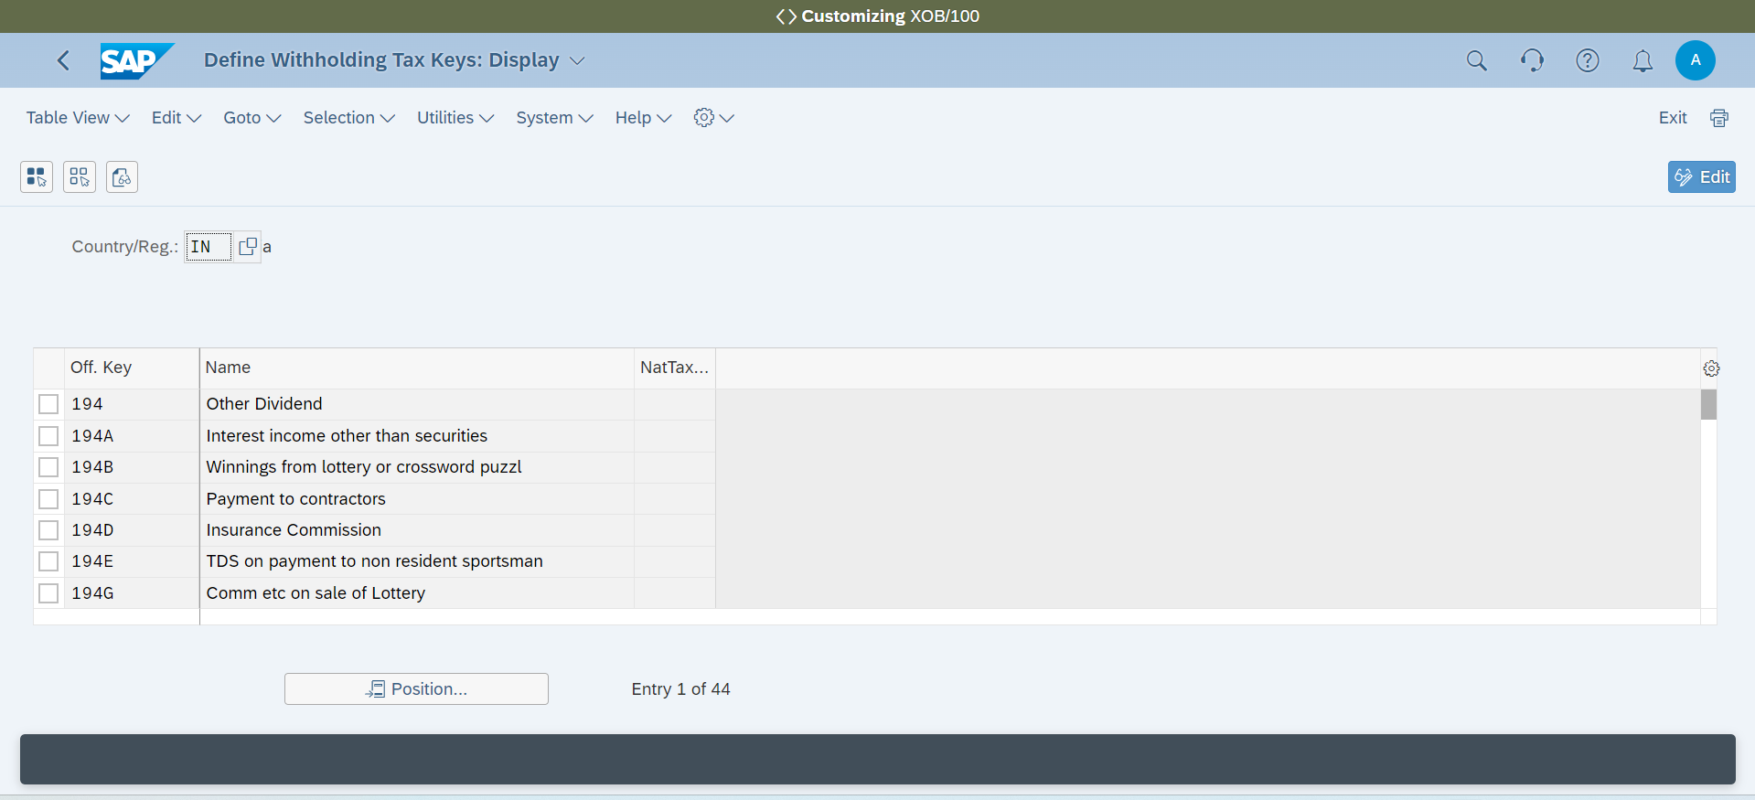

**Withholding Tax 🡪 Define Reasons for Exemption**

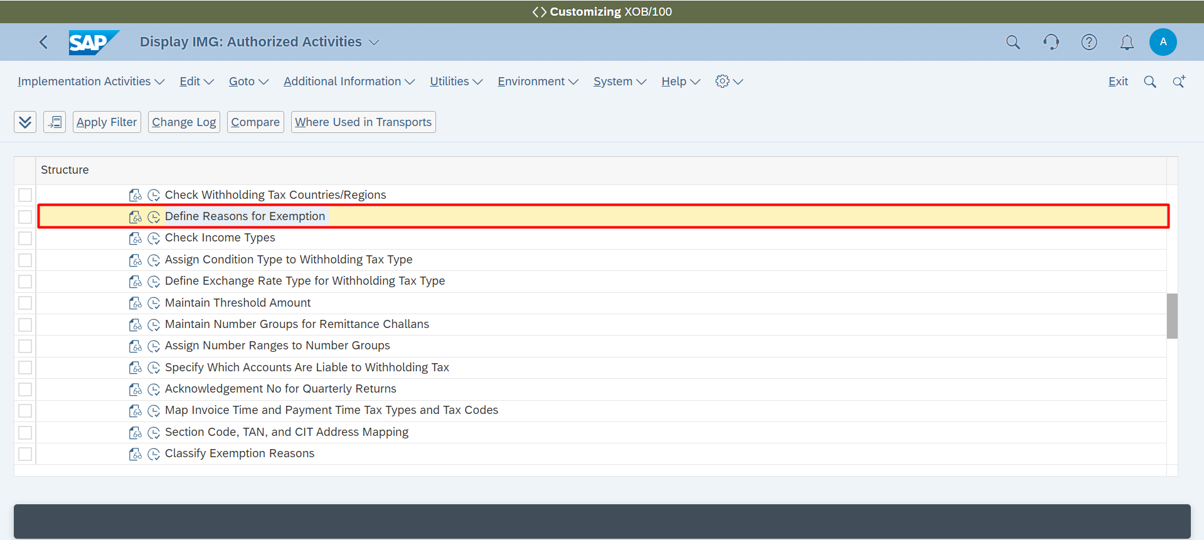

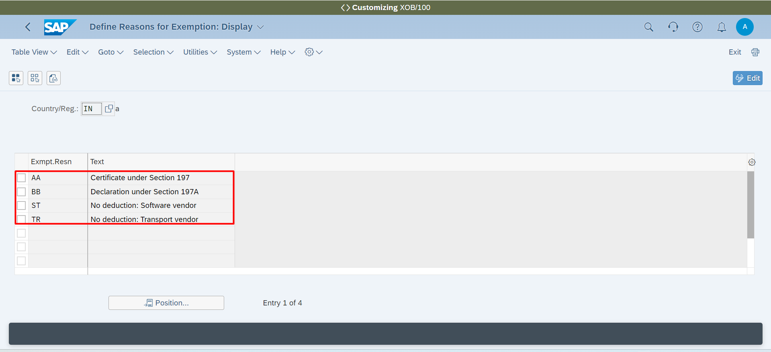

**Withholding Tax 🡪 Define Exchange Rate Type for Withholding Tax Type**

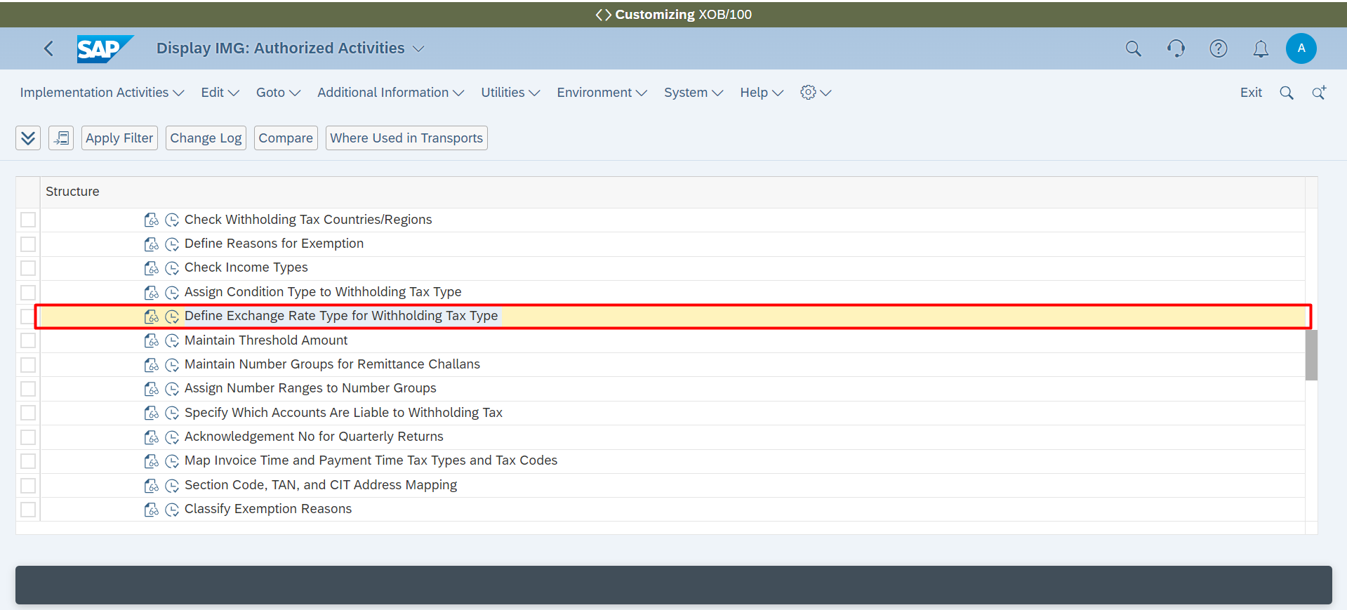

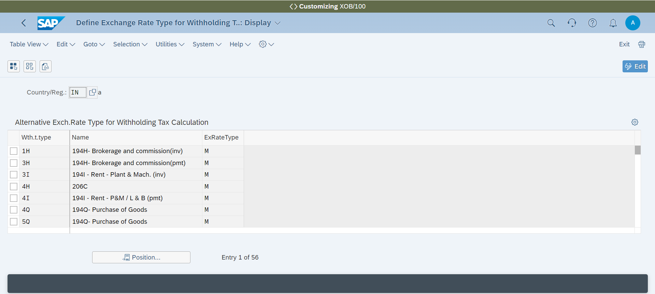

**Withholding Tax 🡪 Maintain Threshold Amount**

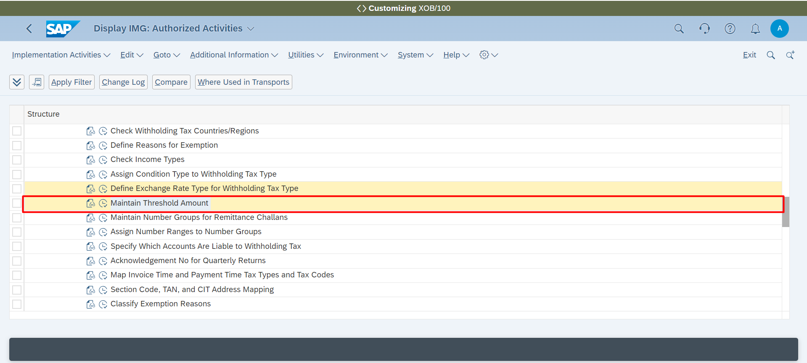

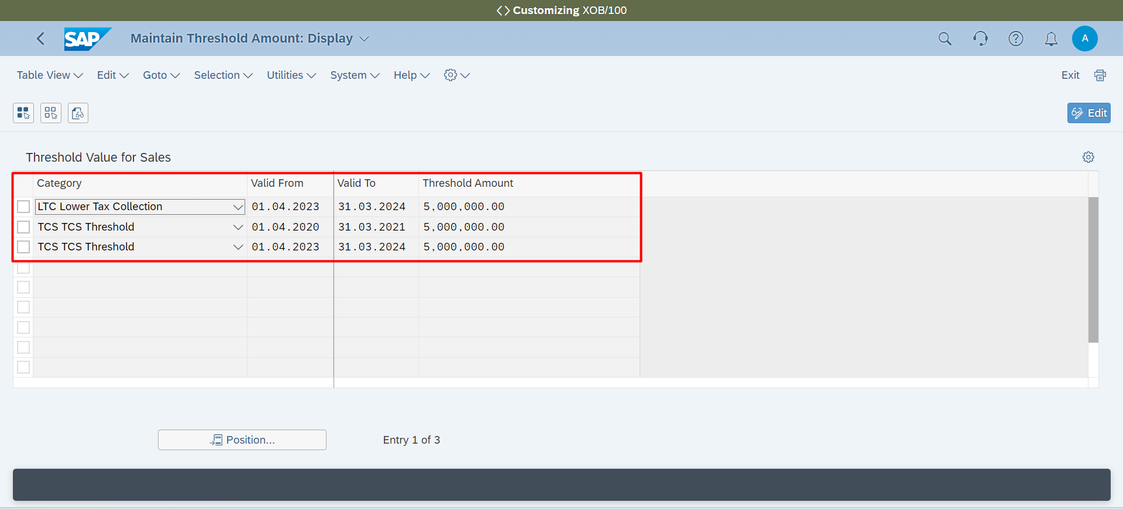

**Withholding Tax 🡪 Maintain Number Groups for Remittance Challans**

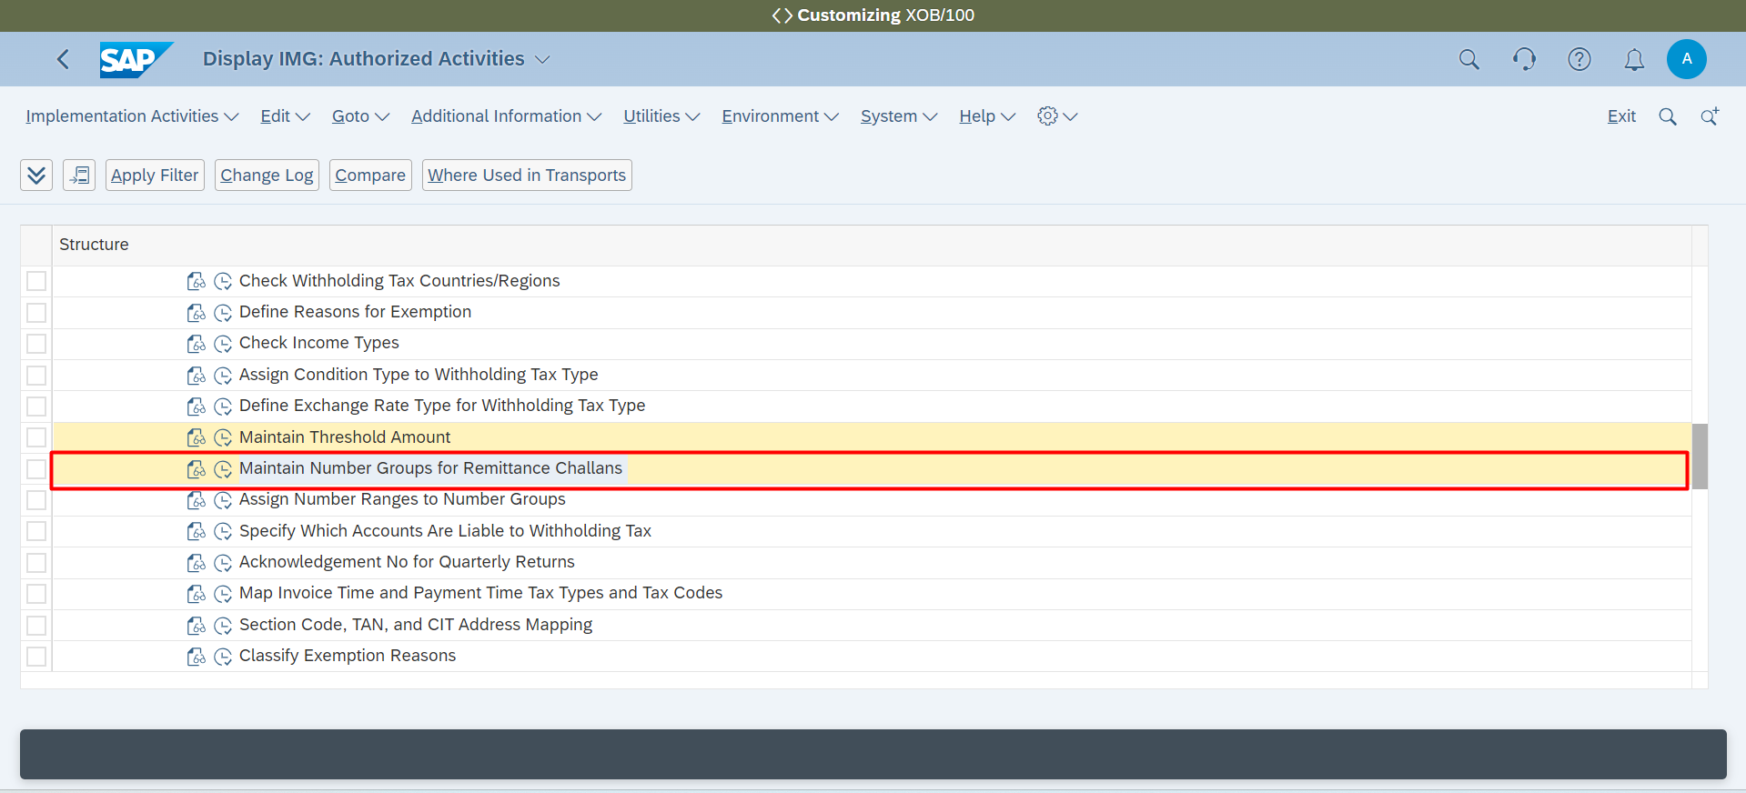

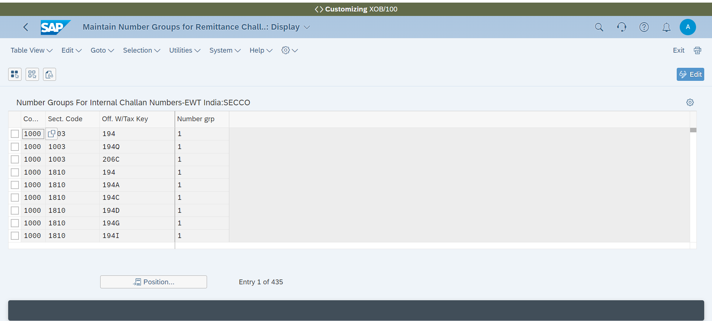

**Withholding Tax 🡪 Assign Number Ranges to Number Groups**

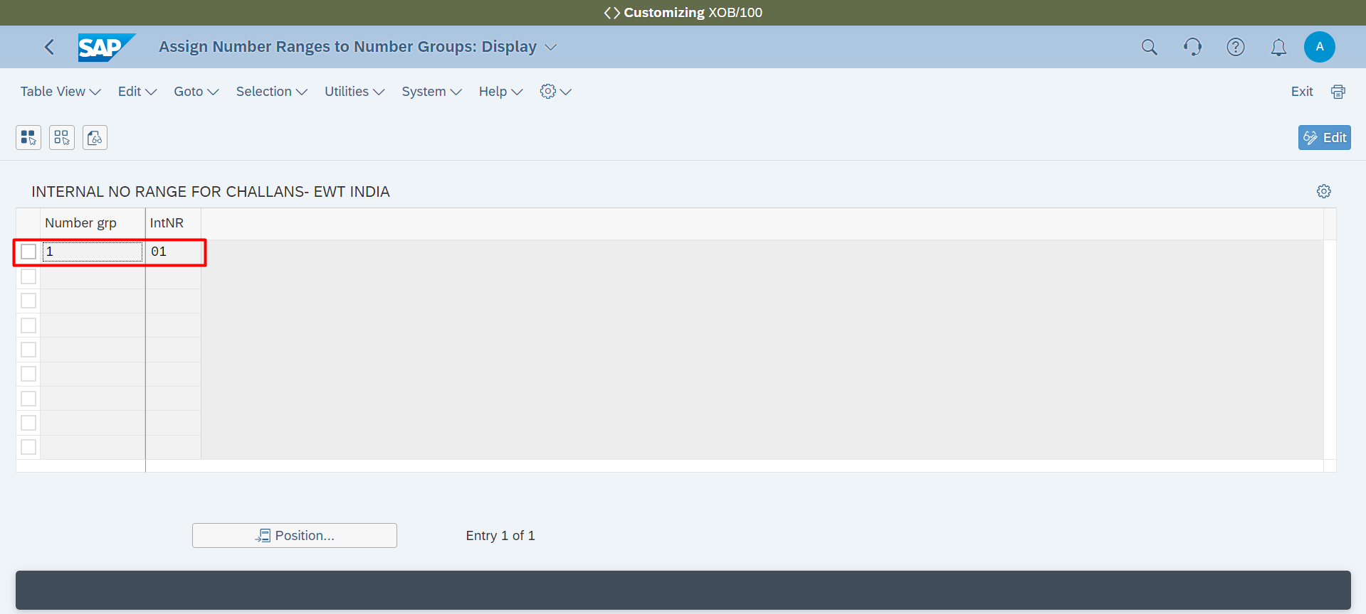

**Withholding Tax 🡪 Map Invoice Time and Payment Time Tax Types and Tax Codes**

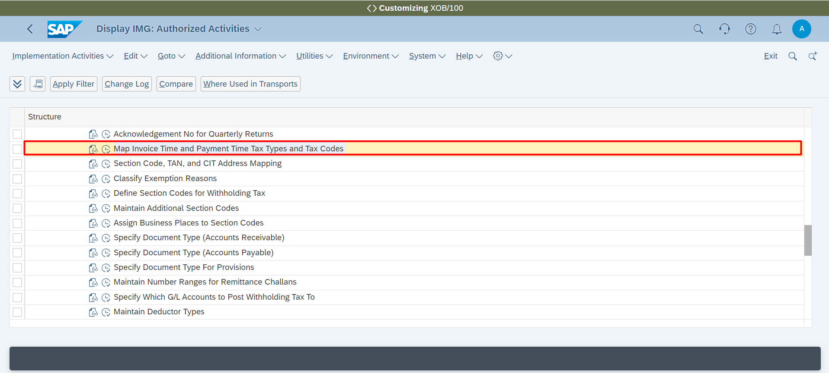

**Withholding Tax 🡪 Section Code, TAN, and CIT Address Mapping**

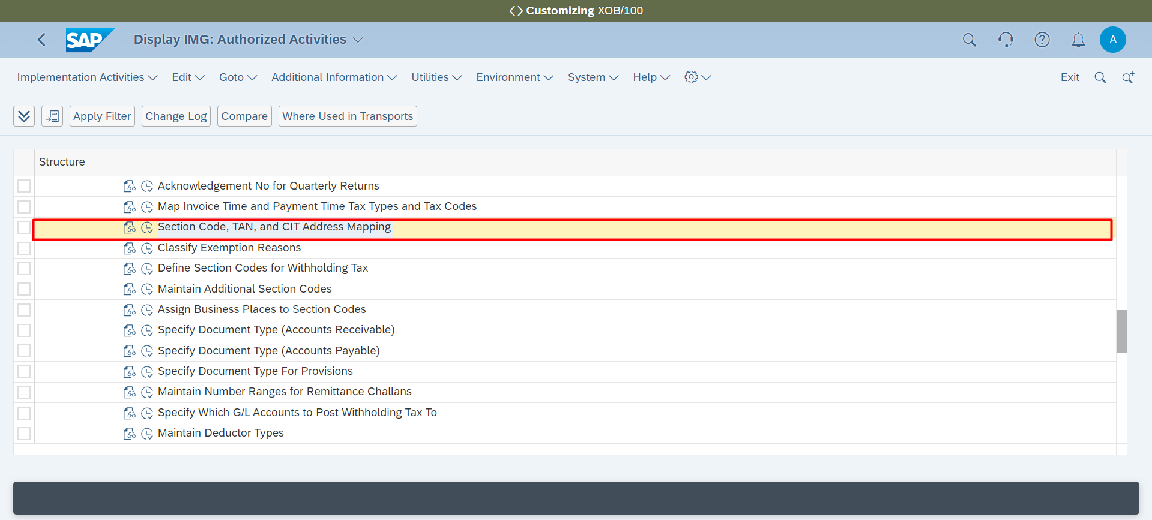

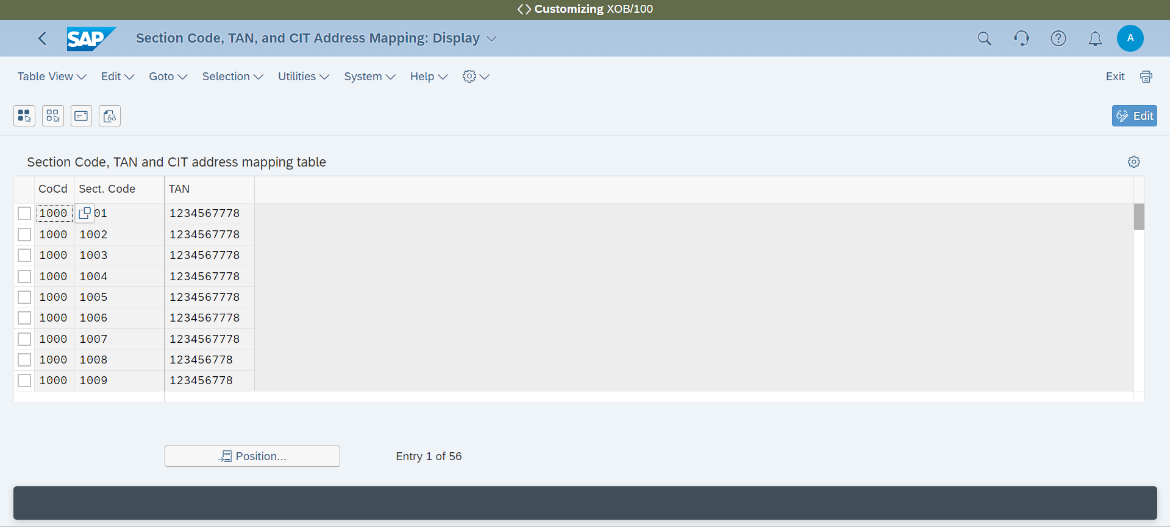

**Withholding Tax 🡪 Define Section Codes for Withholding Tax**

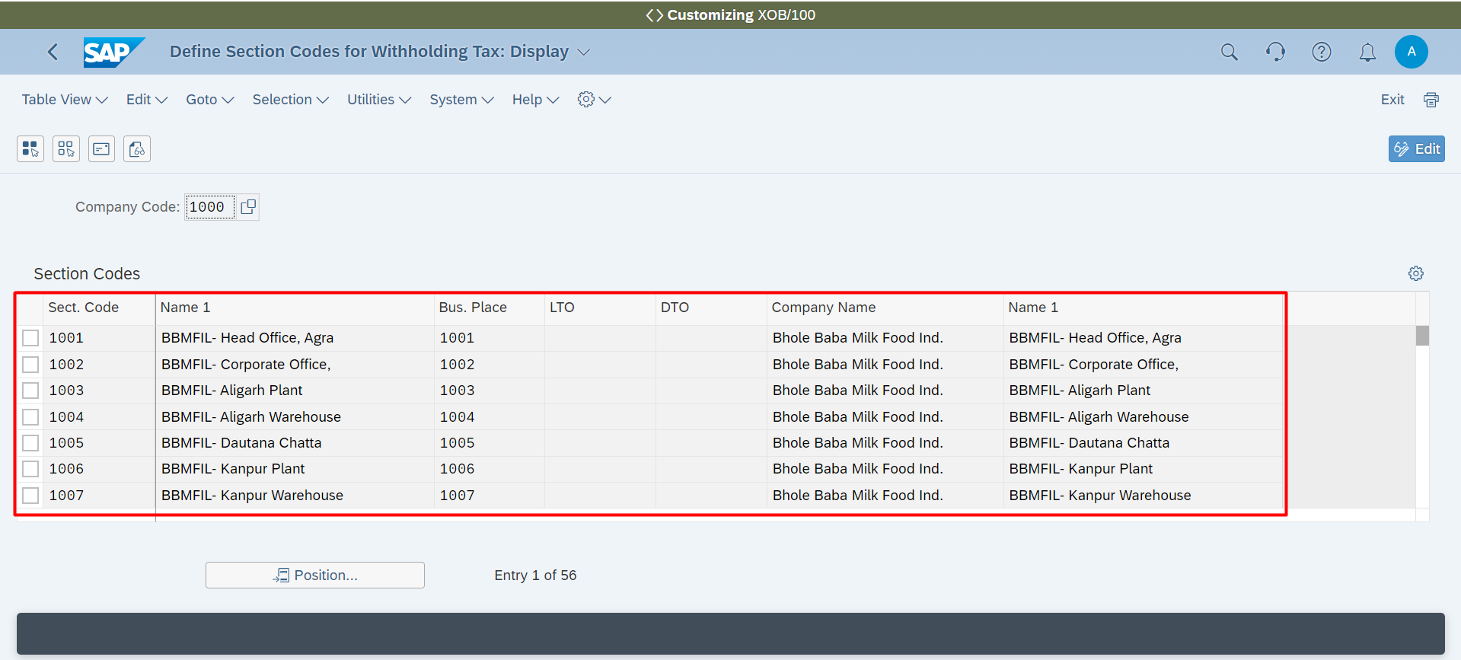

**Withholding Tax 🡪 Assign Business Places to Section Codes**

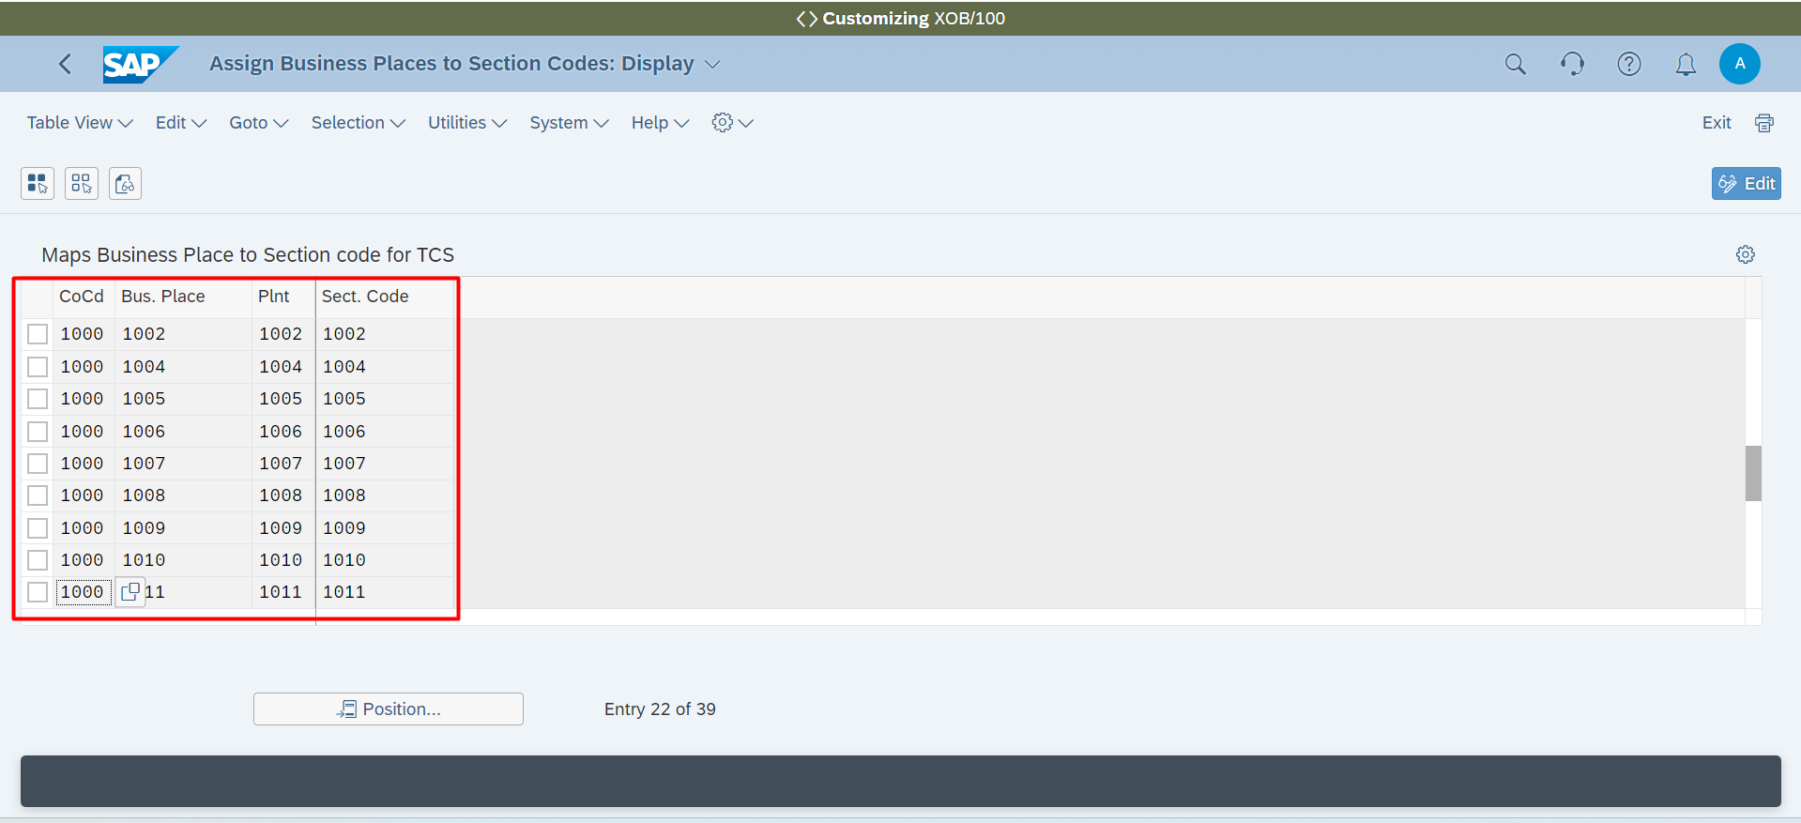

**Withholding Tax 🡪 Specify Document Type (Accounts Receivable)**

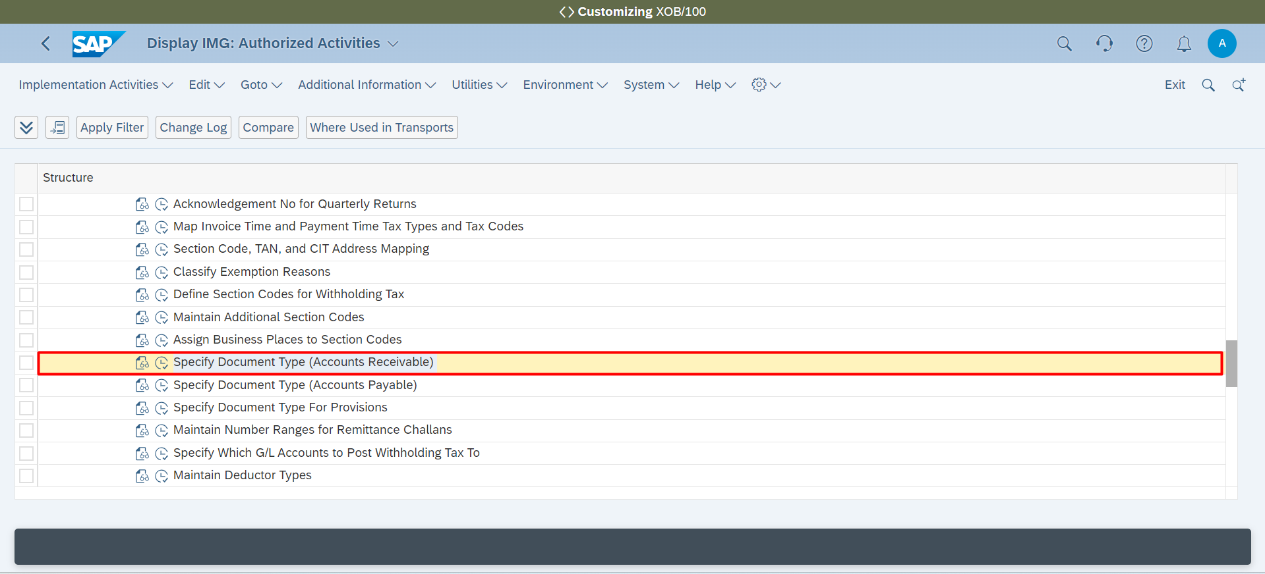

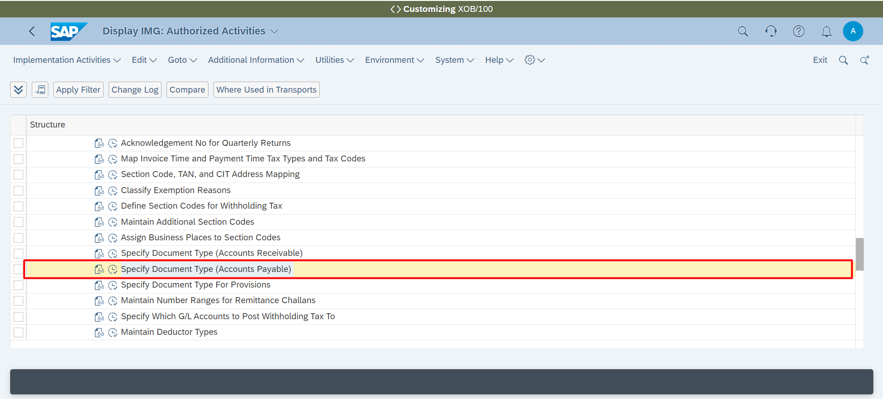

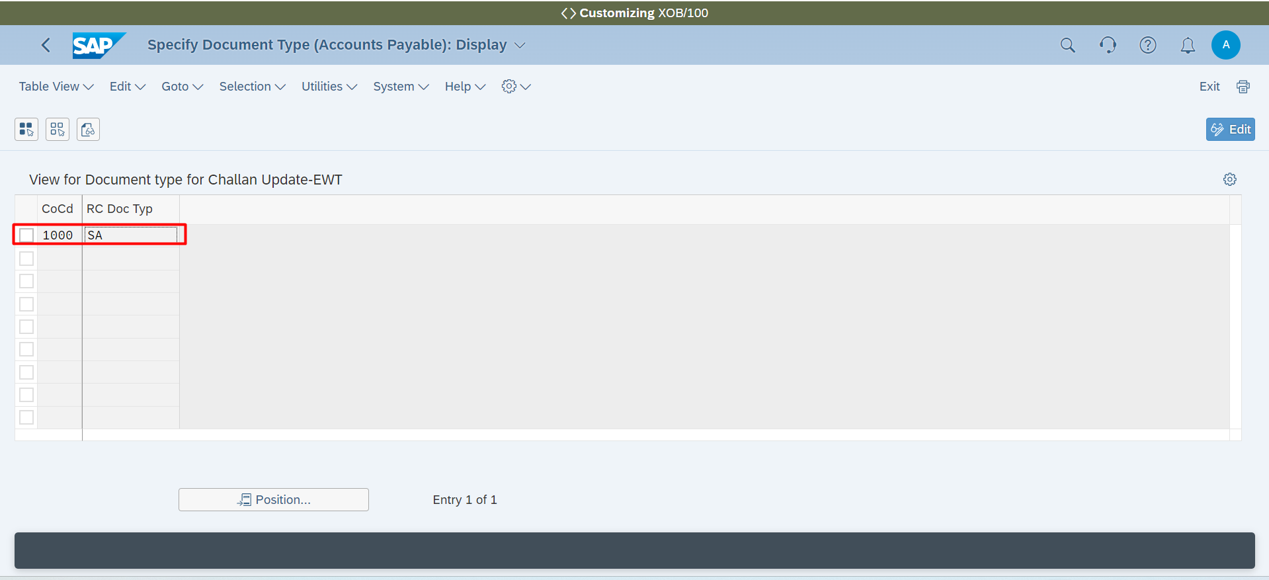

**Withholding Tax 🡪 Maintain Number Ranges for Remittance Challans**

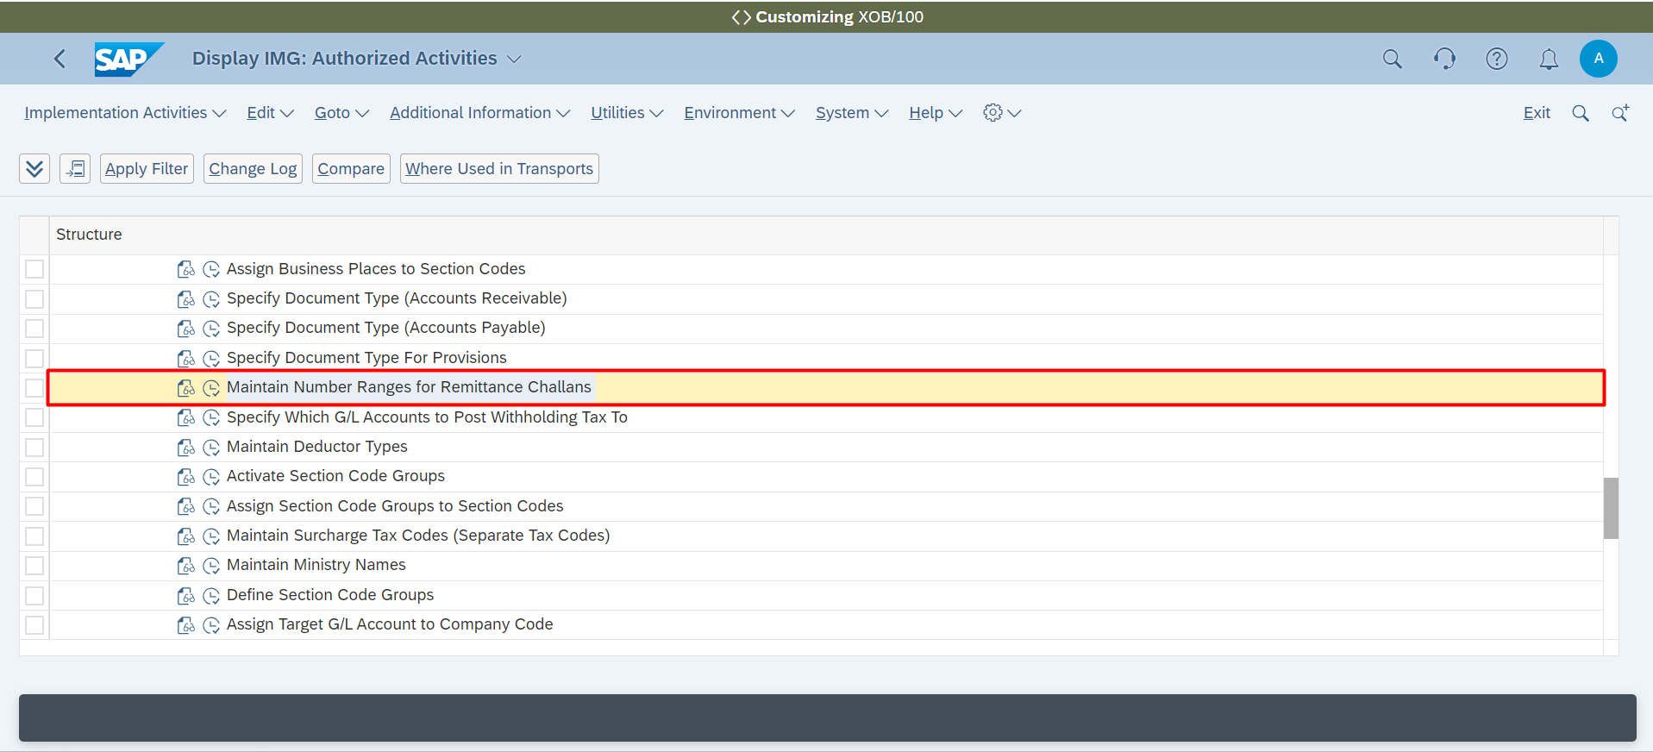

**Withholding Tax 🡪 Specify Which G/L Accounts to Post Withholding Tax To**

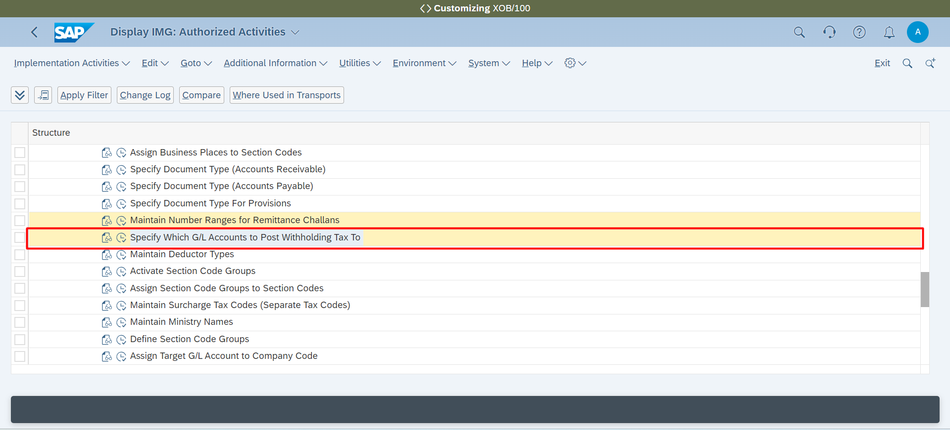

**Withholding Tax 🡪 Activate Section Code Groups**

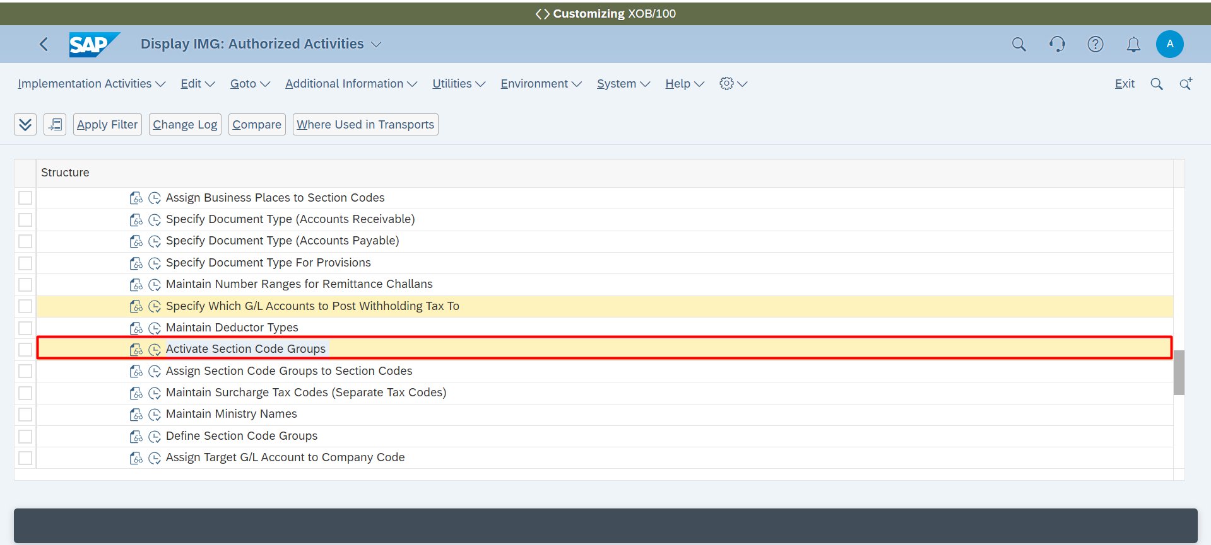

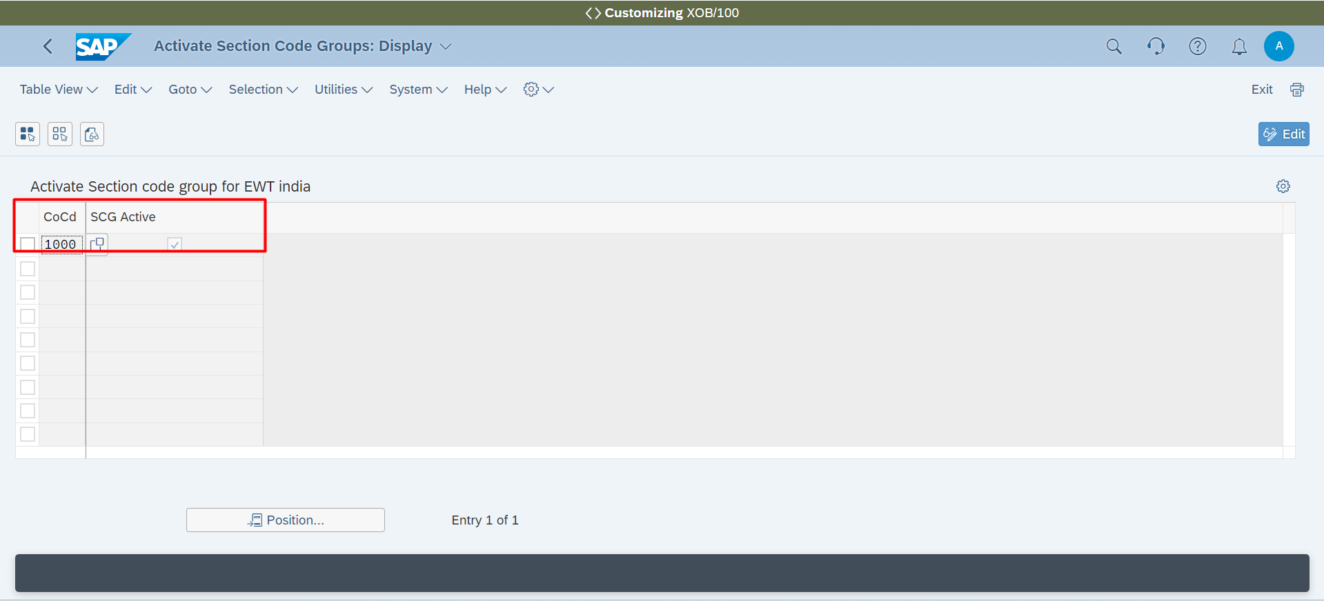

**Withholding Tax 🡪 Assign Section Code Groups to Section Codes**

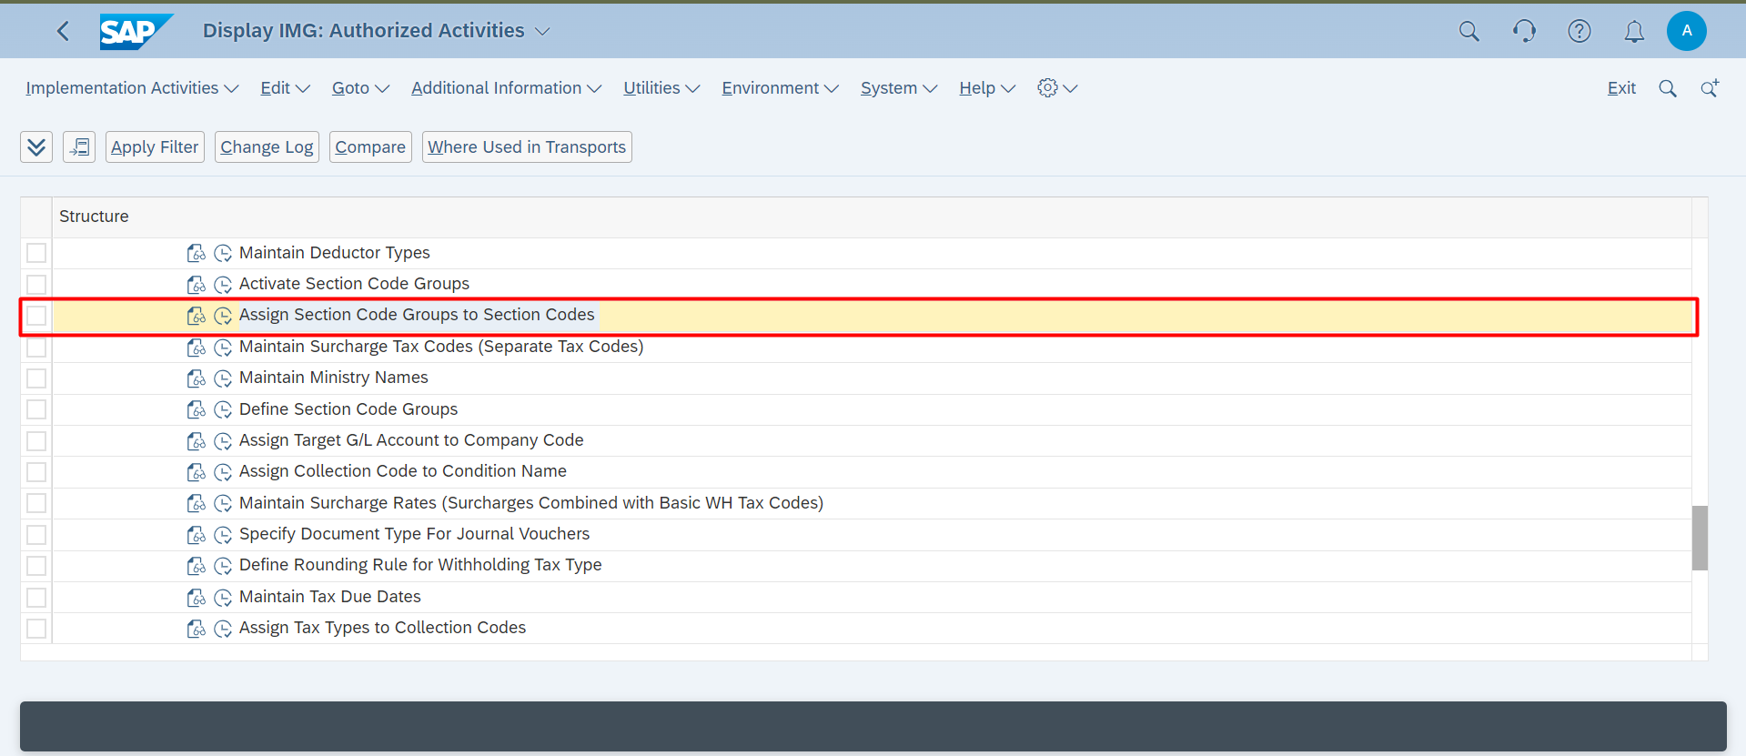

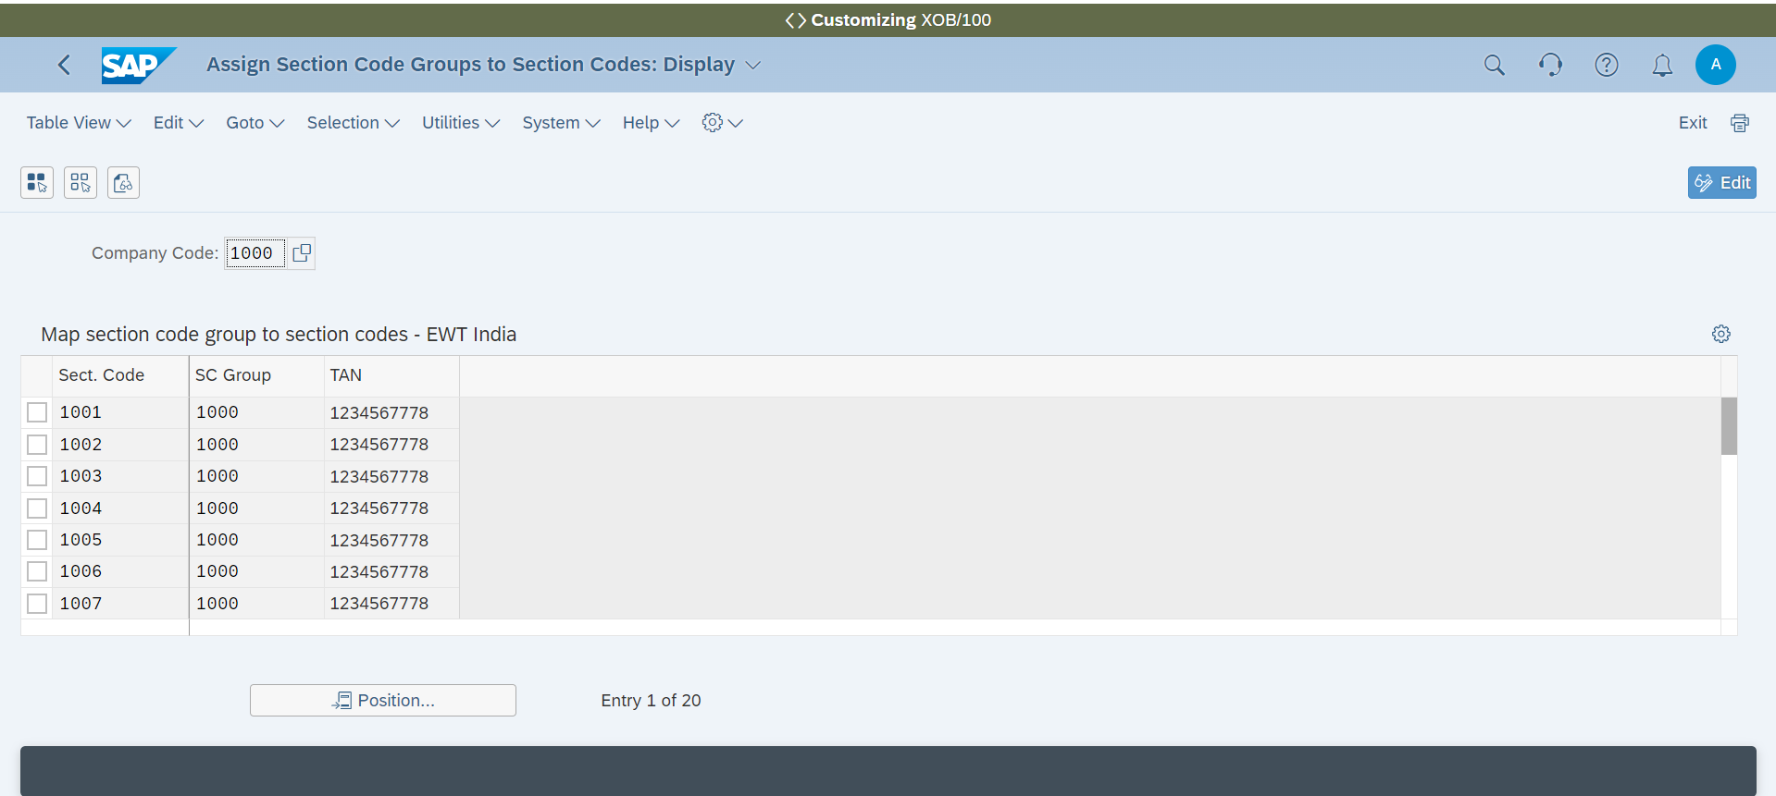

**Withholding Tax 🡪 Define Section Code Groups**

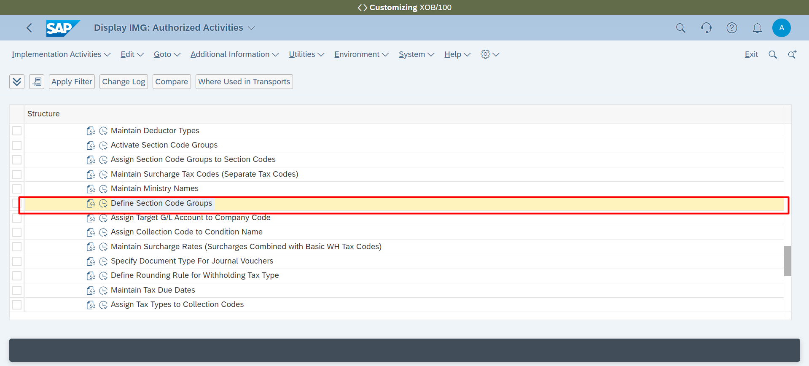

**Withholding Tax 🡪 Define Rounding Rule for Withholding Tax Type**

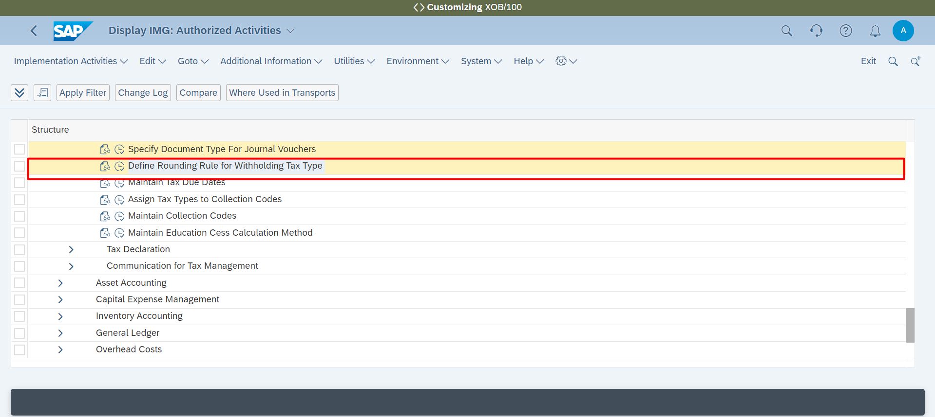

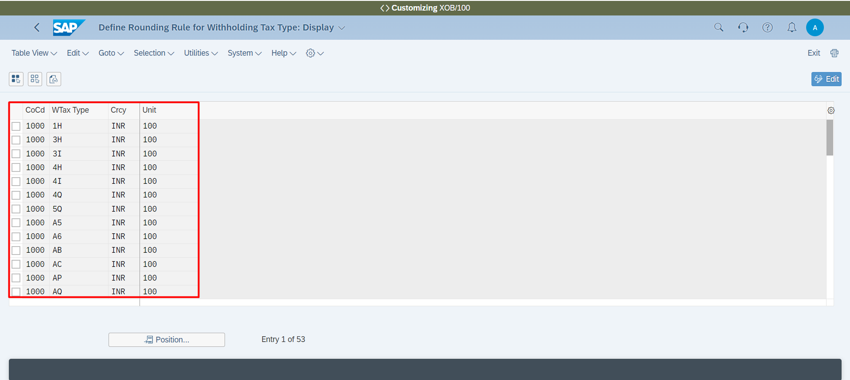

**Maintain Tax Due Dates**

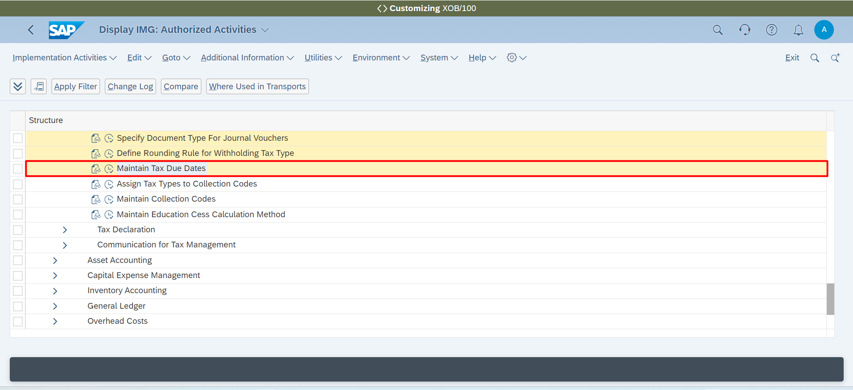

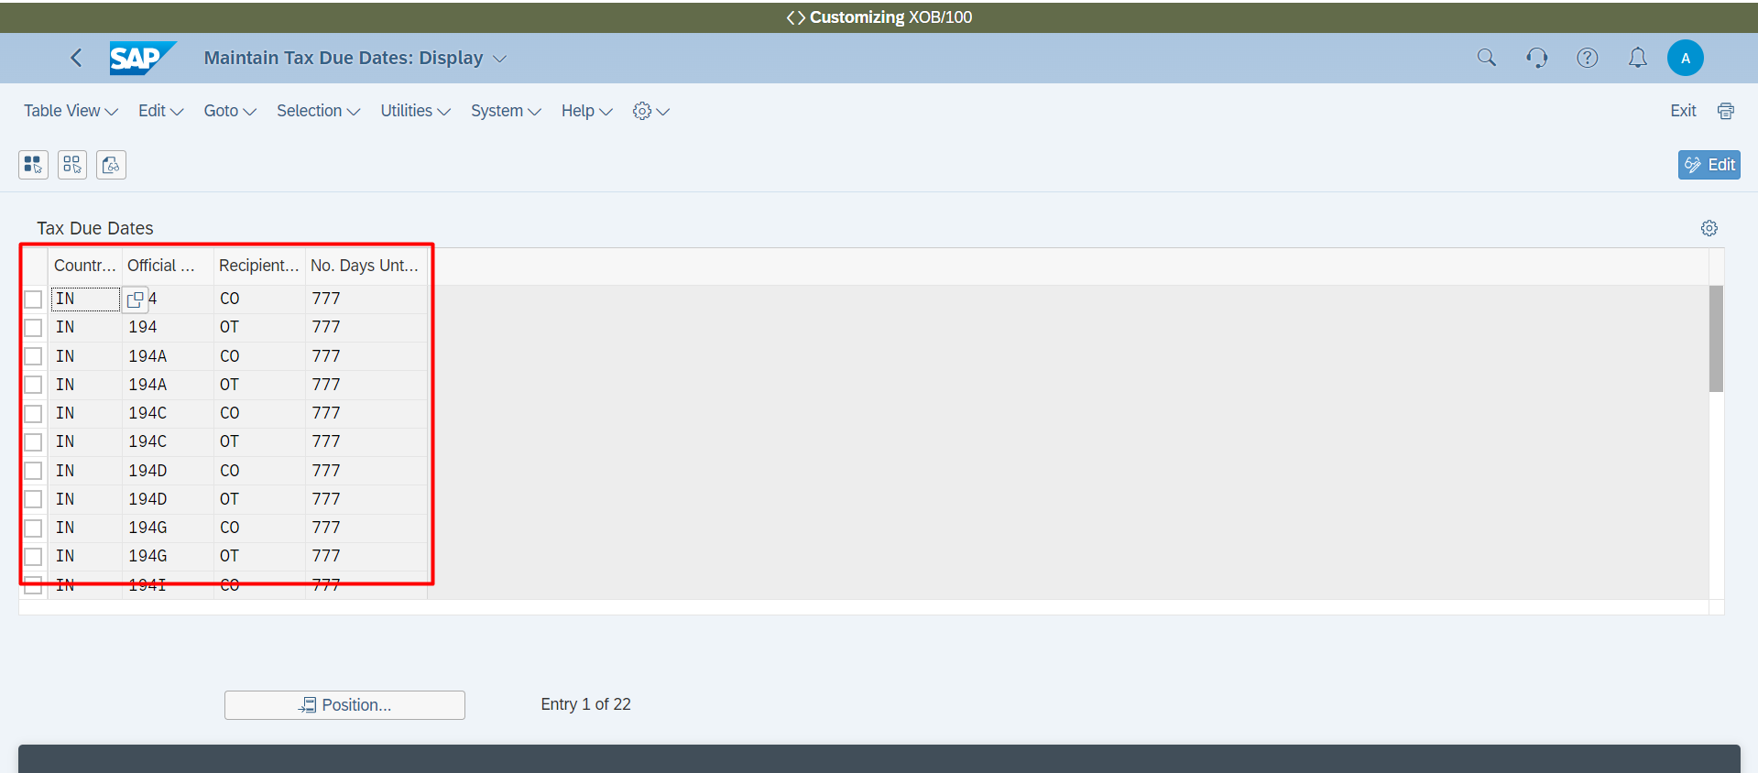

**Payment Processing 🡪 Cash and Bank Accounts 🡪 Do you use a cash journal to manage cash transactions? 🡪 Set Up Cash Journal**

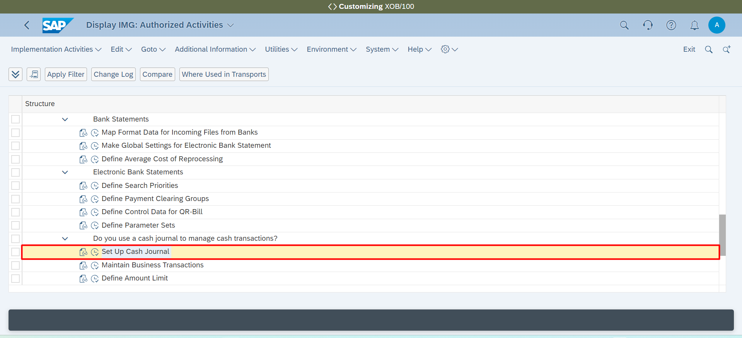

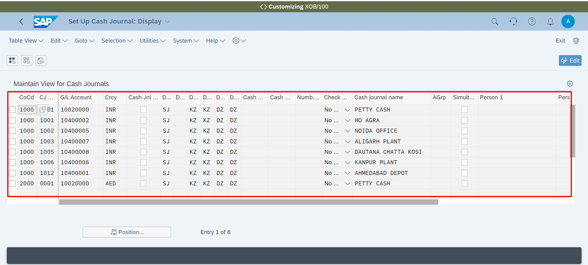

**Payment Processing 🡪 Cash and Bank Accounts 🡪 Do you use a cash journal to manage cash transactions? 🡪 Maintain Business Transactions**

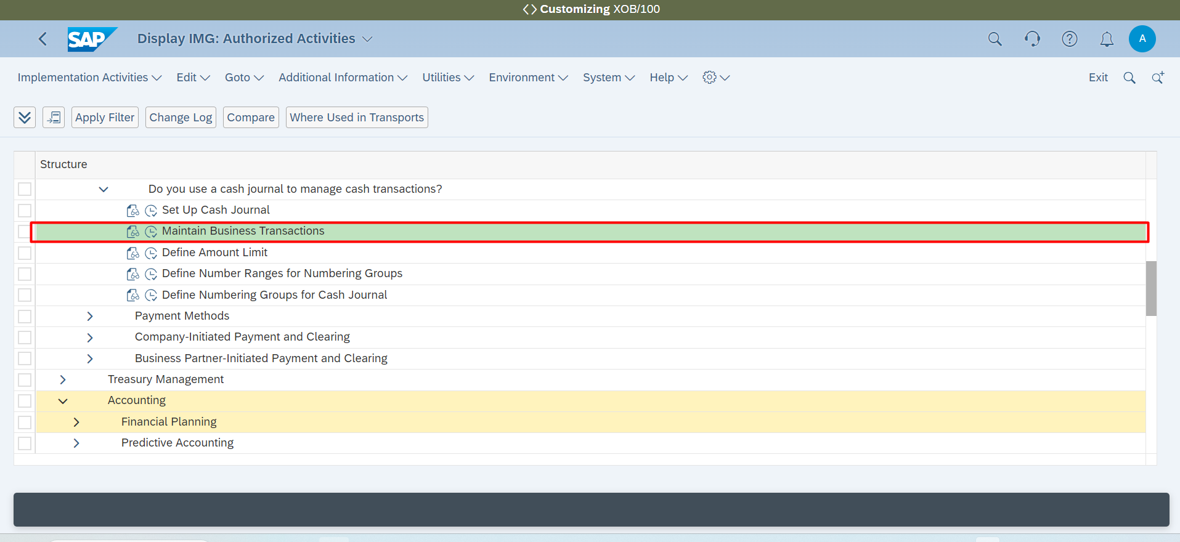

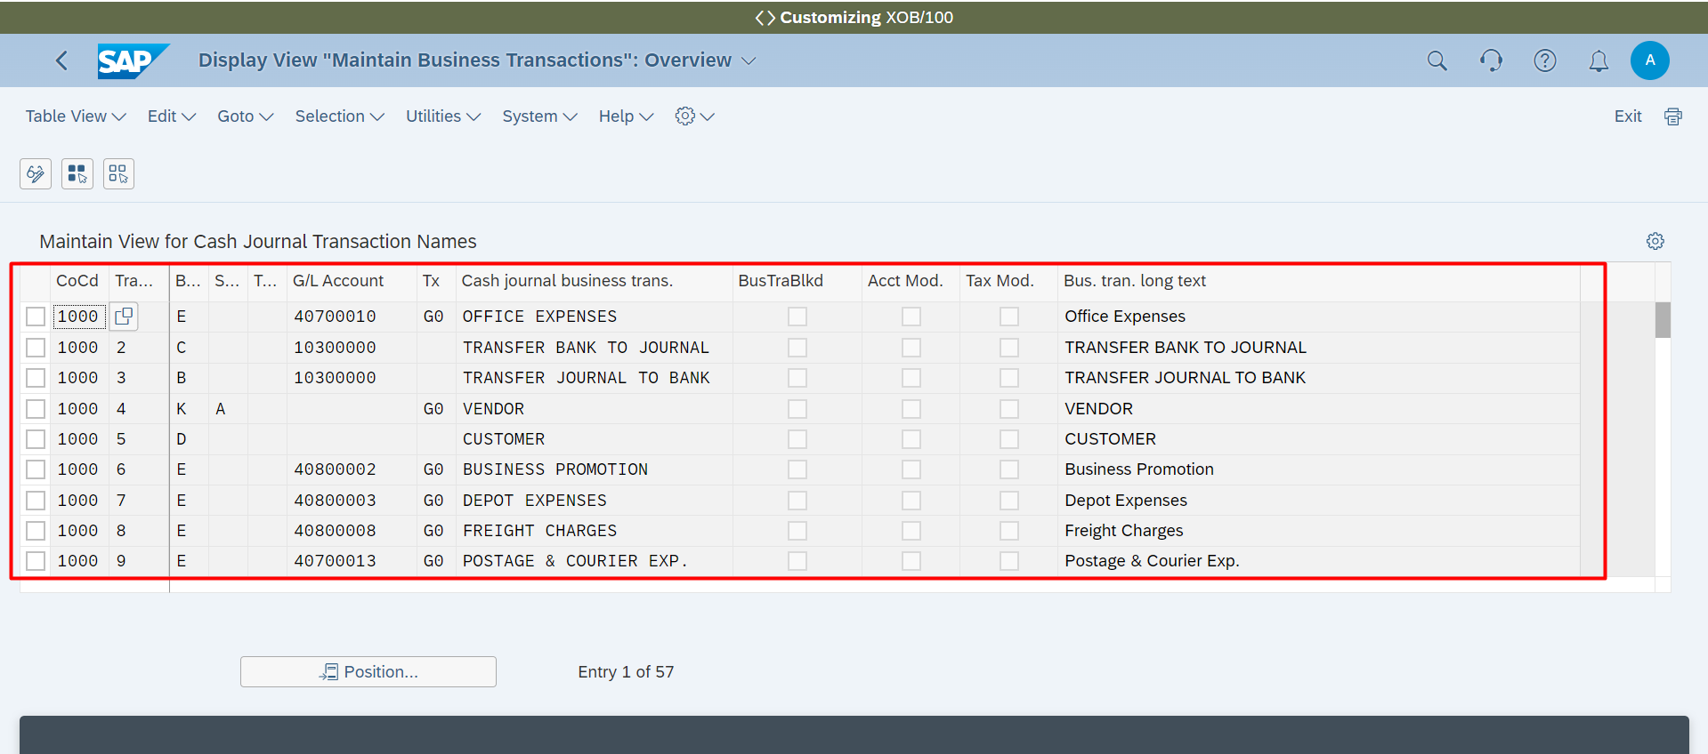

Accounting 🡪 Asset Accounting 🡪 Generally Accepted Accounting Principles 🡪 Define Depreciation Areas in Company Code

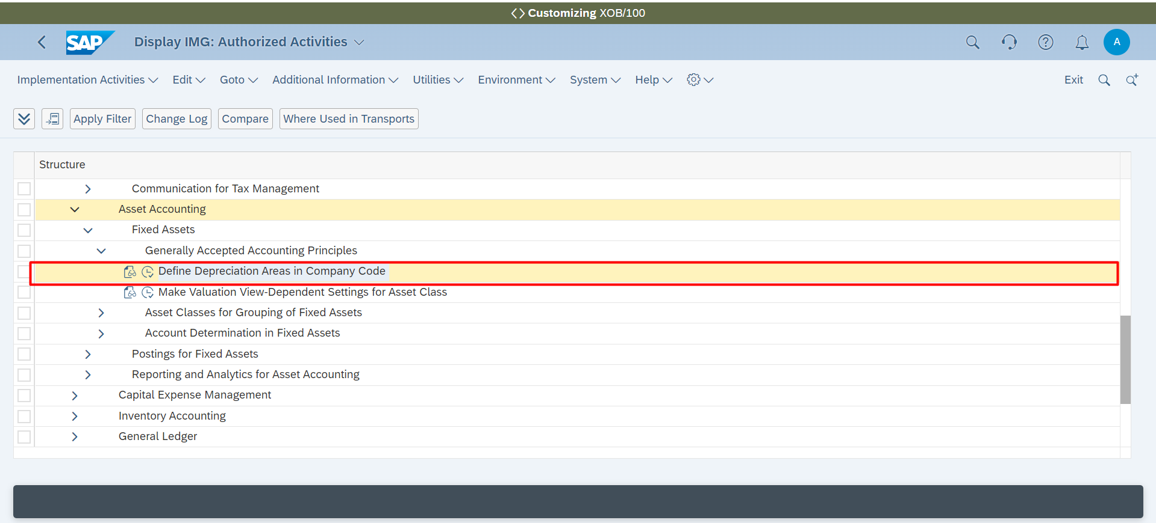

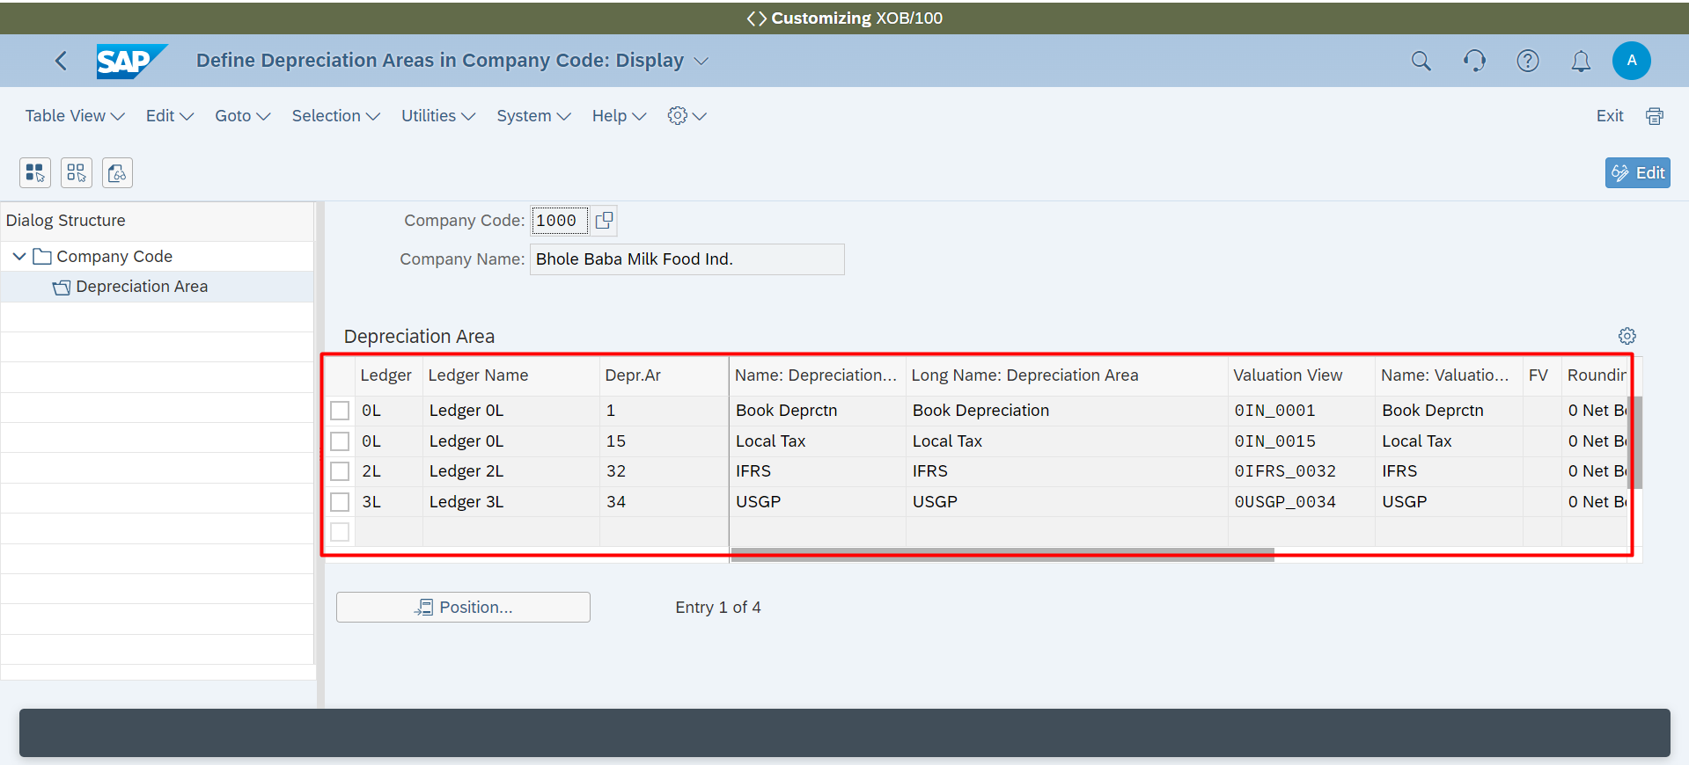

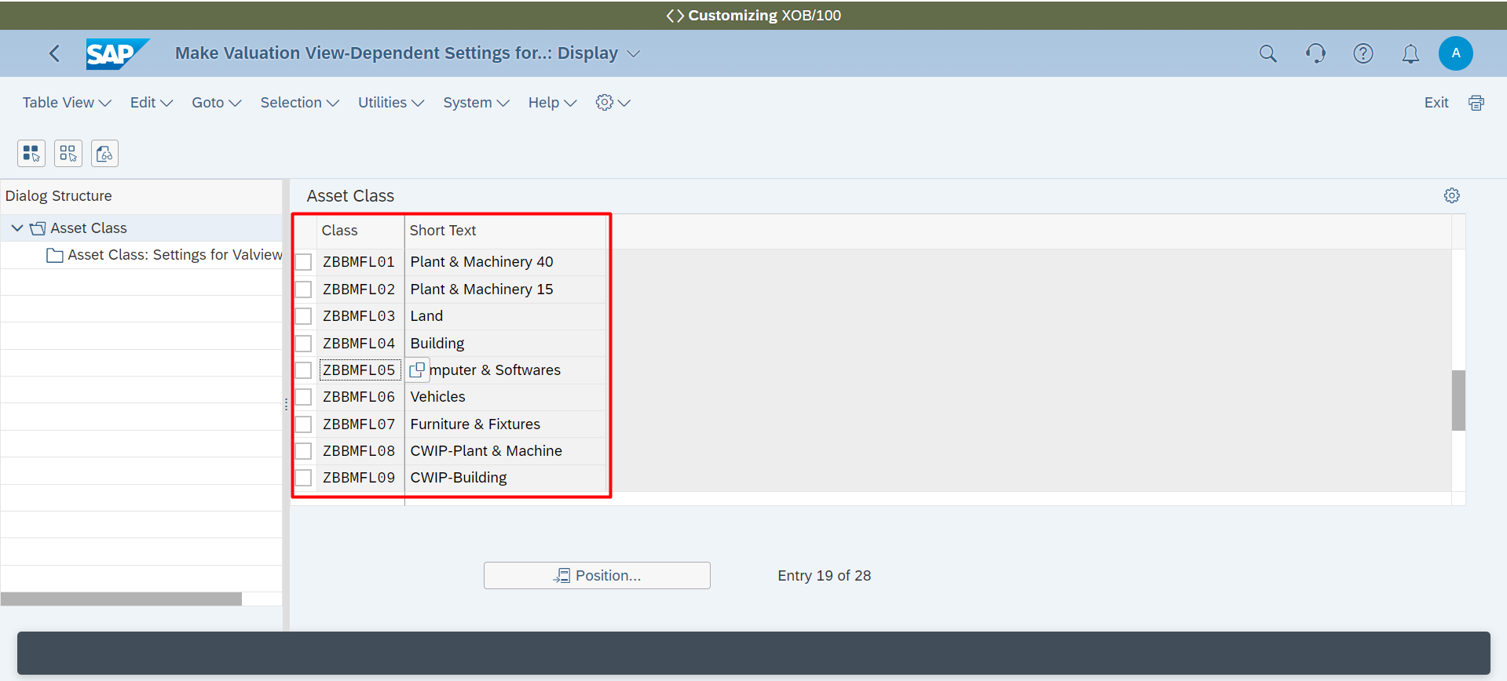

Accounting 🡪 Asset Accounting 🡪 Generally Accepted Accounting Principles 🡪 Define Asset Class

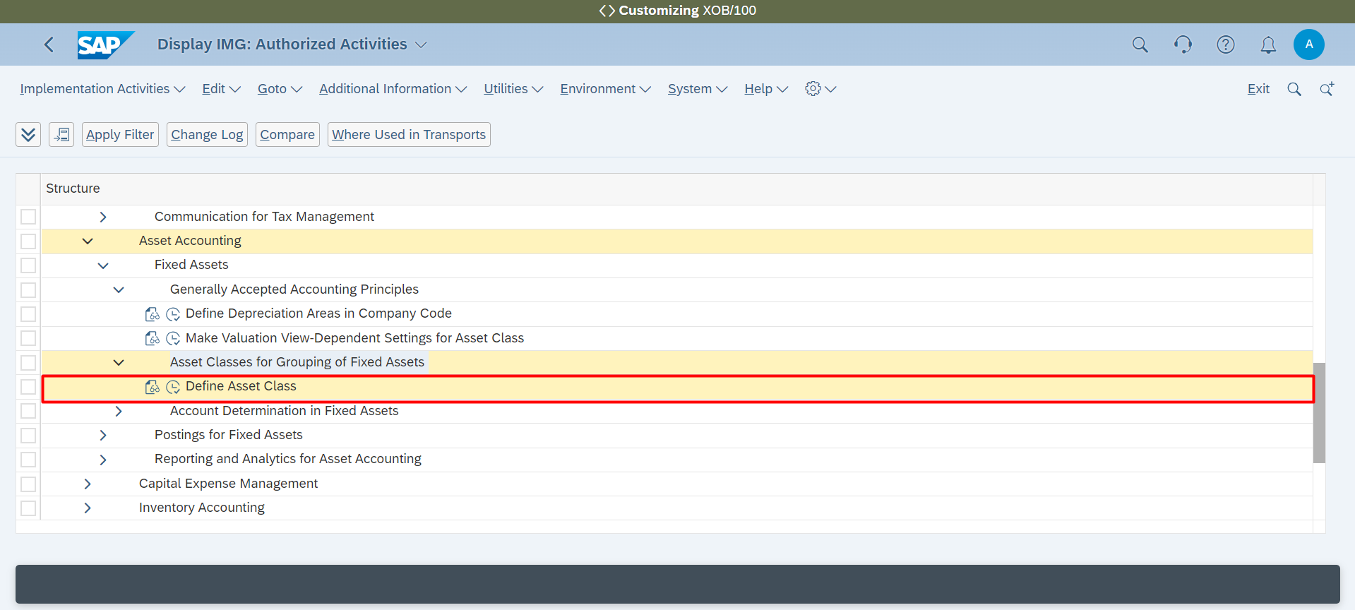

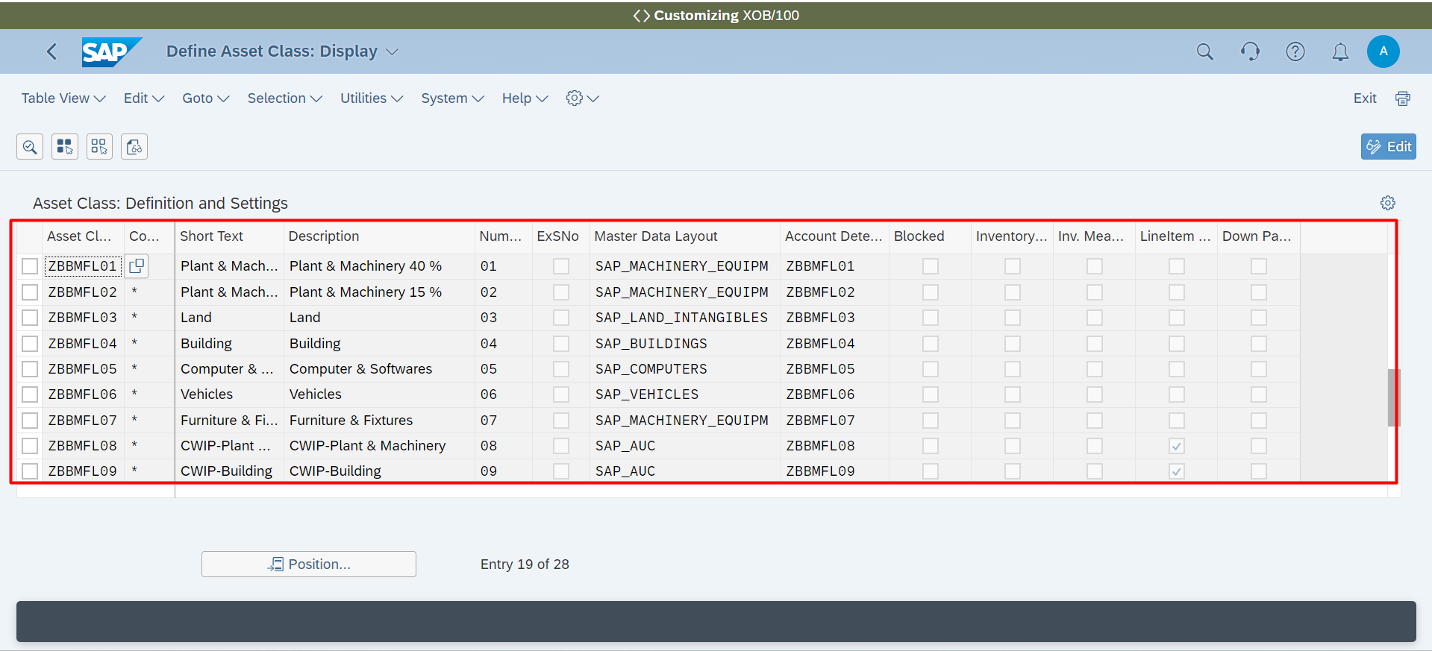

Accounting 🡪 Asset Accounting 🡪 Generally Accepted Accounting Principles 🡪 Define Account Determination

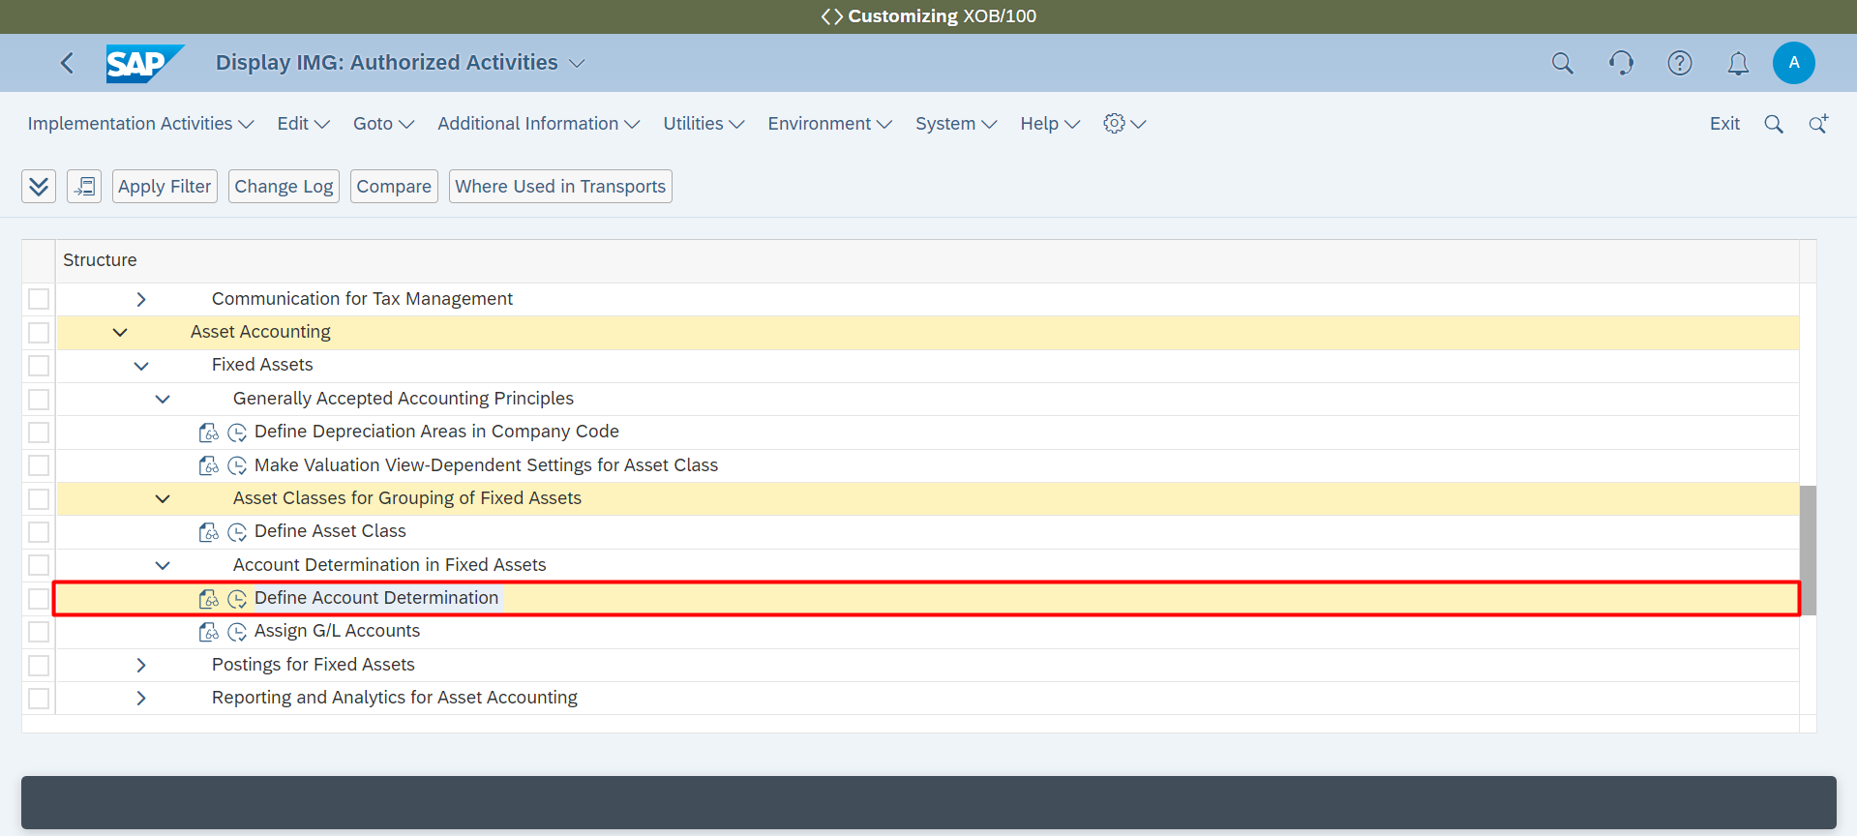

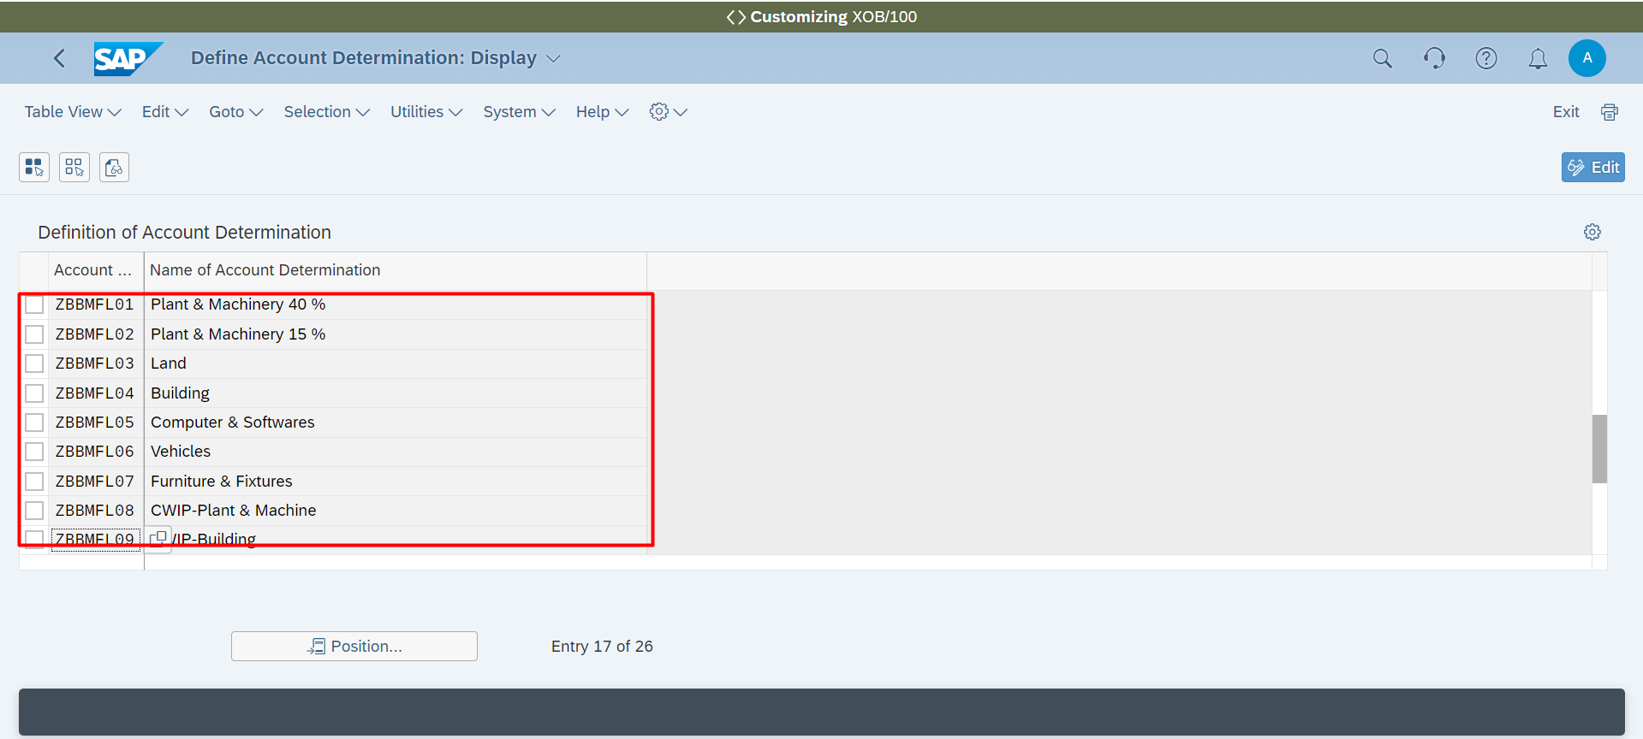

**Accounting 🡪 Asset Accounting 🡪 Generally Accepted Accounting Principles 🡪 Assing Gl Account**

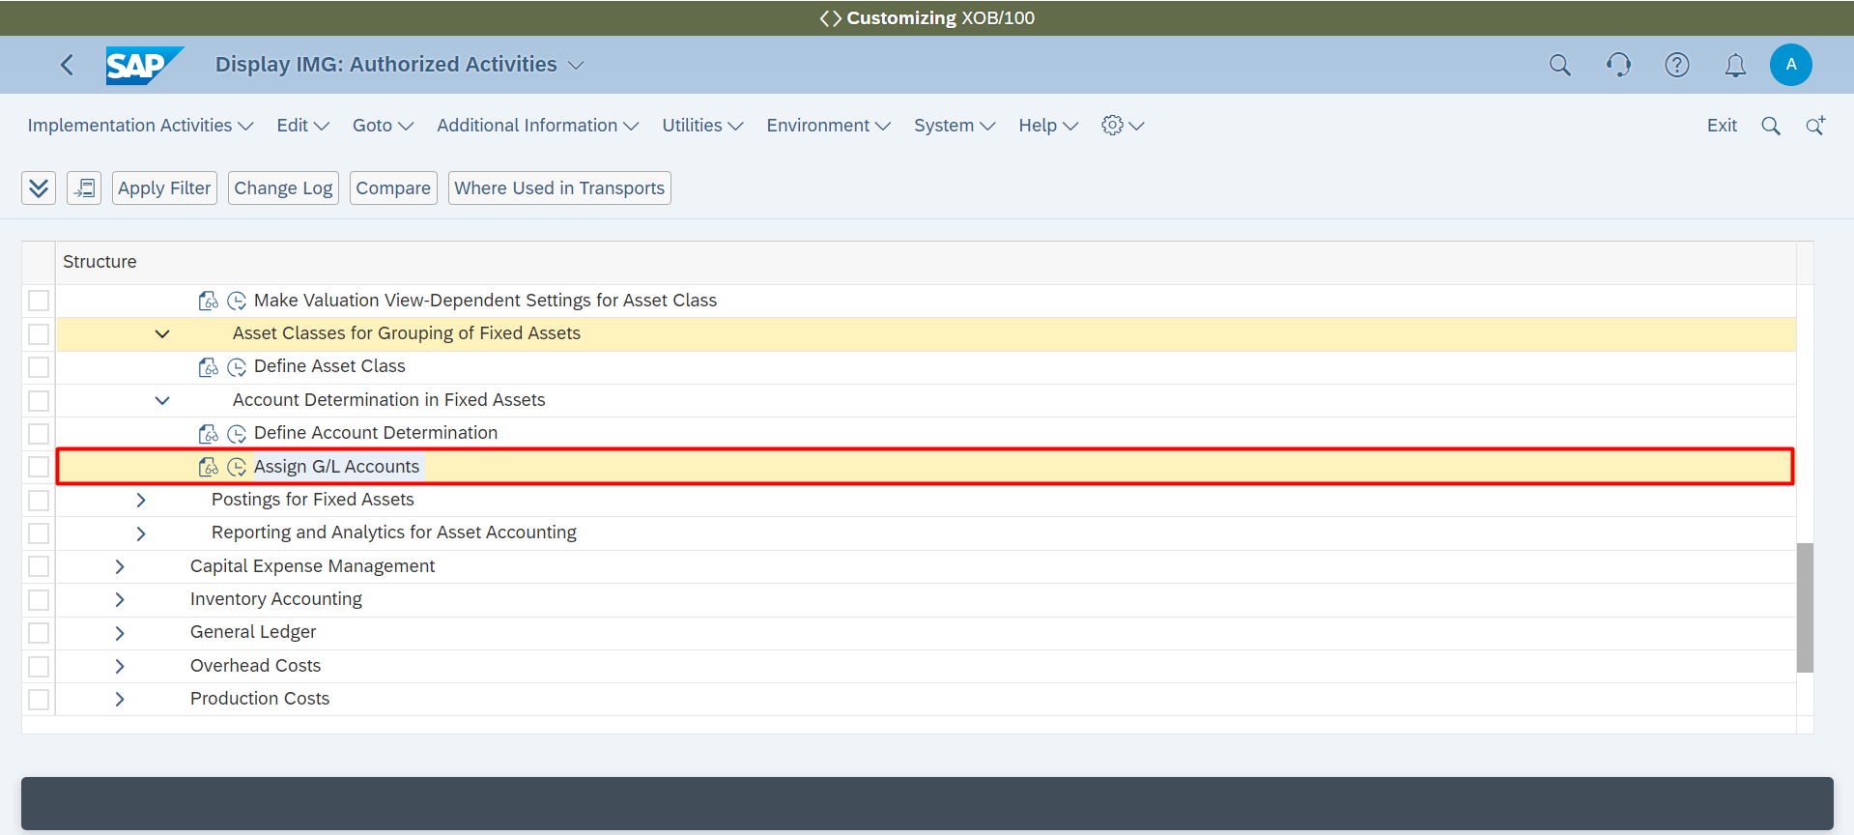

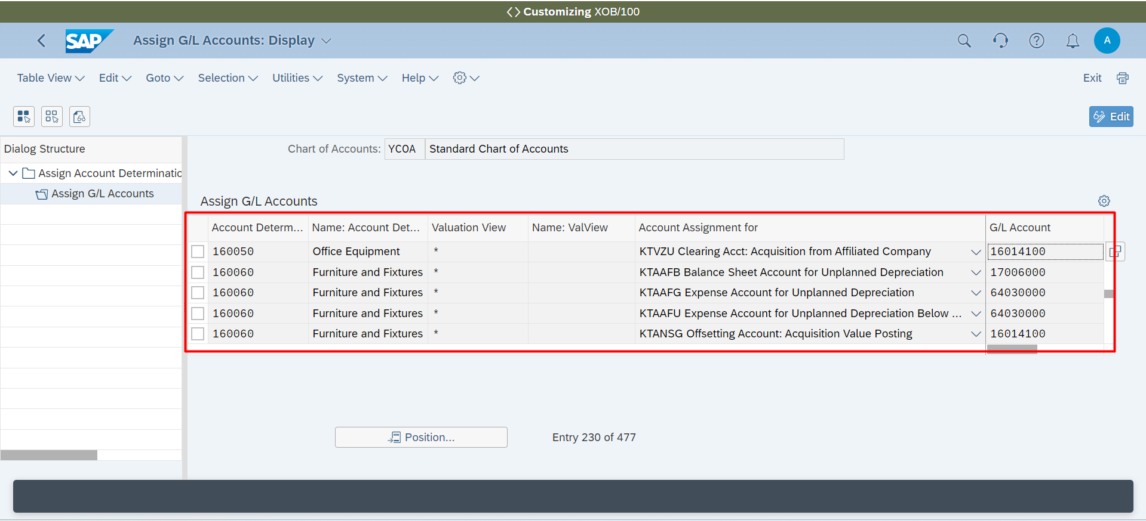

**Accounting 🡪 General Ledger 🡪 General Journal Entries 🡪 Define Document Number Ranges**

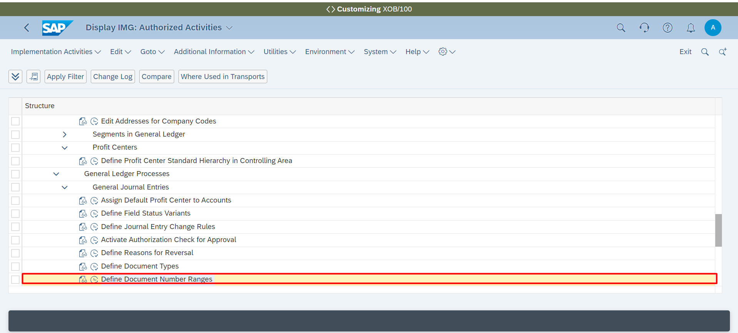

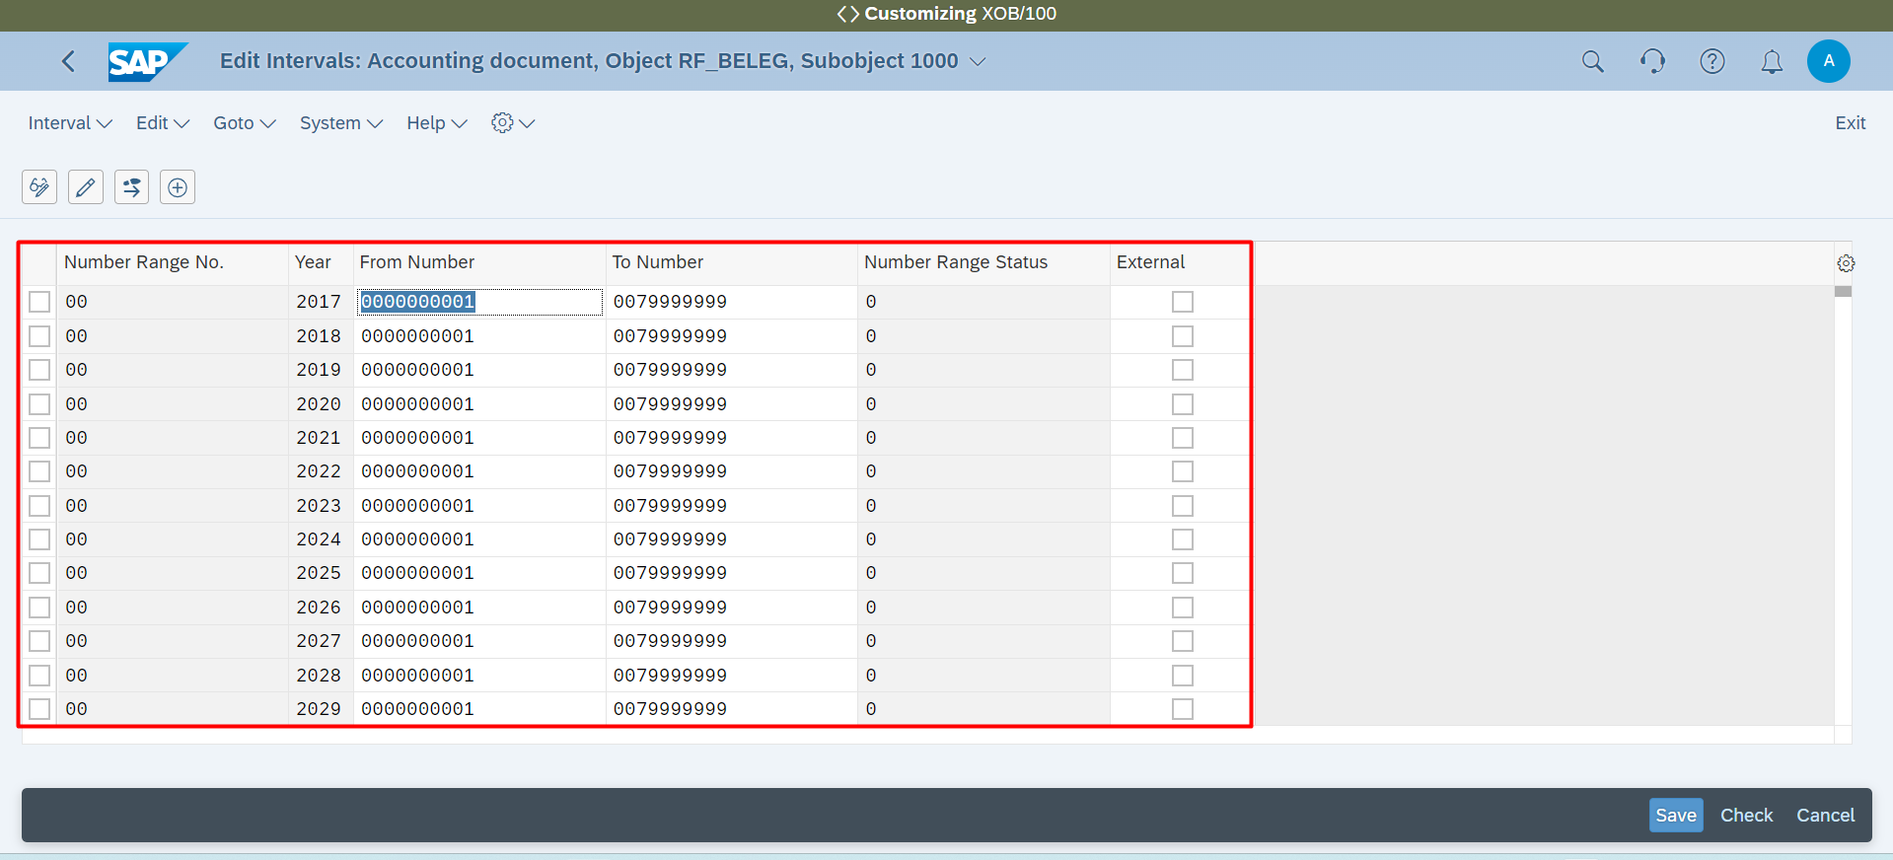

**Payables and Receivables Management 🡪 Payables and Receivables Management 🡪 Bank Statements 🡪 Make Global Settings for Electronic Bank Statement**

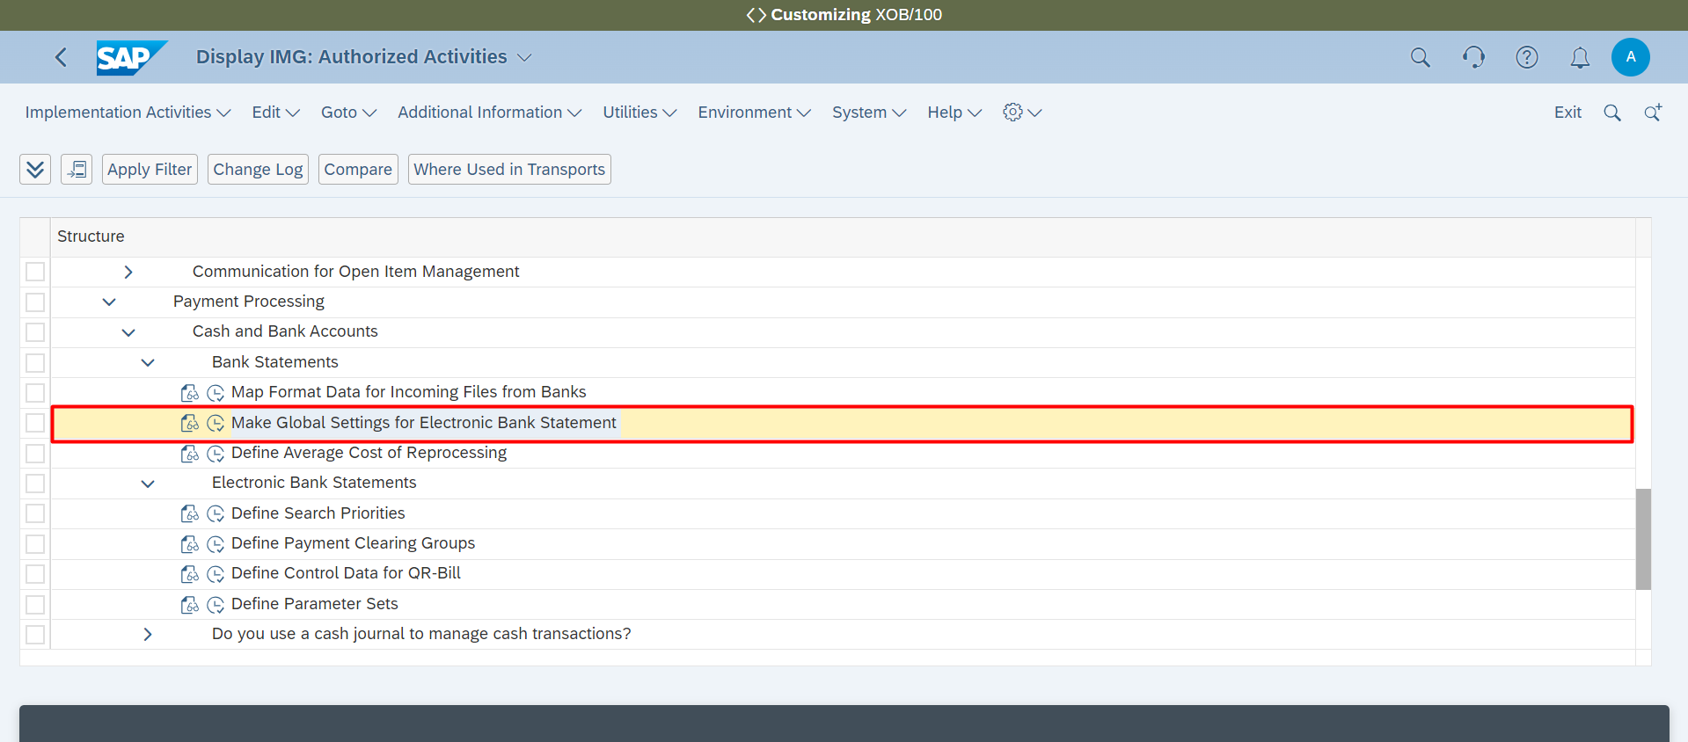

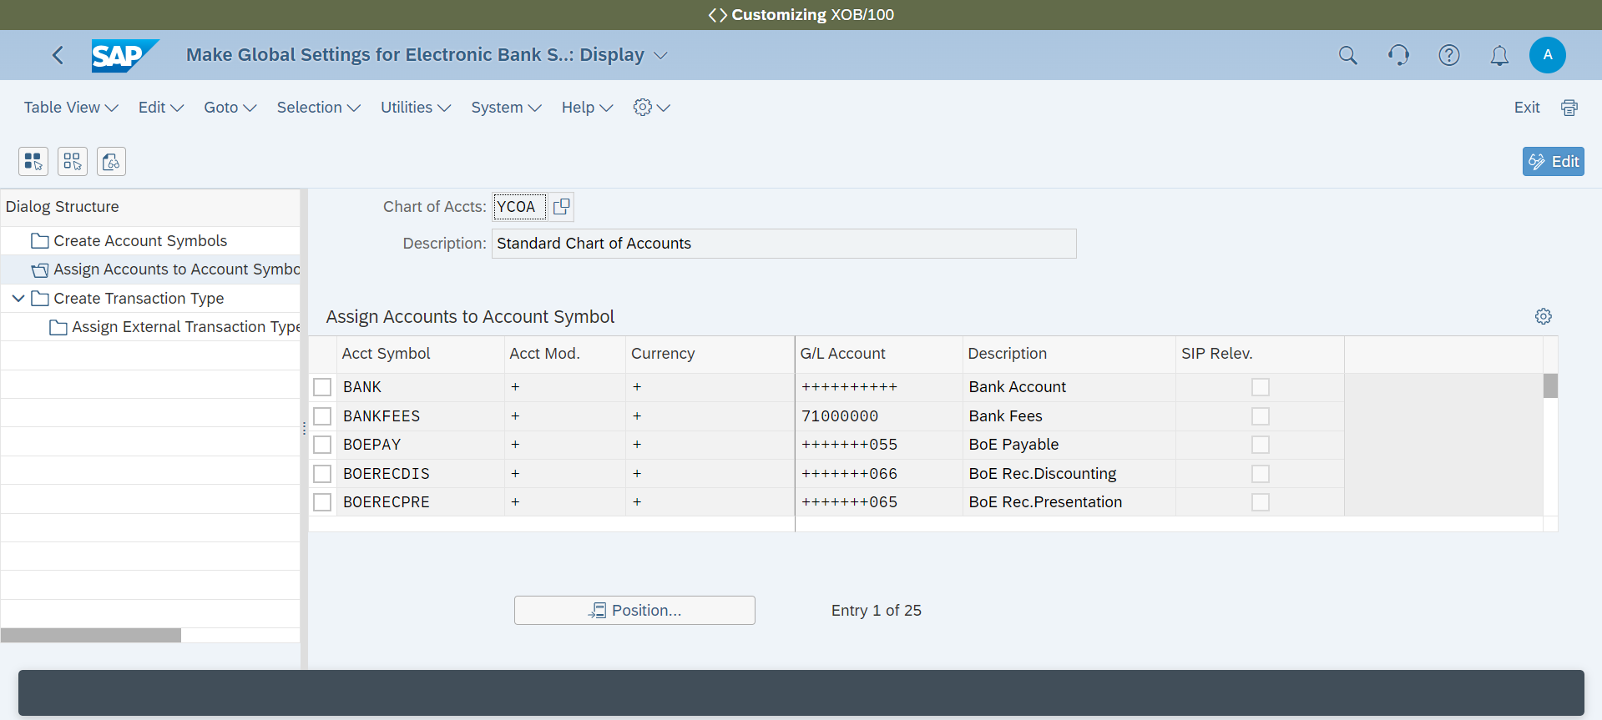

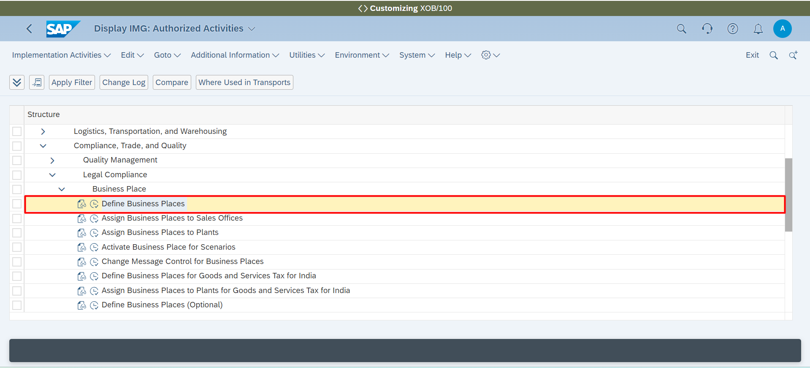

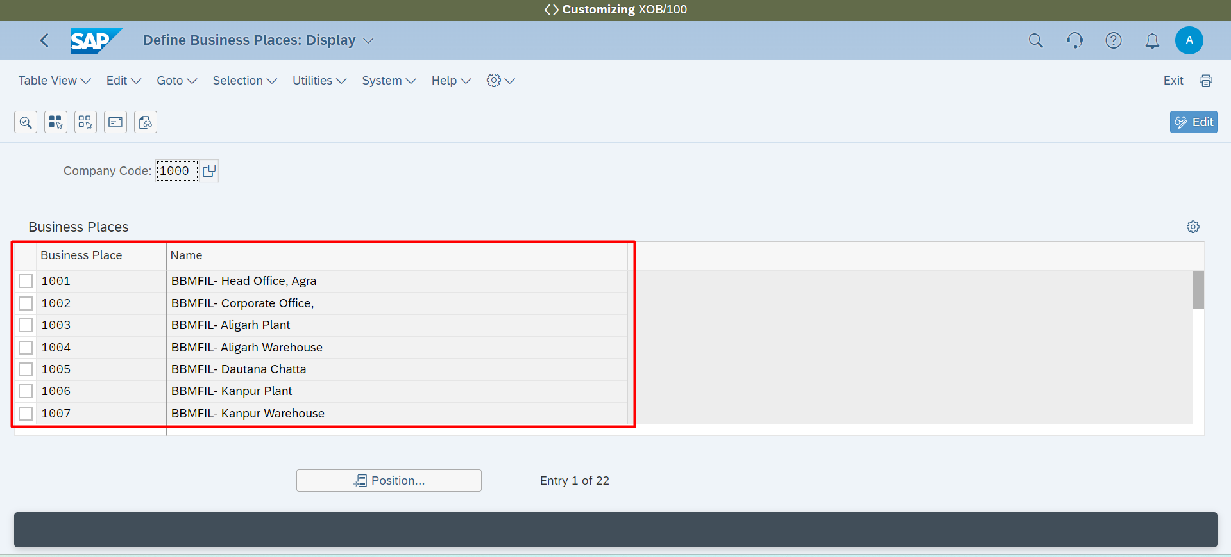

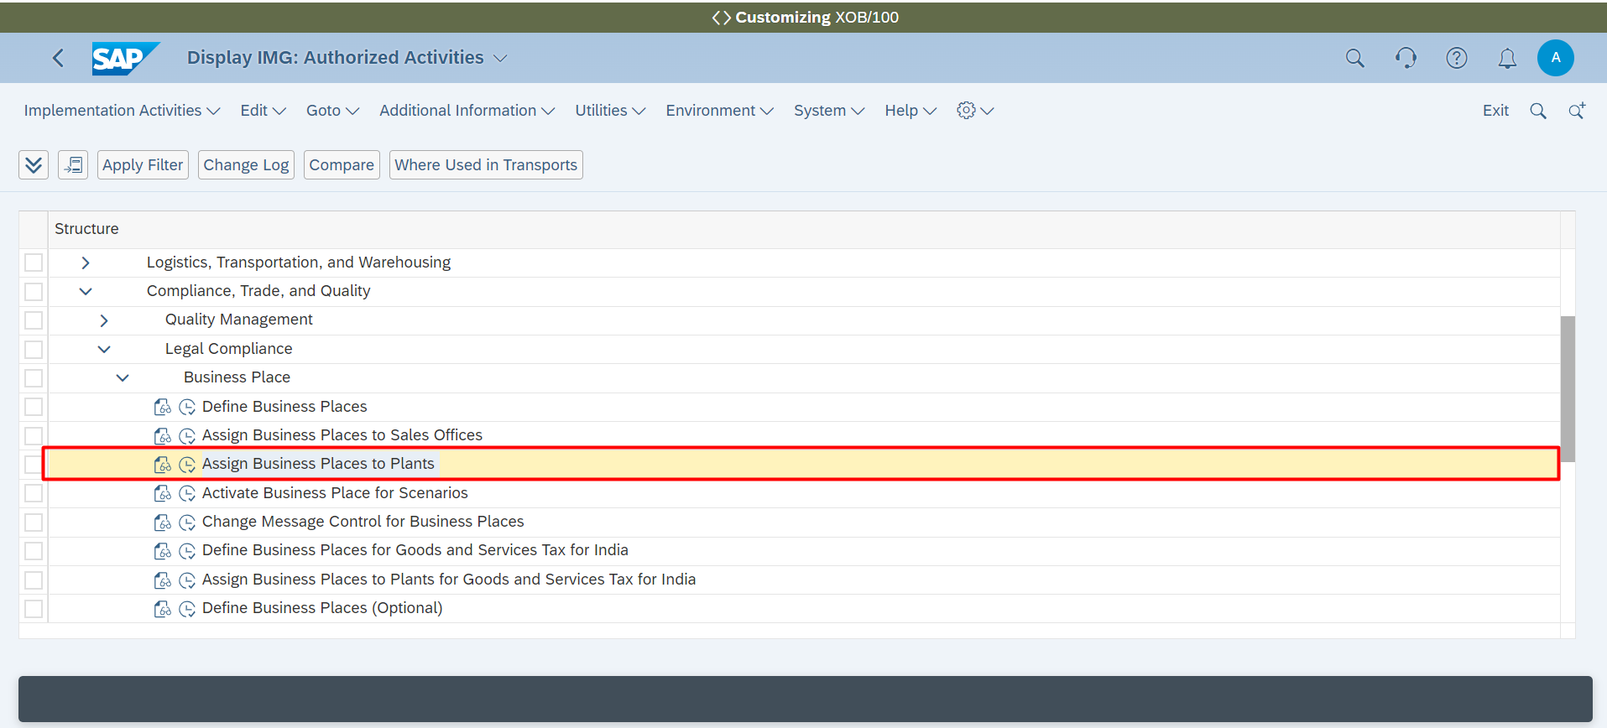

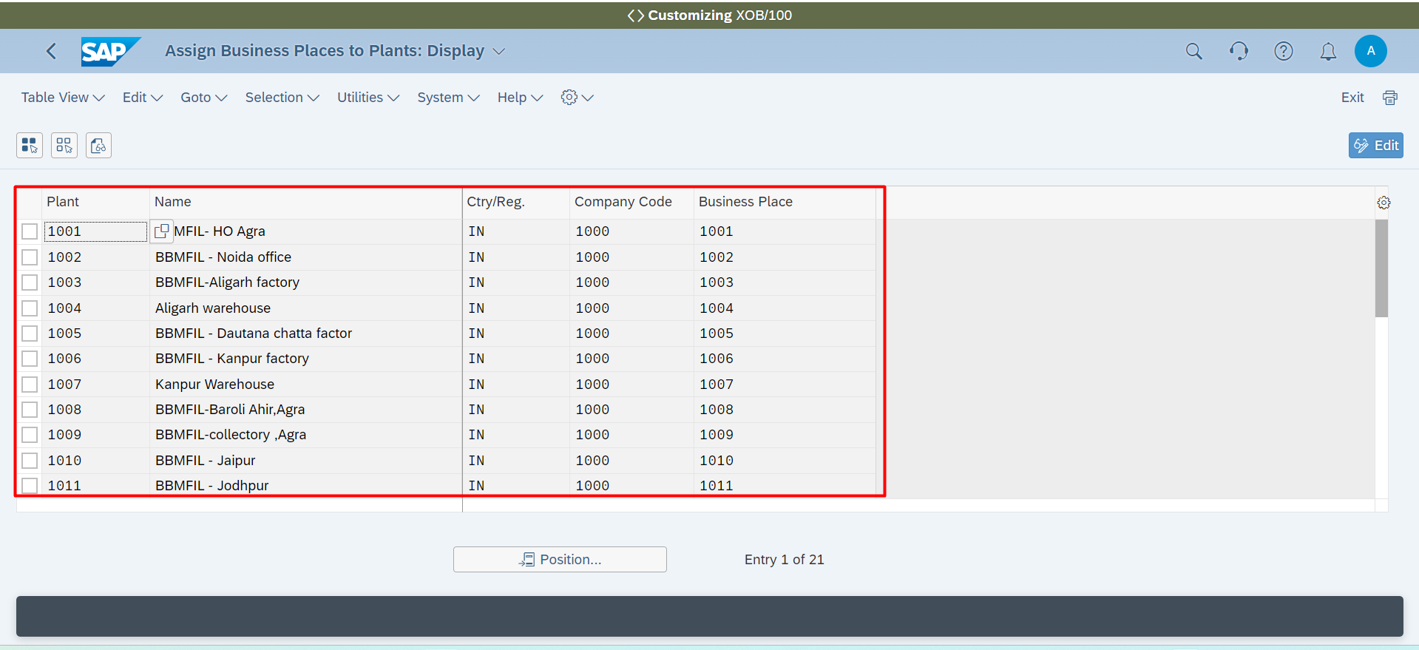

**Define Business Places for Goods and Services Tax for India**

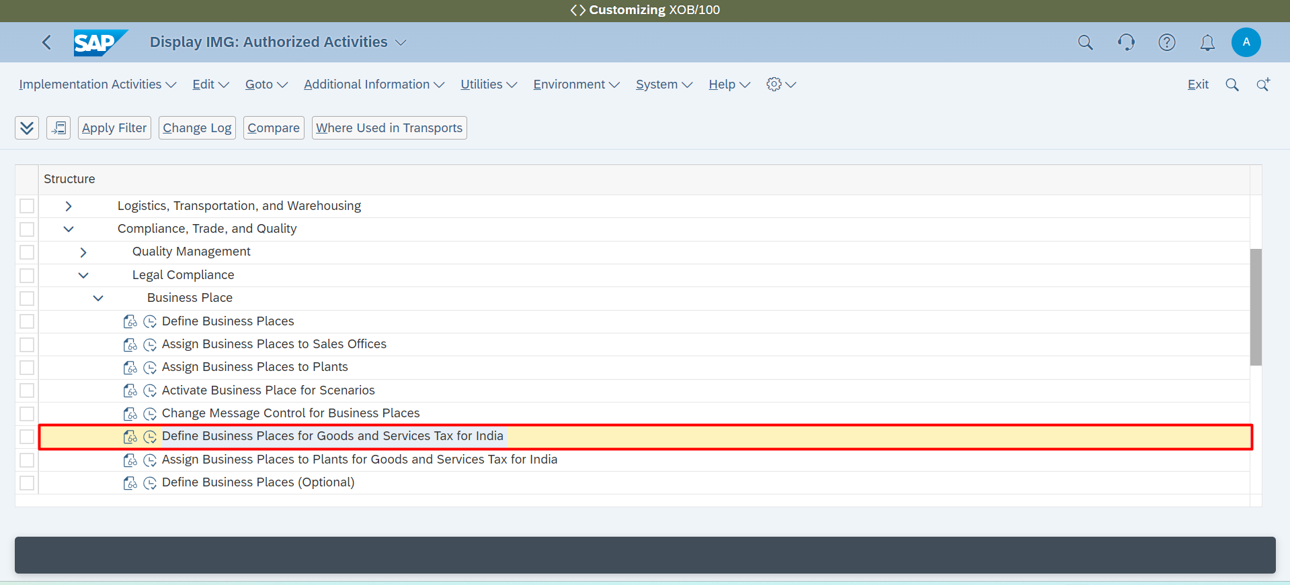

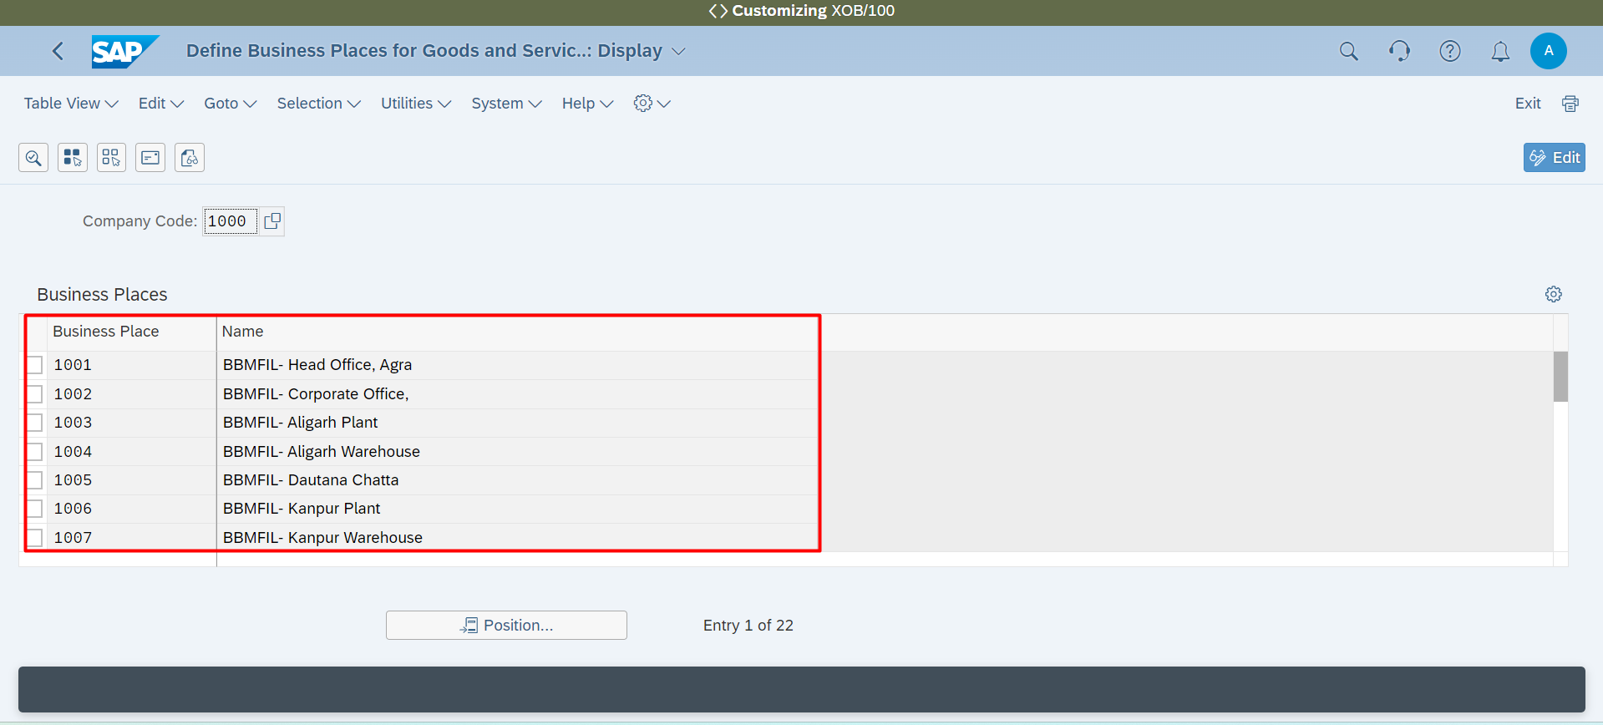

**Assign Business Places to Plants for Goods and Services Tax for India**

